Quick Guide to Internet Explorer 9
The web is constantly changing, and now Internet Explorer has changed too in order to keep up.
If you use Vista or Windows 7 at home, it will be automatically updated on your own computer too before long, so now is the time to get to grips with it.

Search
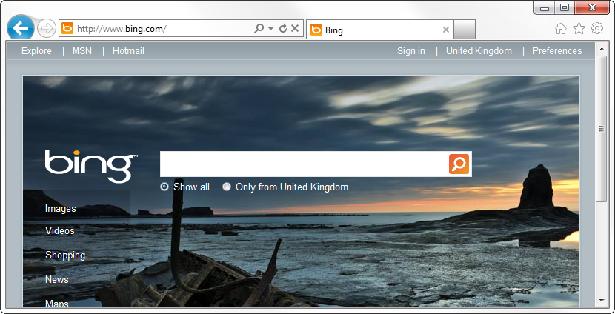
The address bar now doubles as the search bar. If you used to type searches into the search box in the top-right of Internet Explorer 7 or 8, type them here now.

Home
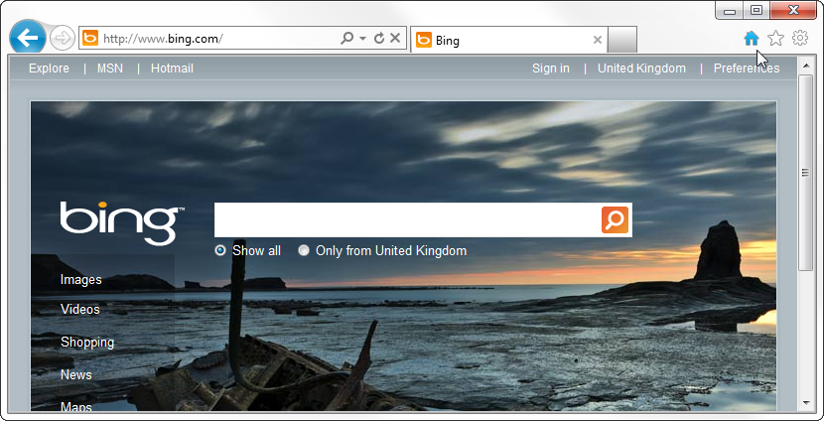
You can get to your home page at any time by clicking the House icon here.

Favorites, Feeds, and History
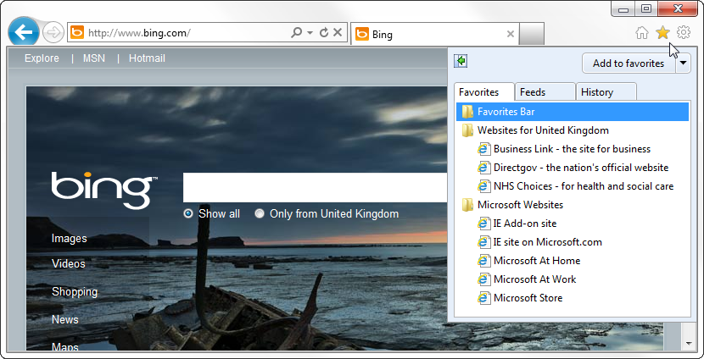
All the Favorites you’ve saved in the past are available by clicking the Star icon (top-right). Your History is also saved here, along with any Feeds you’ve added.

Everything Else
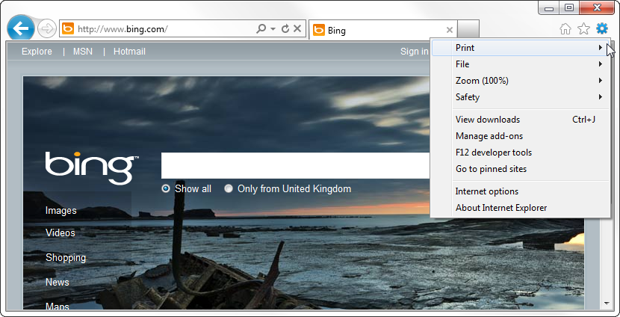
All the other menu options you might need (Printing, Internet options, etc.) can be found by clicking the Cog icon (top-right).

