HOMEPAGE
RHONDDA WOMEN’S AID


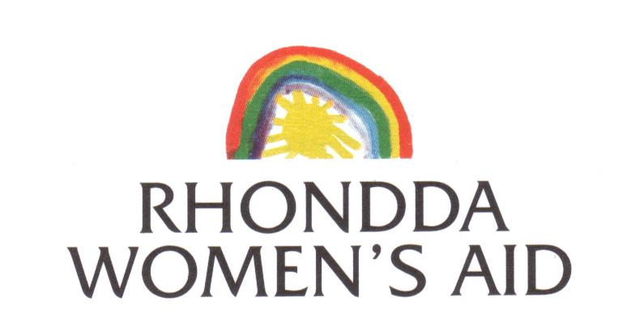
PO Box 1,
Ferndale,
RCT, CF43 3YD

If you are being abused link to new page
Housing Support link to new page
Support in your own home link to new page
Children’ Services link to new page
Statistics, Myths & info link to new page
Contact us link to new page

We came here because my father keeps on hitting us...........
We came here to be safe......

9.00 am to 5.30 pm
01443 731445
Email: info@rhonddawa.org.uk

Evenings & Weekends
DOMESTIC ABUSE HELPLINE
0808 80 10 800
Picture Box
Rhondda Women’s Aid provides information, advice and support to women who are experiencing domestic abuse or violence

