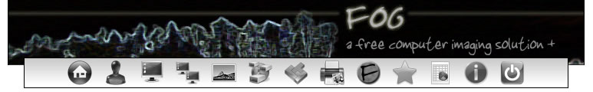
Overview
FOG makes use a database to manage all individual clients, groups and images. Once you get your head round how FOG goes about it’s business it will be very clear how effective it is a cloning solution.
Before you can image a computer you need to create an image to assign to it, register the client with the FOG Server, and also tell FOG what operating system the client is expecting to be imaged with.
This guide assumes you have a FOG Server running with local storage, and default settings.
Step 1: Create the Image on the FOG Server
So, first step is to log into the FOG Management interface, which will most likely (unless it has been changed from the default install) be;
http://ipaddress/fog/
*Default username/password – fog/password
Hit this icon on the menubar to be presented with the Images Menu
You will be presented with an empty form. Give your image a name, description, add it to the desired storage group (default, unless you have additional storage pools configured) as shown below,
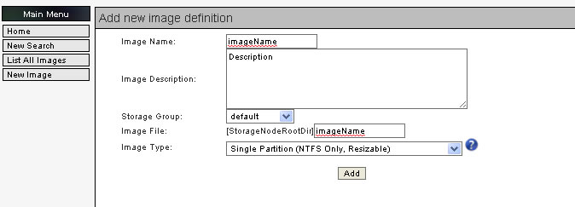
Hit Add. There you’ve created defined your image.

Step 2: Register the Client to upload an Image to the FOG Server
This simple process involves PXE/Network booting the client, registering it with the FOG Server, assigning it an Image ID and Operating System ID, then getting the client to upload an image of its hard disk to the FOG Server.
So, boot the client to Network/PXE (If you don’t know how to do that maybe you should rethink whether your up to the task..)
You will be presented with a FOG Menu after a very short amount of time. Now, you generally have to be paying attention here or the default option will automatically kick in, and your computer will boot, which you really don’t want, especially is you’ve sysprepped it! (It would be recommended to register your host before you sysprep it). So you have a couple of seconds to hit an option. (I tend to hit the down arrow, just to stop it booting from the hard disk).
Here’s what your going to be looking at now. As you can see, Boot from hard disk is top, and is the default option.
We want to select the 4th option here, “Perform Full Host Registration and Inventory”.
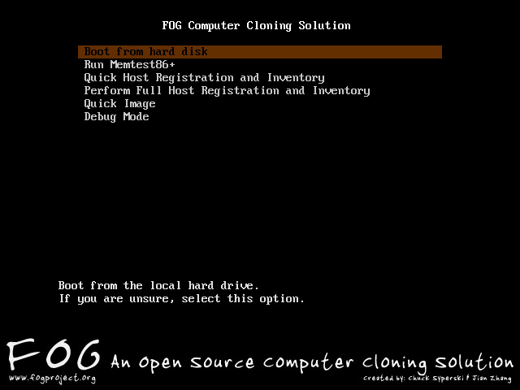
FOG will load a few files, this may take a minute or so. Once its ready you will be presented with a few questions, which will be very easy to answer im sure,
- Enter the Hostname of this computer: Simple, pop in the name your going to give the computer when you connect it to your network. (Eg. ADMIN-01, ICT226-01). You get the idea.
- Enter the ip for this computer: unless you’re assigning static address ignore this, and hit enter to continue
- Enter the Image ID for this comuter: Right, you just defined an image to assign to this computer, hit ? and FOG will list the current images you have define. Select the appropriate number and hit enter.
- Enter the OS ID for this computer: as above really, hit ? and select the right number which corresponds to the Operating System your computer is running.
- Would you like to add this host to AD? Unless you’ve configured FOG’s AD settings, you can leave this as default, which is No.
- Enter the primary user for this computer: Again, ignore.
- Enter the other tag #1 for this computer: Add additional info about the client if you like..
- Enter the other tag #2 for this computer: As above…
- If you entered all the required information would you now like to image this computer now? : Because were only getting ready to create an image we wont be imaging this comuptuer just yet, so leave this as default, No.
That’s it. FOG will register your host and reboot it. (WARNING if you have Sysprepped, you don’t want it to reboot, and boot from the hard disk, so make sure you turn it off before it gets chance to do this).
If you go back to the FOG Management interface and click on the Hosts button, the list hosts you will see the client you just registered If you cant, something went wrong .
(Hosts Icon)
Step 3: Creating the Image
We now need to tell FOG to upload the image from the client. So, on the management interface, hit the tasks button.
(Tasks)
You’ll be presented with a screen similar to below:
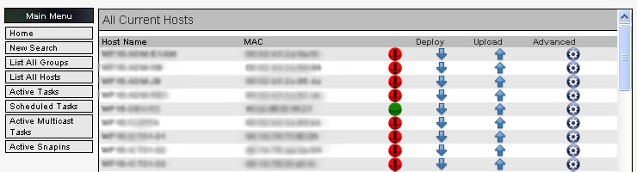
Find the name of your newly registered client, and hit the Upload Arrow that corresponds to your client.

You then get presented with some options, if your happy to image the computer immediately, just hit the Image now button, otherwise, schedule FOG as required to collect the image the computer.
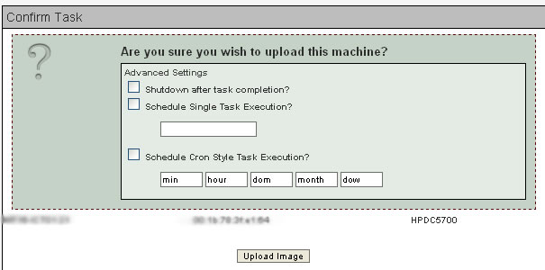
You will now be able to see the job in the Active Tasks menu, within the Tasks section of the Management Interface.
If Wake on LAN is working on your network, and your computer is set to Network boot before hard disk, then you can pretty much stay where you are, FOG will do the rest, its that good.
If not, shimmy over to your client, and boot it to the Network, and again, FOG will do the rest.
Troubleshooting Issues.
FOG doesn’t like unclean shutdowns – it can’t create the image if there are certain flags on the NTFS partition, if you get a FOG error because of this, you will need to chkdsk your drive, and possible reboot it a couple of times.

