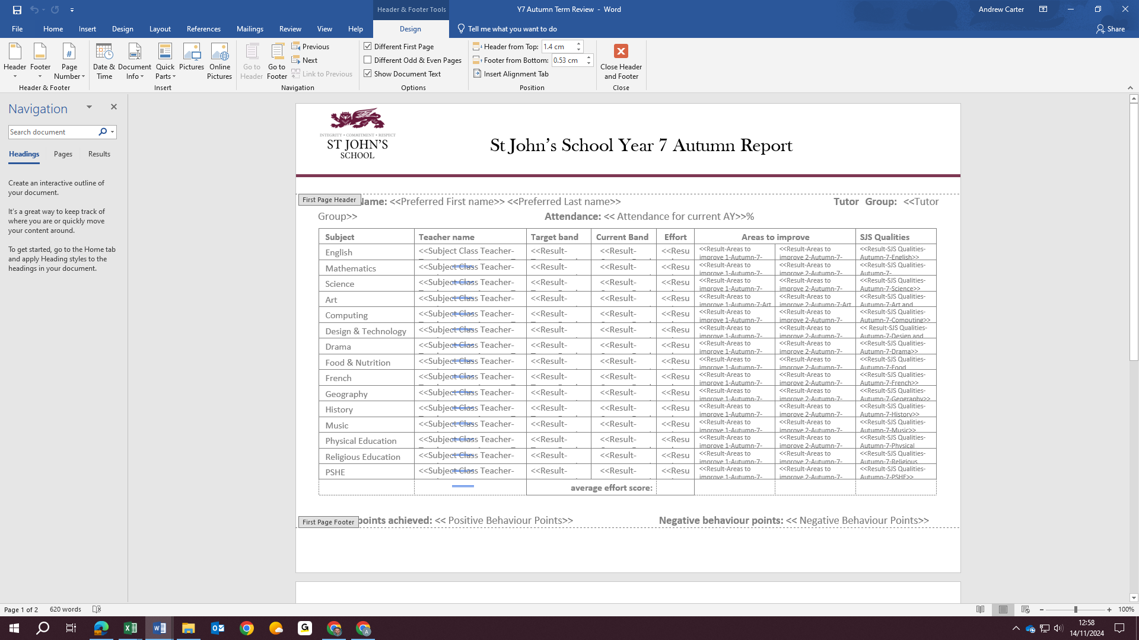
Header settings for ‘Y7 Autumn Term Review’

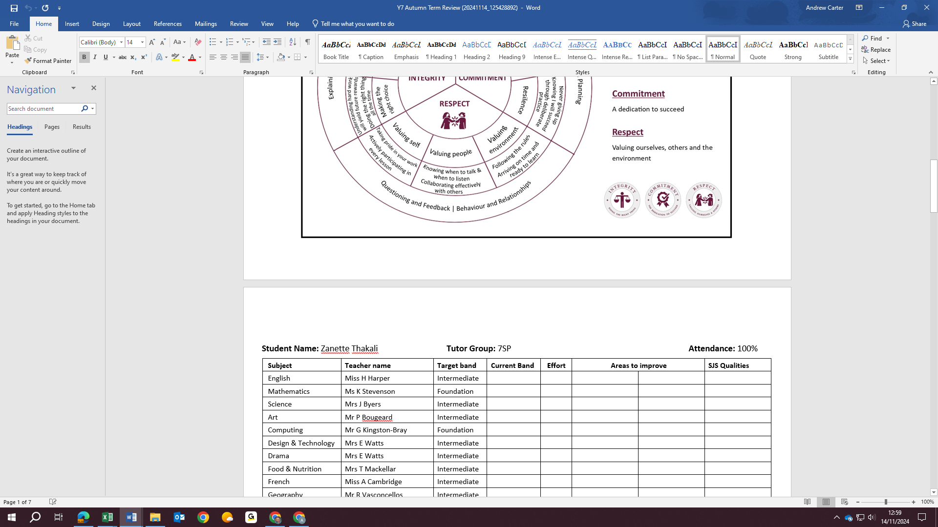
Merge from ‘Y7 Autumn Term Review’ – header only appearing on page 1 of the whole mail merge document

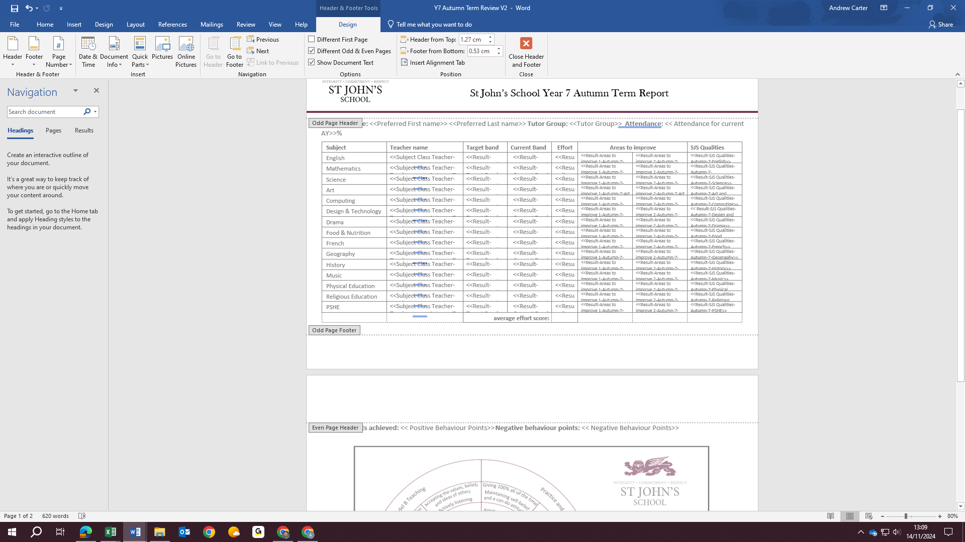
Header settings for ‘Y7 Autumn Term Review v2’ (NB. Header settings also applying to page 2, & points fields displaced to page 2 – I don’t want this)

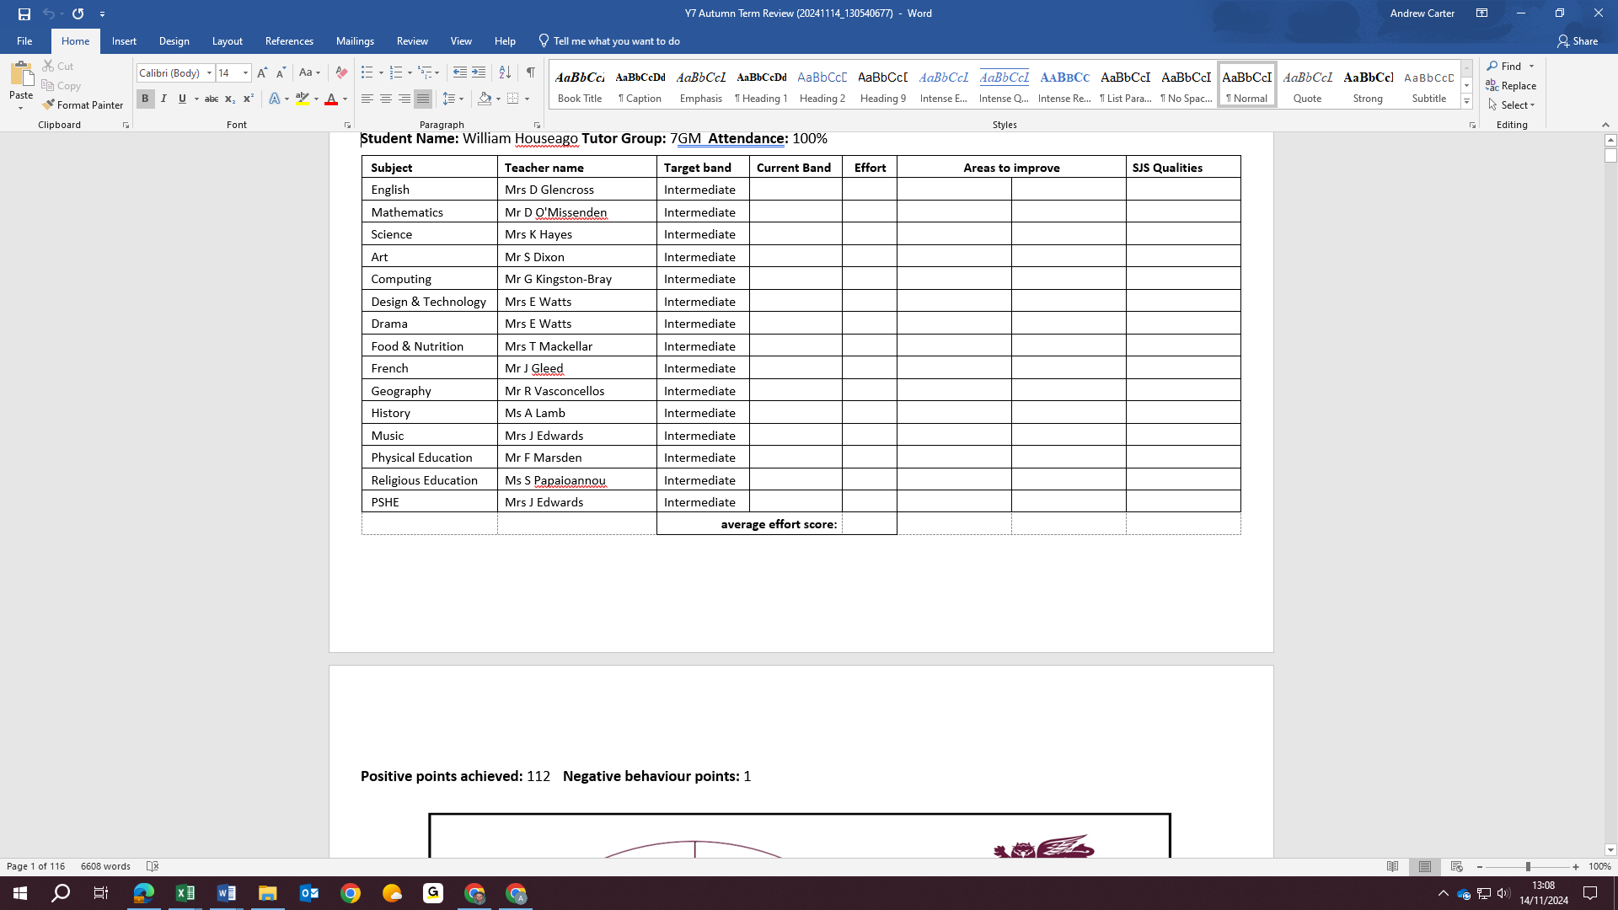
Merge from ‘Y7 Autumn Term Review v2’ – points fields displaced to p2 & pedagogy wheel ‘chopped off’ at bottom

Will now try & merge from ‘Y7 Autumn Term Review’, but with ‘Different Odd & Even Pages’
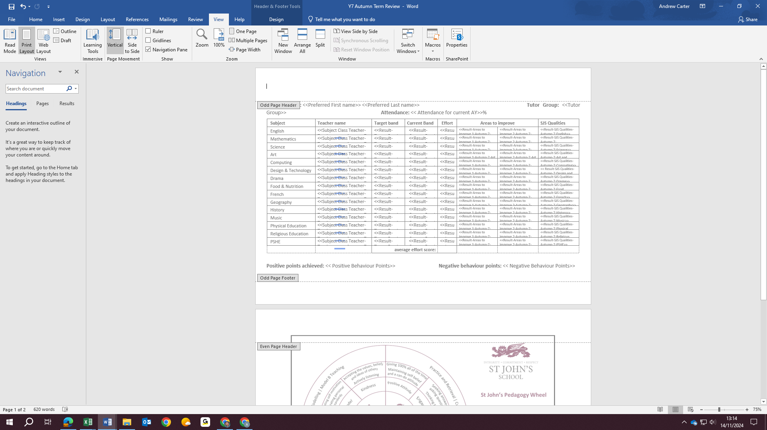
The header disappears from both pages.

Will now try & merge from ‘Y7 Autumn Term Review’, but with both ‘Different First Page’ & ‘Different Odd & Even Pages’
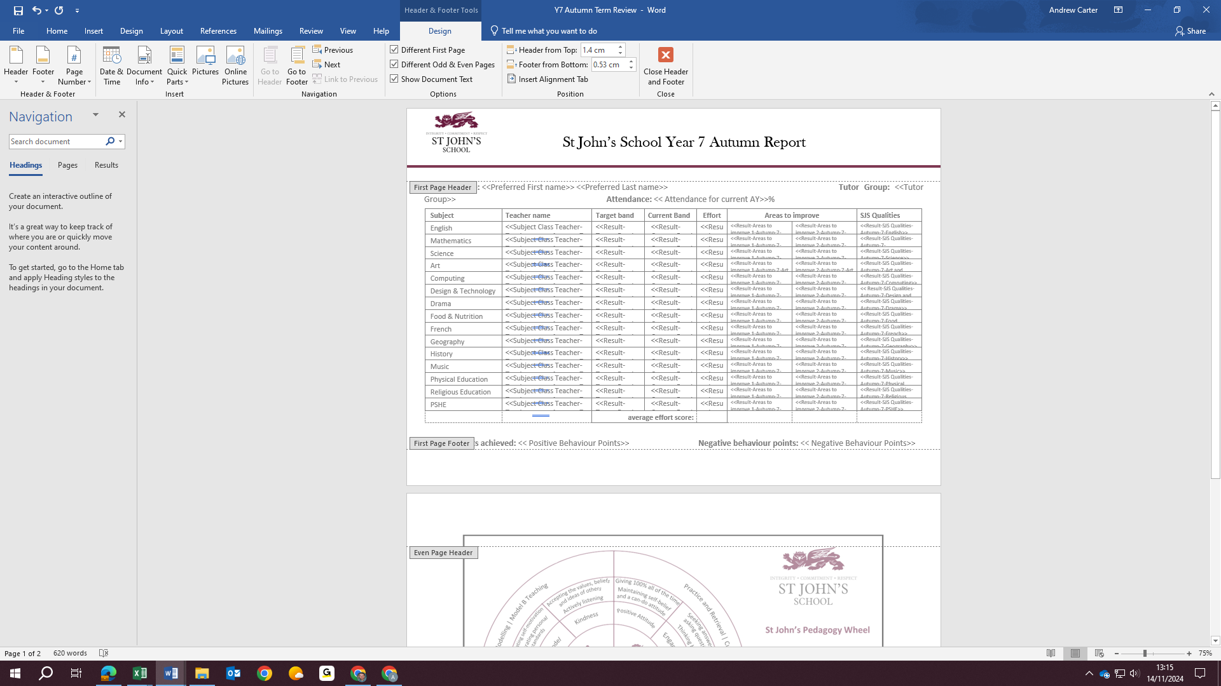

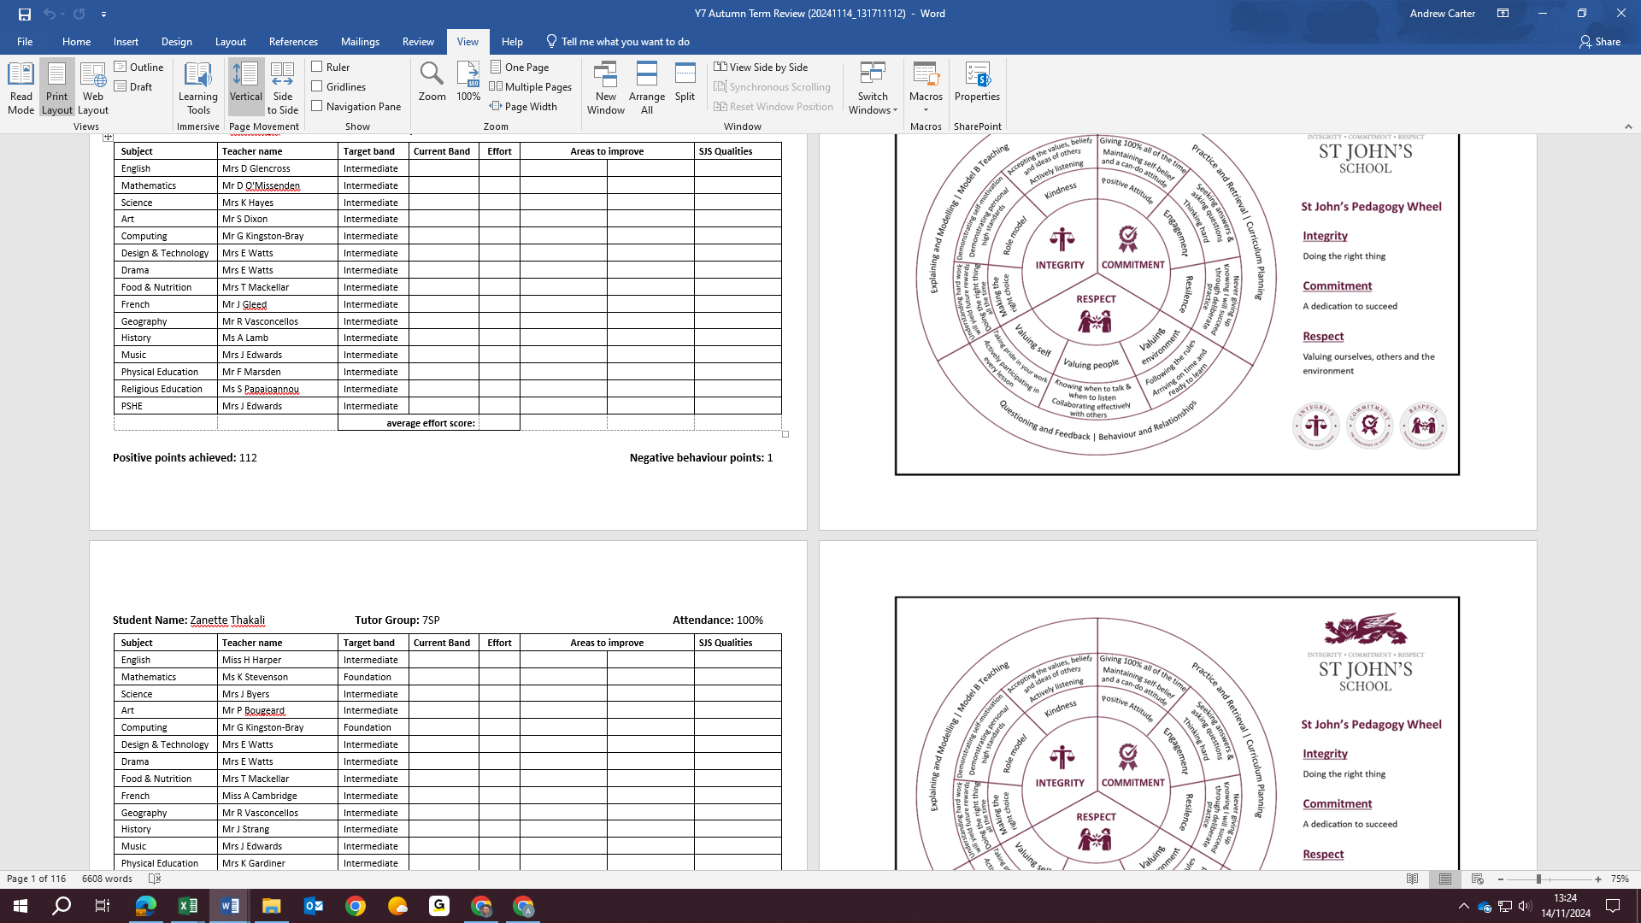
Header still only showing on page 1 of whole mail merge document

