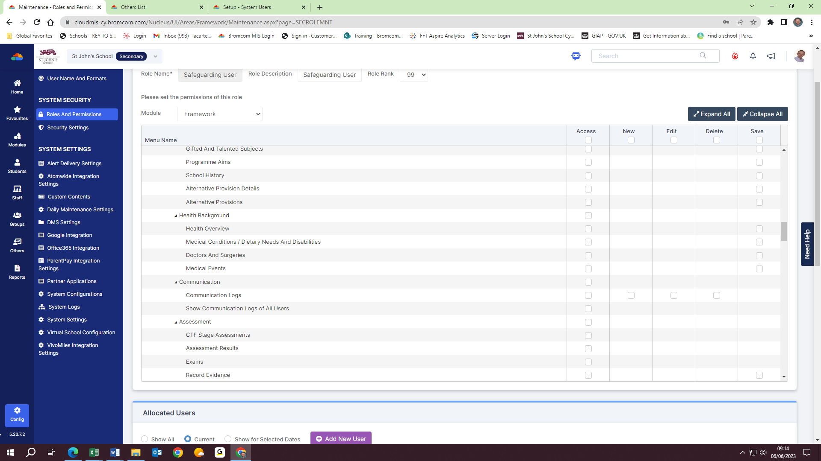
Which role would enable me to amend permissions for, e.g. the ‘Health Background’ permissions, such that the user could also add/edit/delete/save records as required? (not possible under ‘Framework’)

