Adding a resource to Moodle
One of the most common uses for Moodle is as a repository for existing course materials that you want to make available to your students when they’re not in college. To do this you need to upload files to the Moodle server and then create a link to them from your course page.

Adding a resource
- On your course page click the turn editing on button in the top left
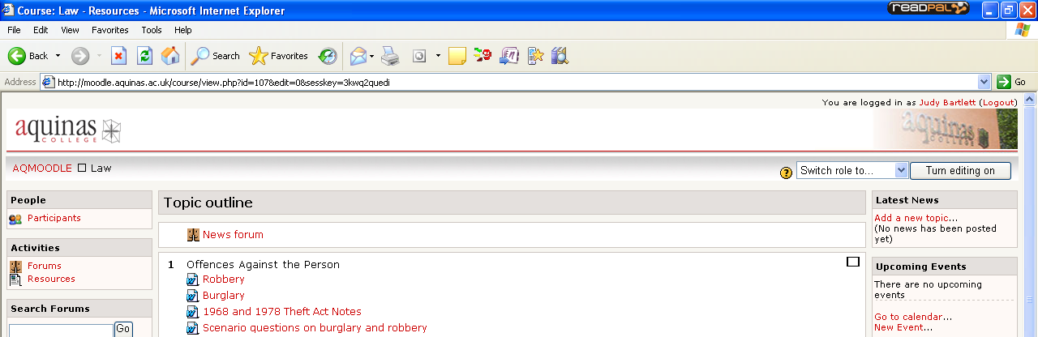
- Now editing tools are available. Each topic has an Add a resource… and an Add an activity… dropdown menu.
- Scroll to the topic or week you want to add the resource to.
- Click on the add a resource drop-down menu in the topic you want to add to and select Link to file or website
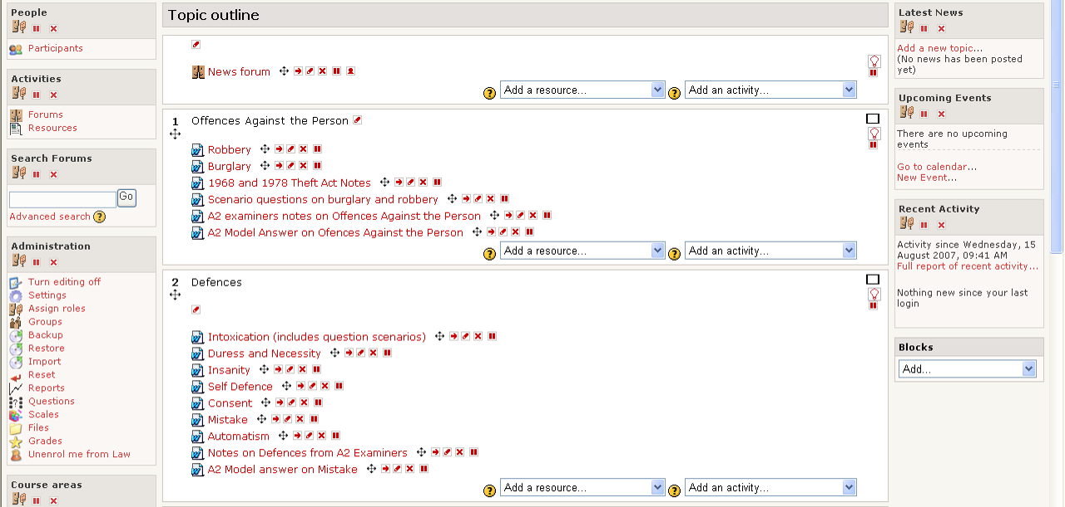
- This will bring up the Adding a resource page.
- Type in a name for your resource. You can put a summary but it’s not required.
- Click on the choose or upload a file button
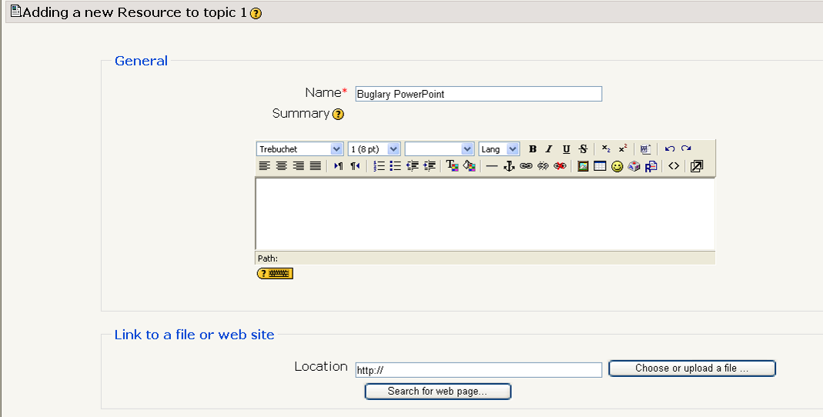
- This brings up your course files. Click on the folder you want to put the file in (if applicable) then scroll to the bottom and click the Upload a file button. 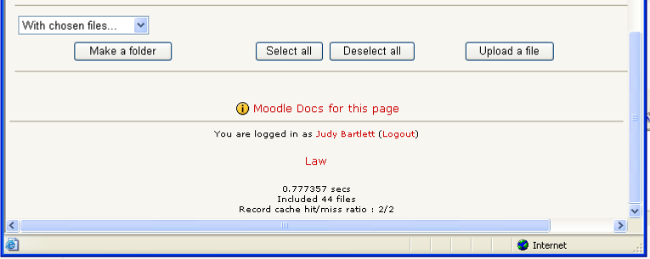
- This brings up the file upload screen. Click Browse…
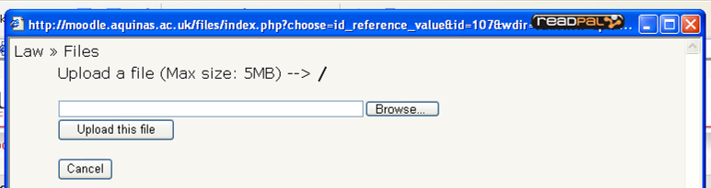
- This brings up your area – find the file you want to upload then either double-click it or click Open
- The name of the file should appear in the box. Click Upload File
- This takes you back to the list of your course files. Find the file you’ve just uploaded and click the choose link next to it.
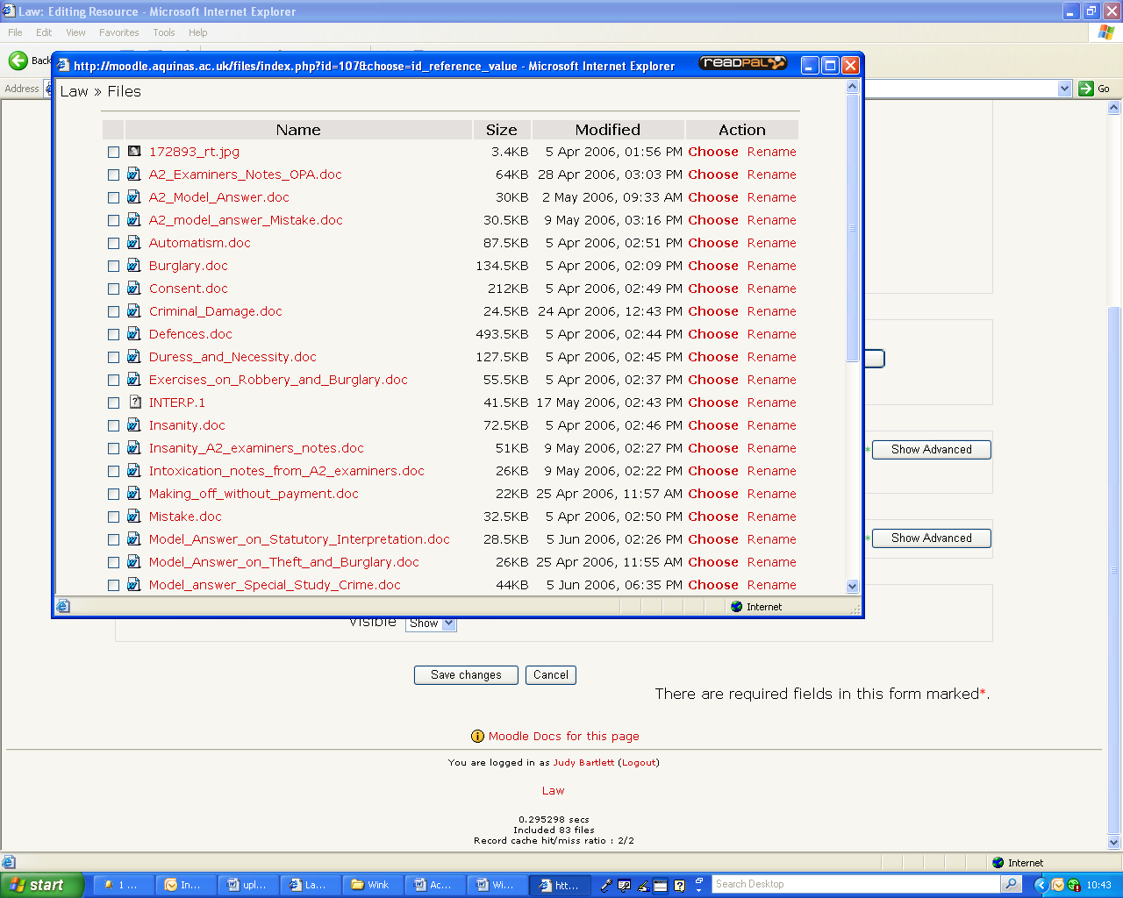
- 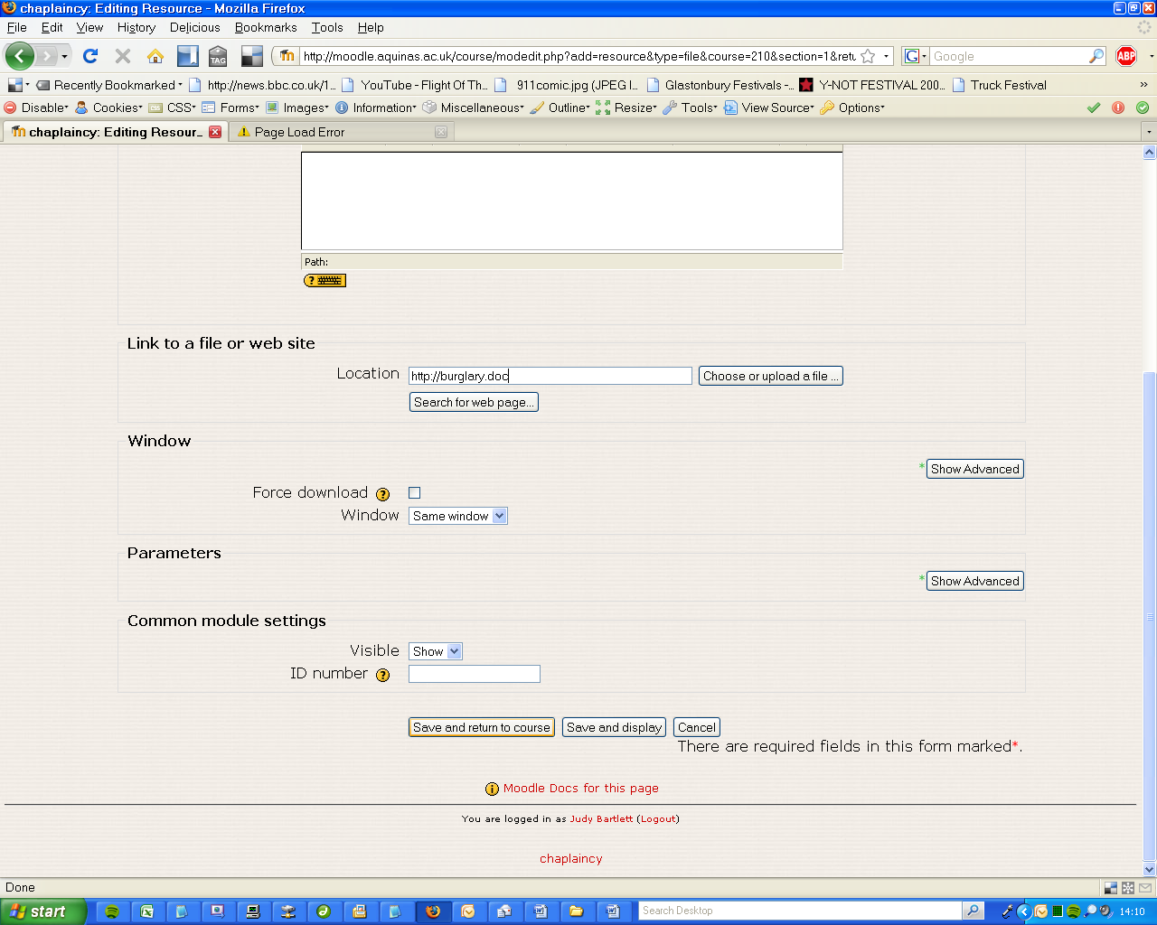This takes you back to the Adding a Resource page. The filename should appear in the Location box

- Click Save and return to course
- Moodle will now attempt to give you a preview of your resource, the result depends on your browser – see viewing a resource for details

Common Problems
After I click on the file I want to upload I can’t find it in the course files list
The file might be too big. Try uploading again and this time check at the top of the course files list for an error message. The maximum size is 10MB – if your file is bigger give it to IT to upload.
When I click on the resource I just get a blank screen
Look for a yellow bar at the top of the screen – click on it and select download. For more information check the Viewing a resource sheet.
If there is no yellow bar, edit the resource (click the edit icon next to it) and check that the filename is in the location box. If not, repeat steps 7-15.
I get an error “Required parameter ID is missing”
This can happen if you’re automatically logged out of moodle – log in and try again.

