Adding a Resource Flowchart
yes
no
website
Enter the web address in the location box
Click on the folder you want to put the file in (if applicable)
Click the upload a file button (at the bottom of the page)
Click the Turn editing on button
Click on the add a resource… dropdown menu and select link to file or website
This takes you back to the Adding a new resource page. Scroll down and click save and display or save and return to course
Find the file you want to link to and click the choose link next to that file
This should close the dialog box. Click the upload this file button. This takes you back to the list of your course files
Either double click the file or select it and click Open
Click the browse… button to and find the file you want to upload
This brings up the Adding a new resource page. Enter a name for the resource in the name box
Scroll to the topic or week you want to add the resource to.
If you click save and display you’ll get a preview of your resource. If it is a file it may be blocked by internet explorer security. For more info see Viewing a resource on the reverse.
This brings up your course files.
Is the file you want to add already in your course files?
file
Click the Choose or upload a file button
Do you want to add a file or a website?
Viewing a resource

Sometimes when you click on a resource in Moodle it doesn’t display immediately. This is because the browser (Internet Explorer) thinks it might be a virus. If you click on a resource and just get a blank page look carefully for a yellow bar a t the top.
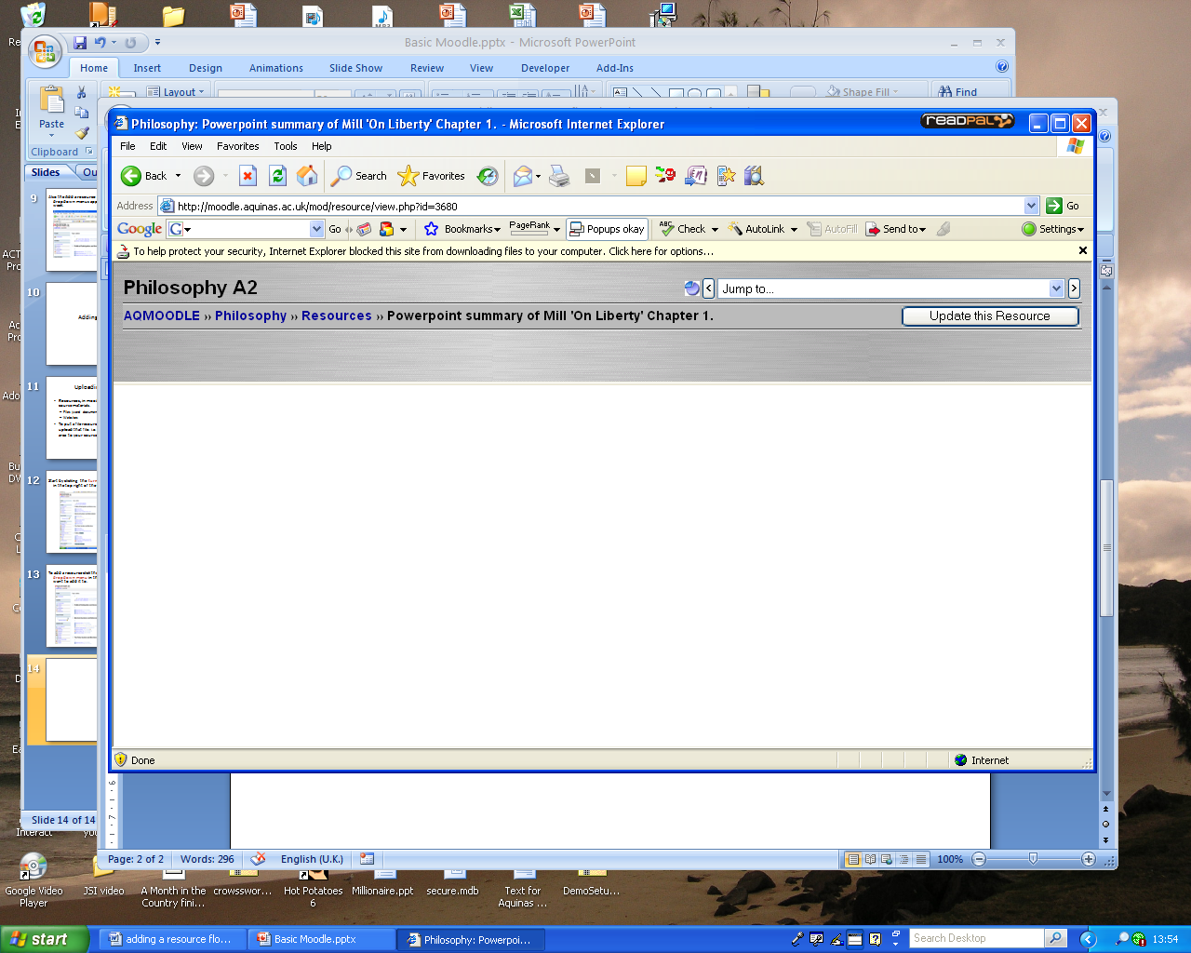

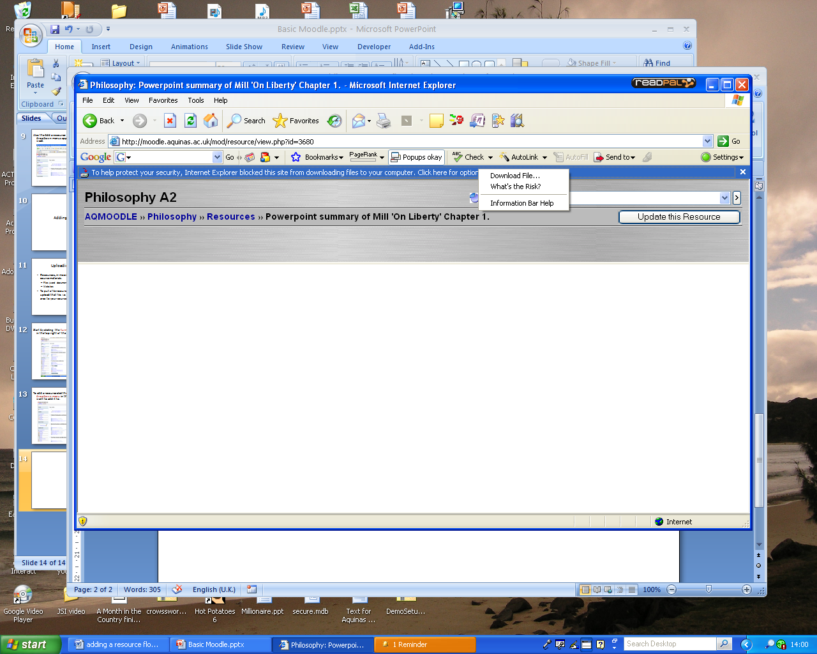

Click on the bar to bring up a menu

Select Download File…

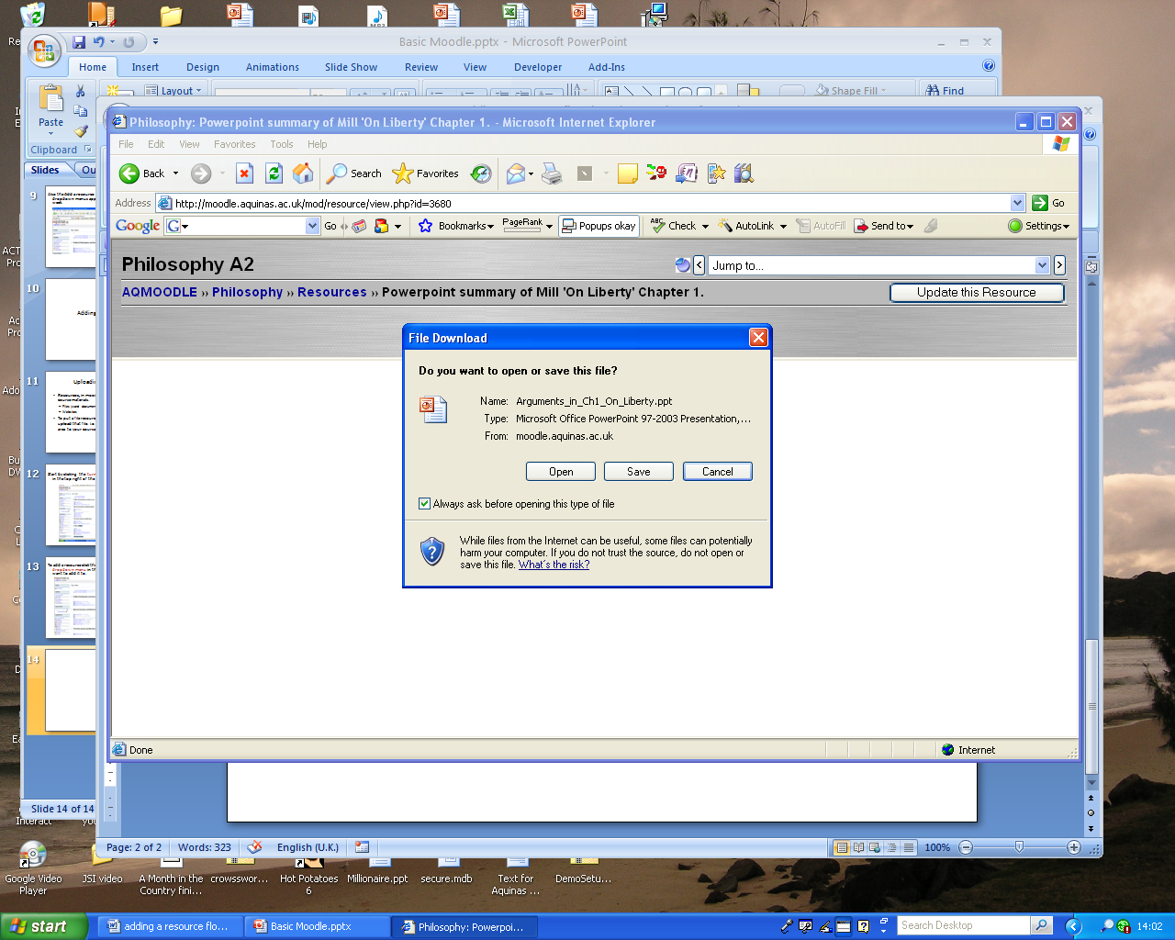Click Open to open on your PC or click Save to save to your area.

