This is a screenshot of our update compliance dashboard for 1853 devices. This relates to the October 2022 patch Tuesday patches for Windows 10:
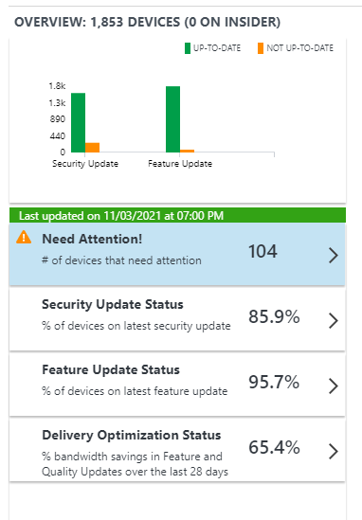
As you can see this is pretty effective! We wake desktop PCs at 10pm to run scans, laptops catchup when they can using Windows 10 maintenance schedules. We have PCs grouped into three rings with different deferral dates for quality updates - test, pilot and deploy. These are the registry settings (configured in Group Policy Preferences) we use to configure Windows Update and WuFB for our "deploy" ring.
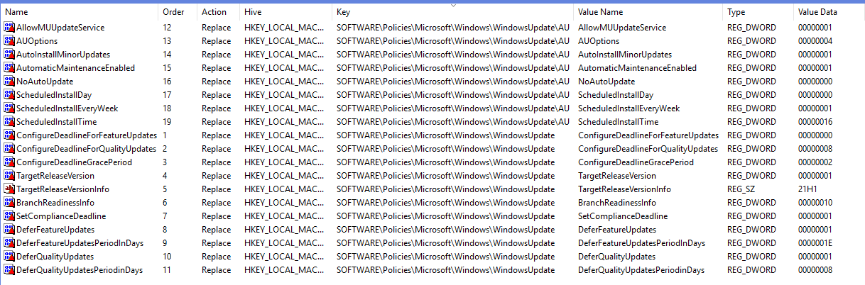
We settled on these settings after reading through Microsoft's Optimizing Windows 10 update adoption document. Note that these settings are optimised for 1909 and above, some of the older feature updates didn't support some of these settings. We actually use Intune to deploy these now, but the above registry values translate to these settings:
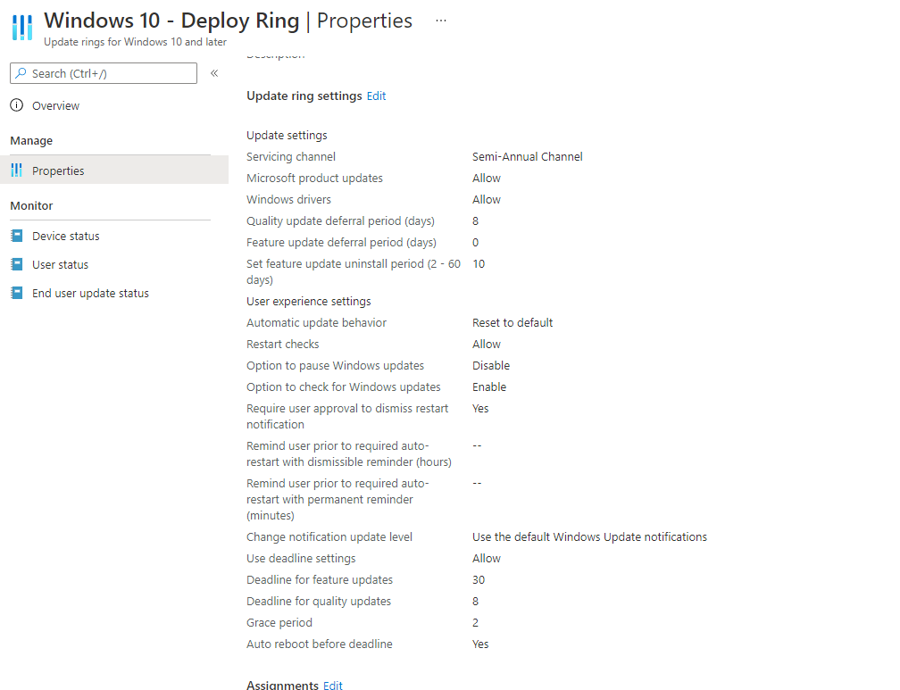

Here are our delivery optimisation settings configured in a GPO:
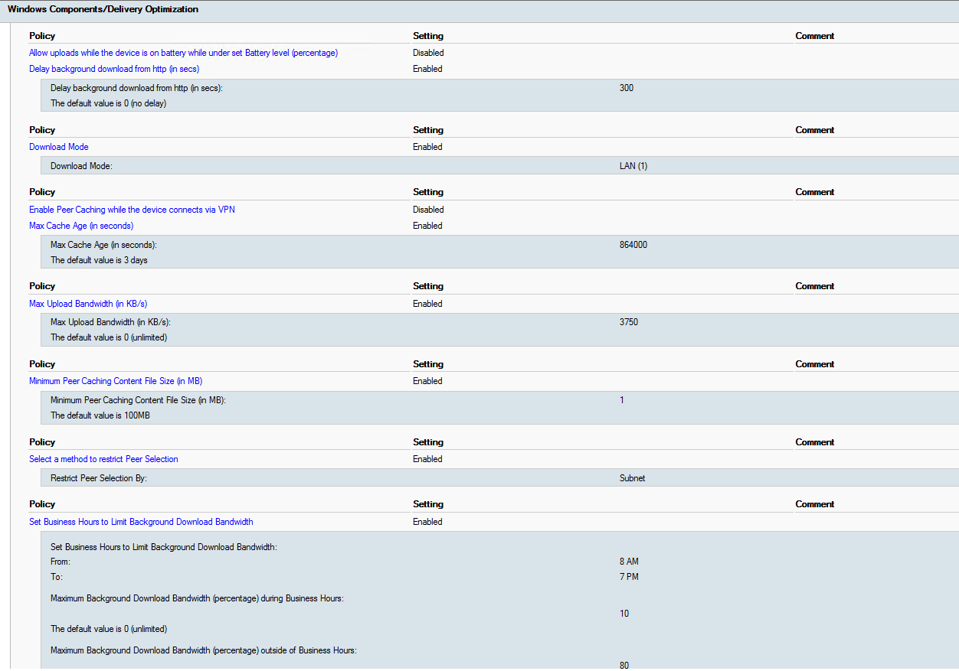
We use our web filter's bandwidth limiting feature to restrict the "software updates" category from using more than 10Mb per client during the working day (we have a 1Gb internet link). Hope this is useful.

