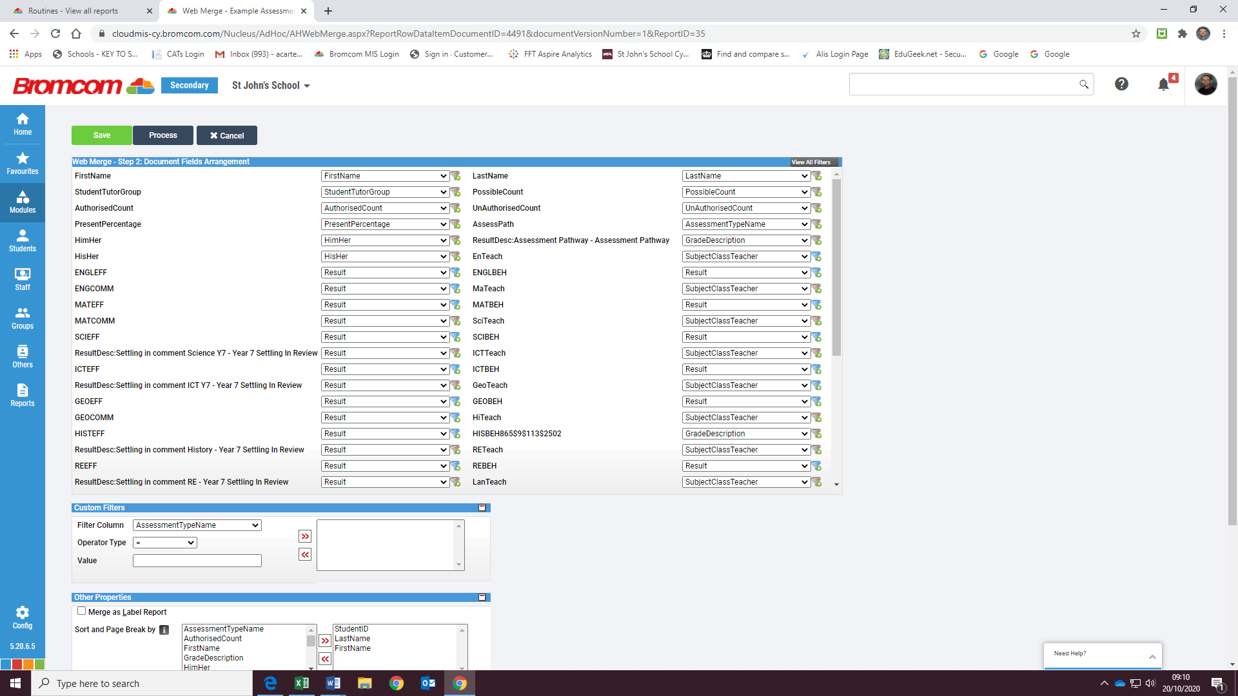
Web Merge Stage 2 as at 9.11am 20/10/20
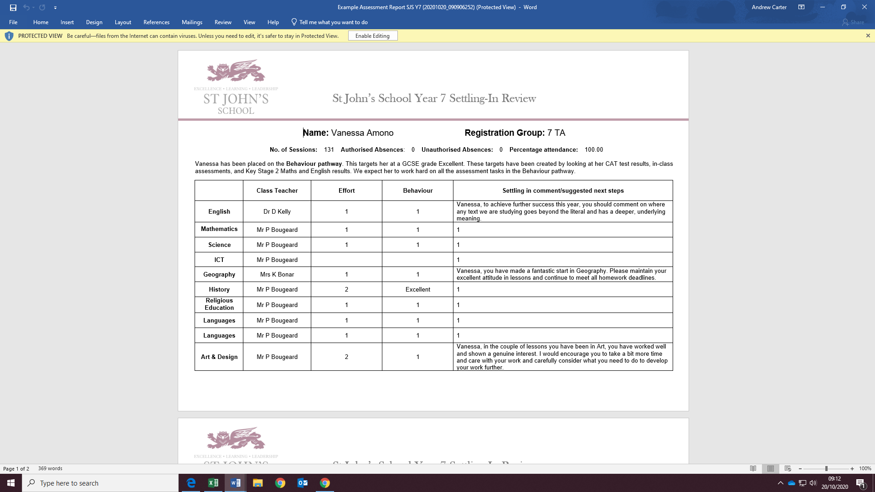
Document produced by mail merge. I will now try and change the English Effort and Behaviour fields so that they display the underlying comments, rather than the numerical grades.

Change ENGLEFF from ‘Result’ to ‘Grade Description’
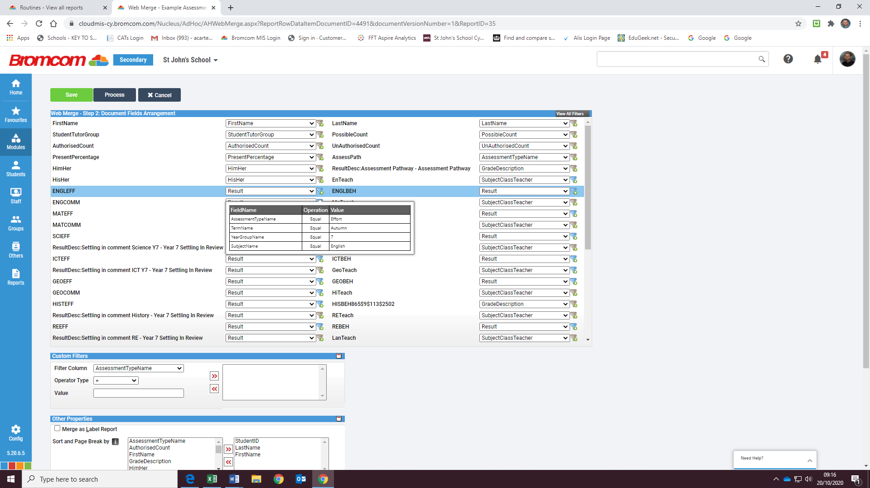
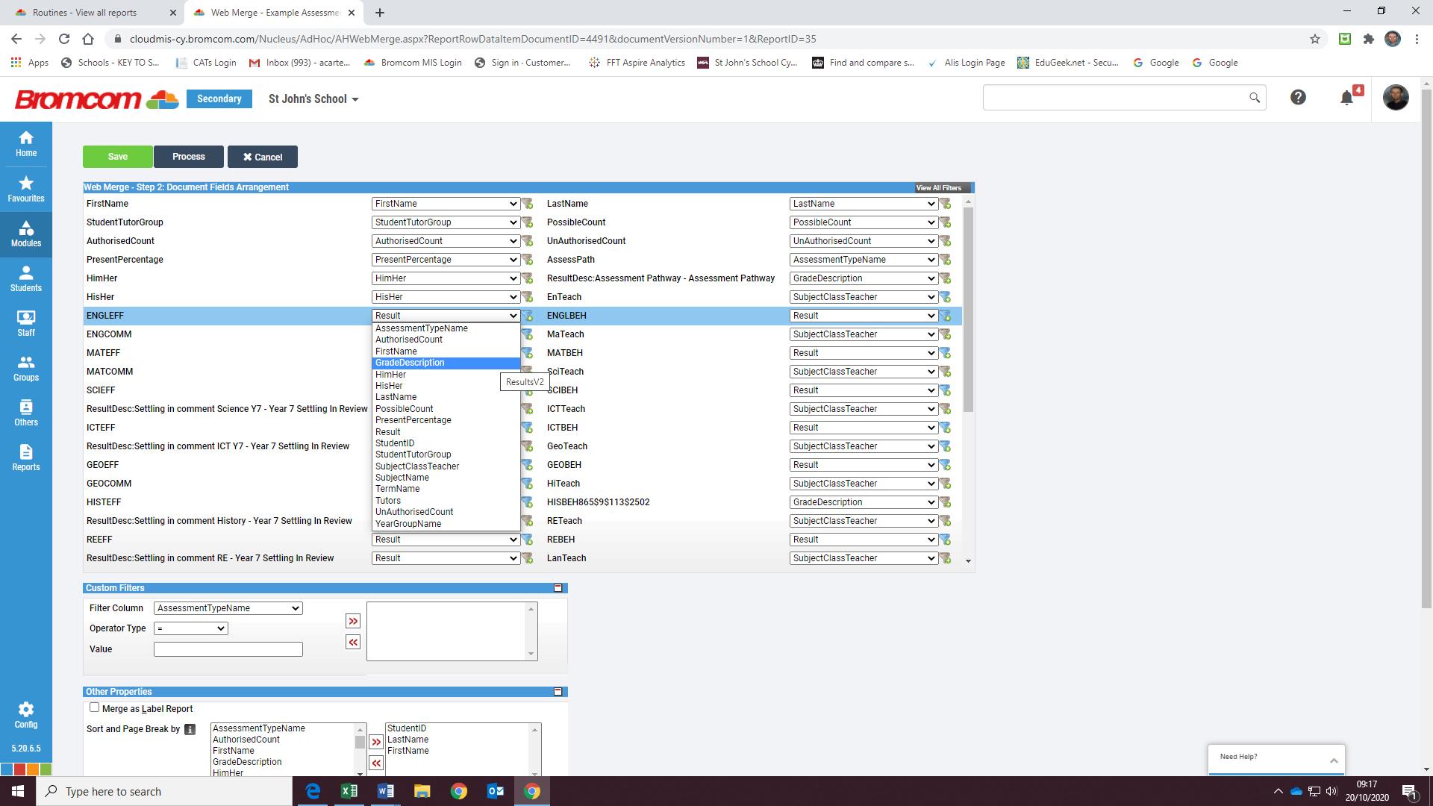

When clicking on ‘Grade Description’, the following message appears:
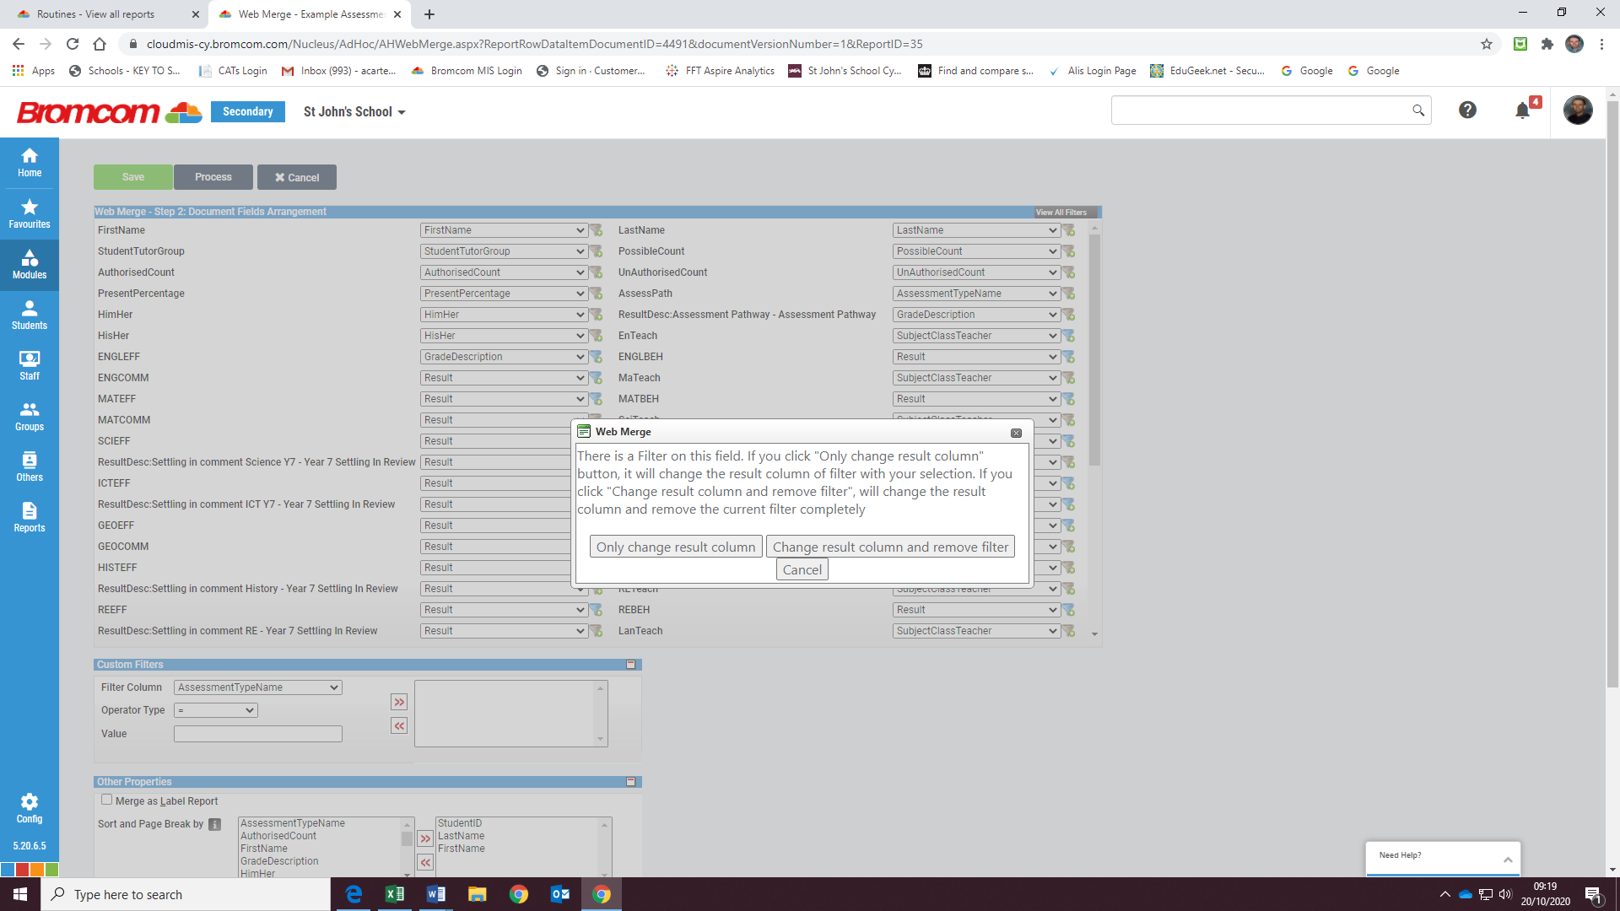

I’m assuming ‘only change result column’ is the correct option, and click on it accordingly. I repeat the process for ENGLBEH and save the report again.
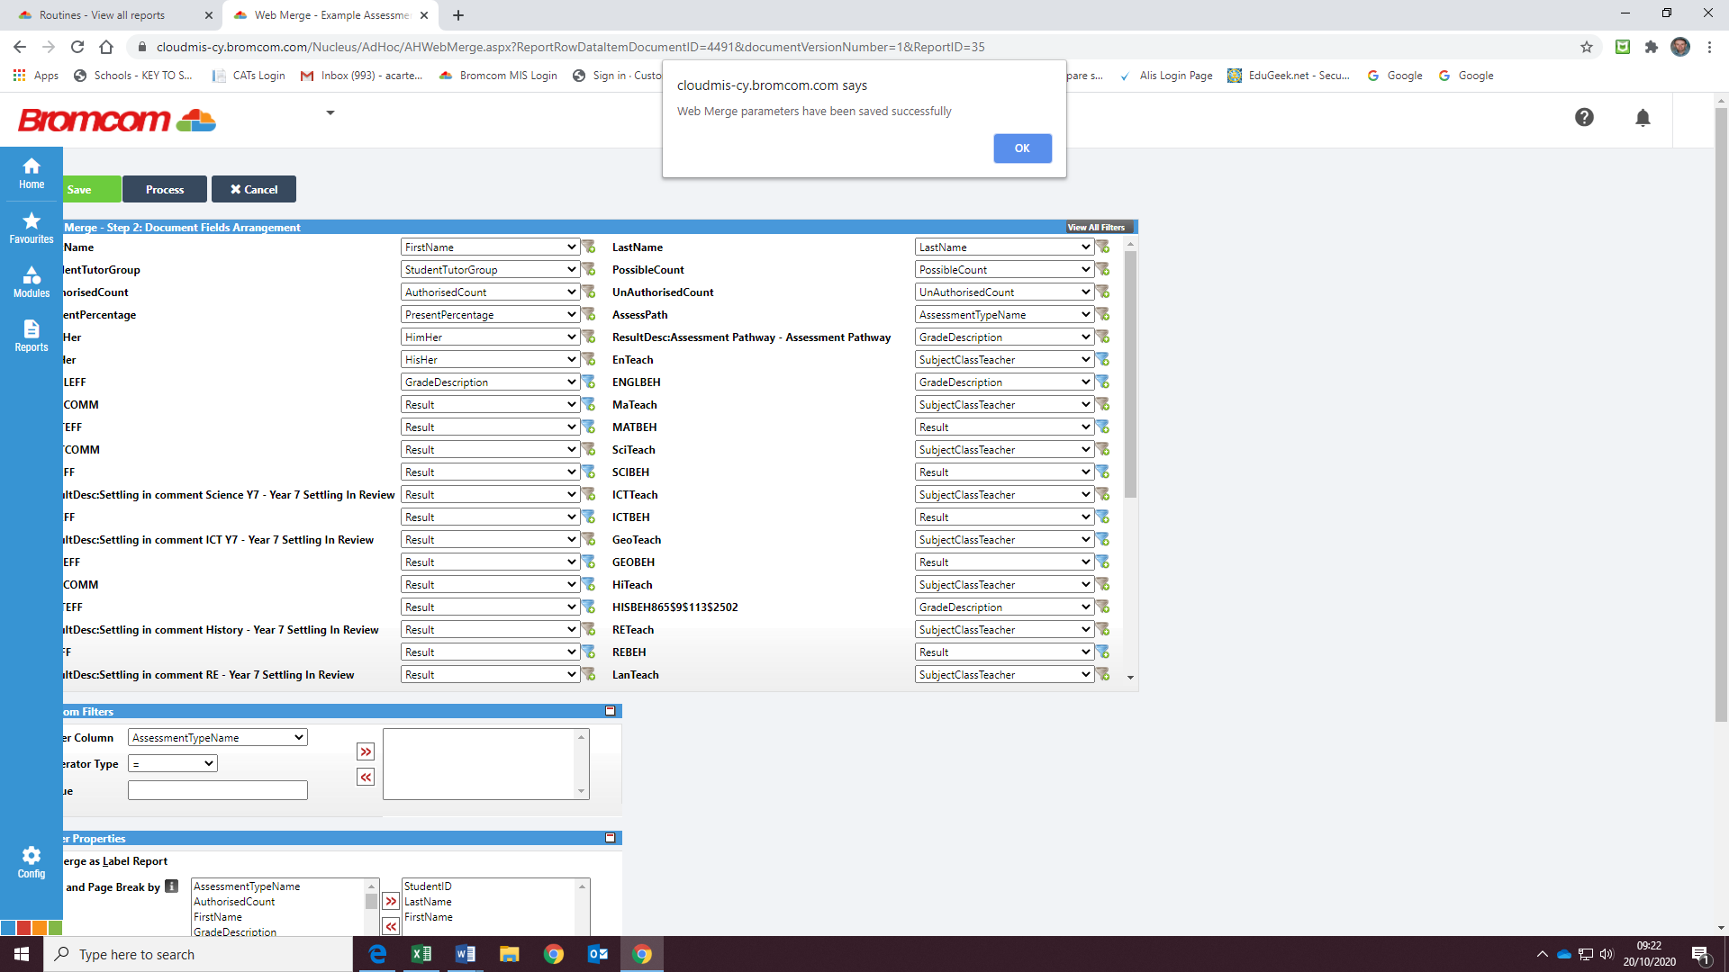

ENGLBEH showing as follows:
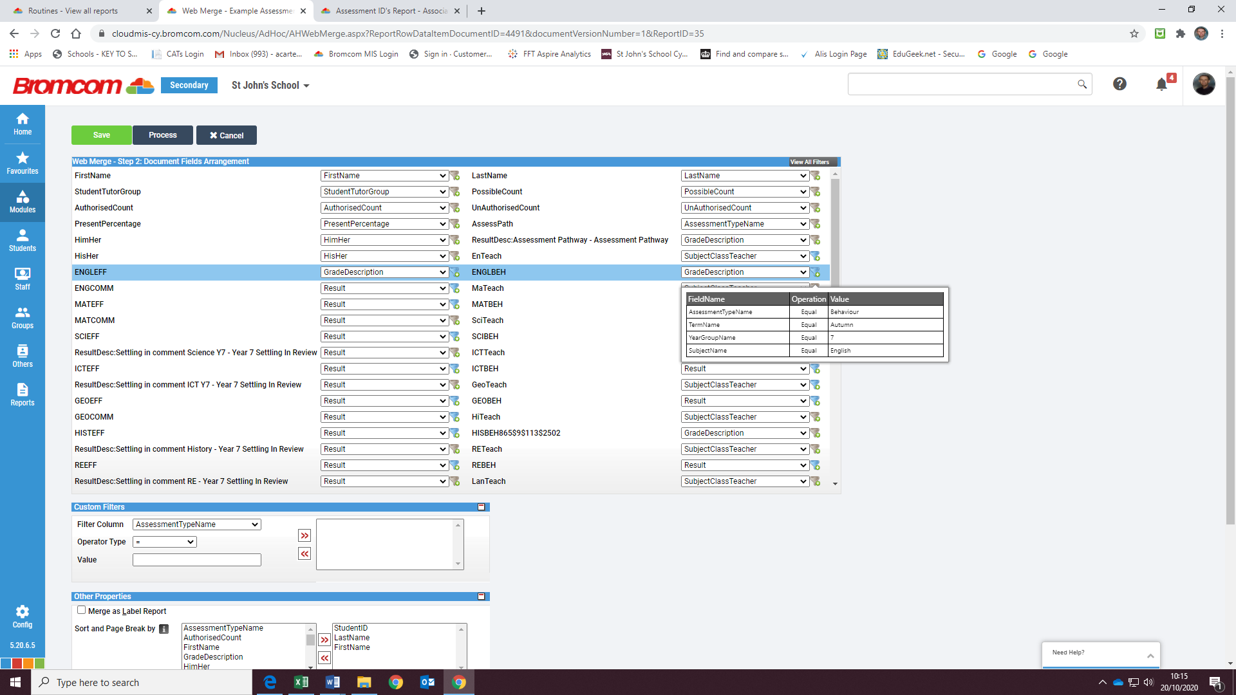

I’ll now click on Process:
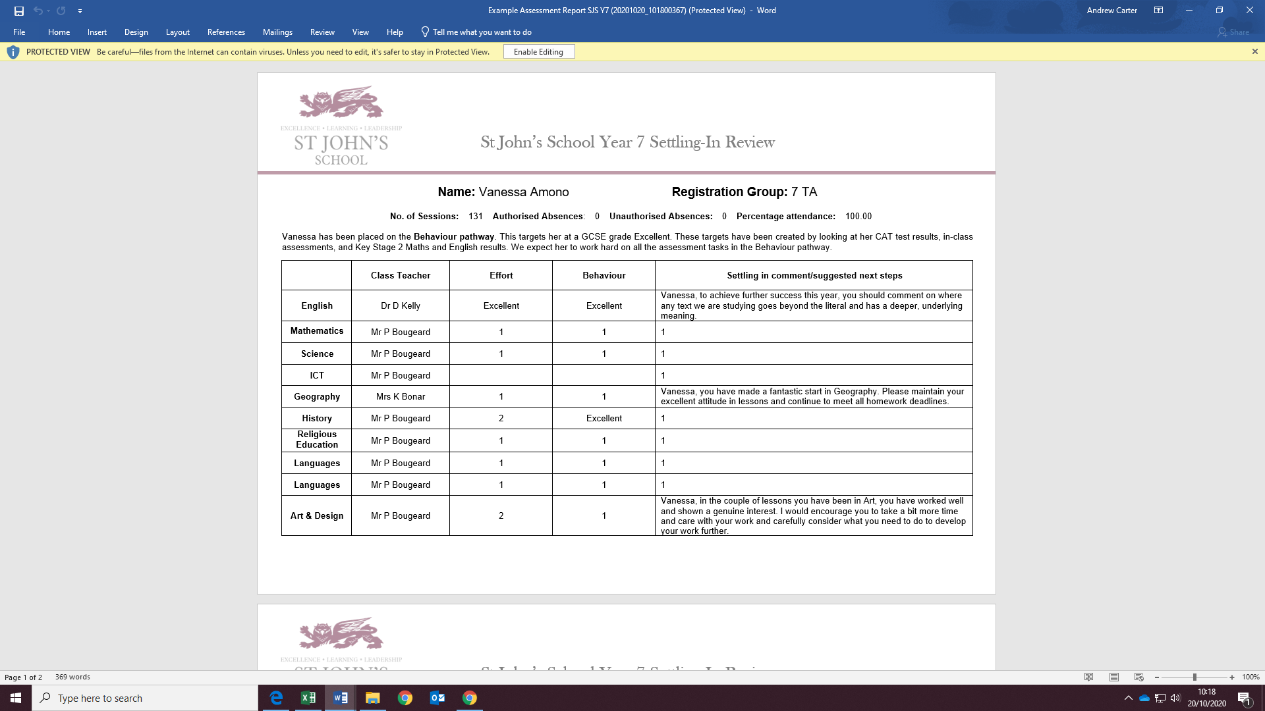
The English & Effort behaviour grades are now showing correctly in the report.

There’s no obvious exit from this stage. What do I do next – open up the report again within this tab, or close this tab and open up Reports in a new one?
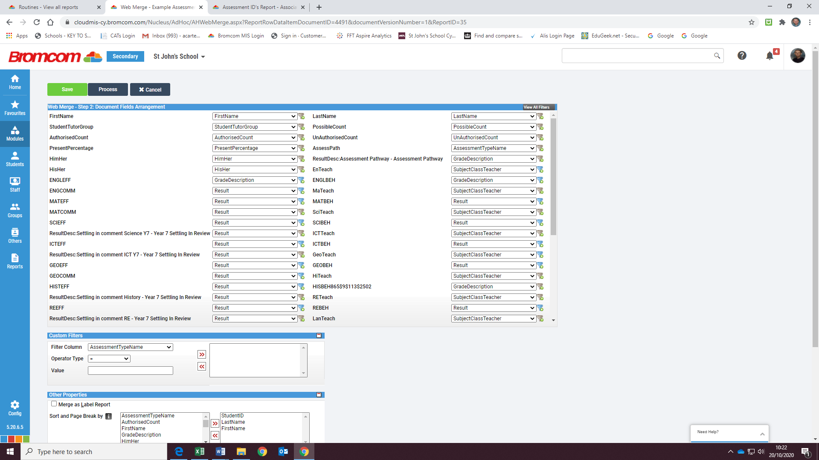

On this occasion I’ll open the same report up within this tab (in the meantime, I’ve populated the Comments fields in the Word report as follows)
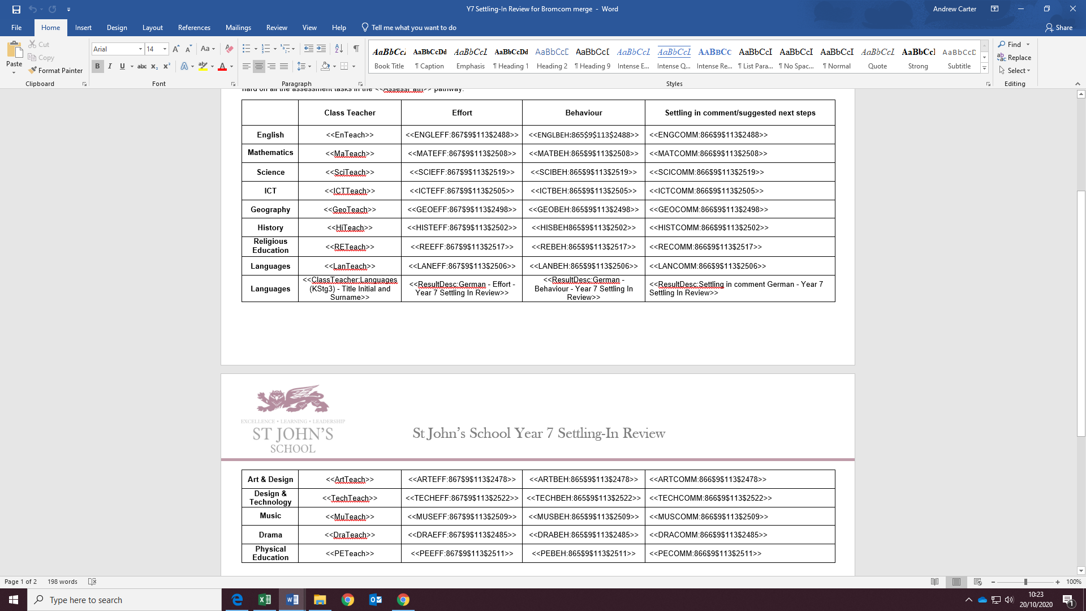

I’ll click on ‘Select Last’ for everything, then on Web Merge.
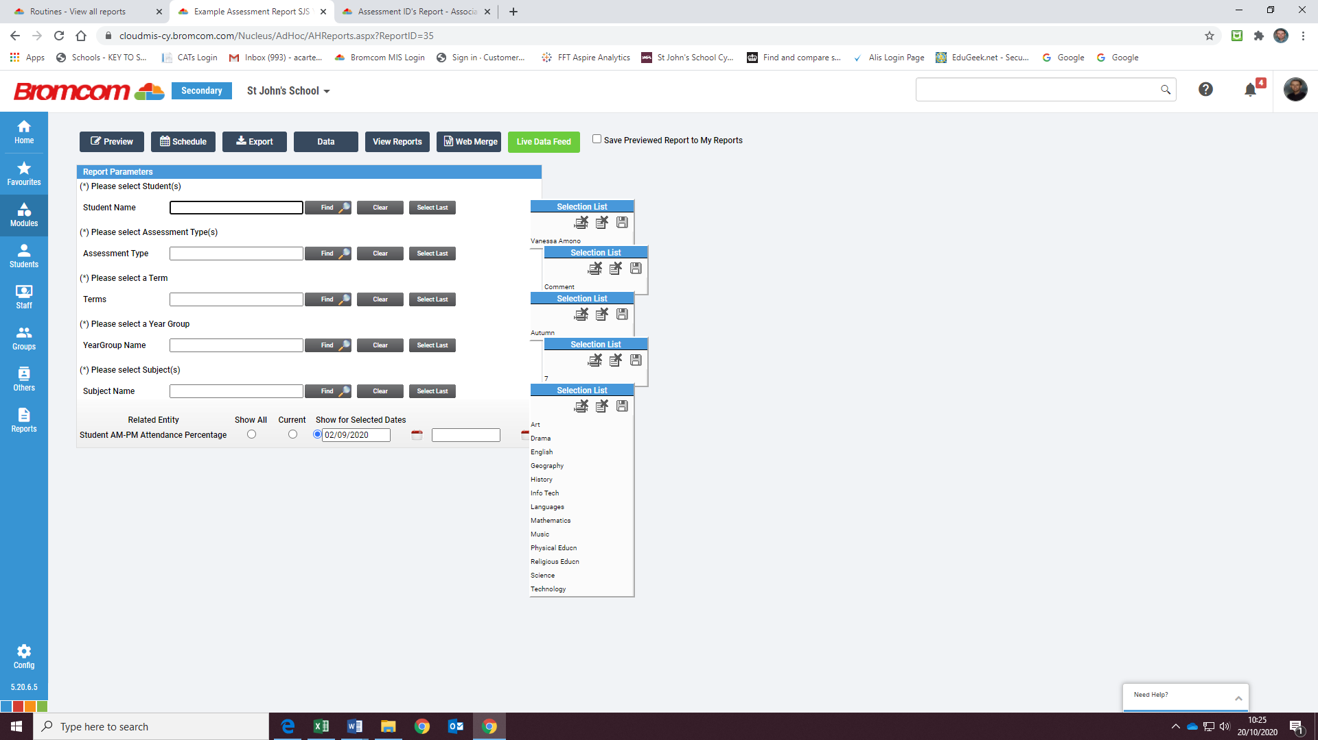

As I’ve changed the Word template in the meantime, I’ll select ‘Select Document’ and choose accordingly.
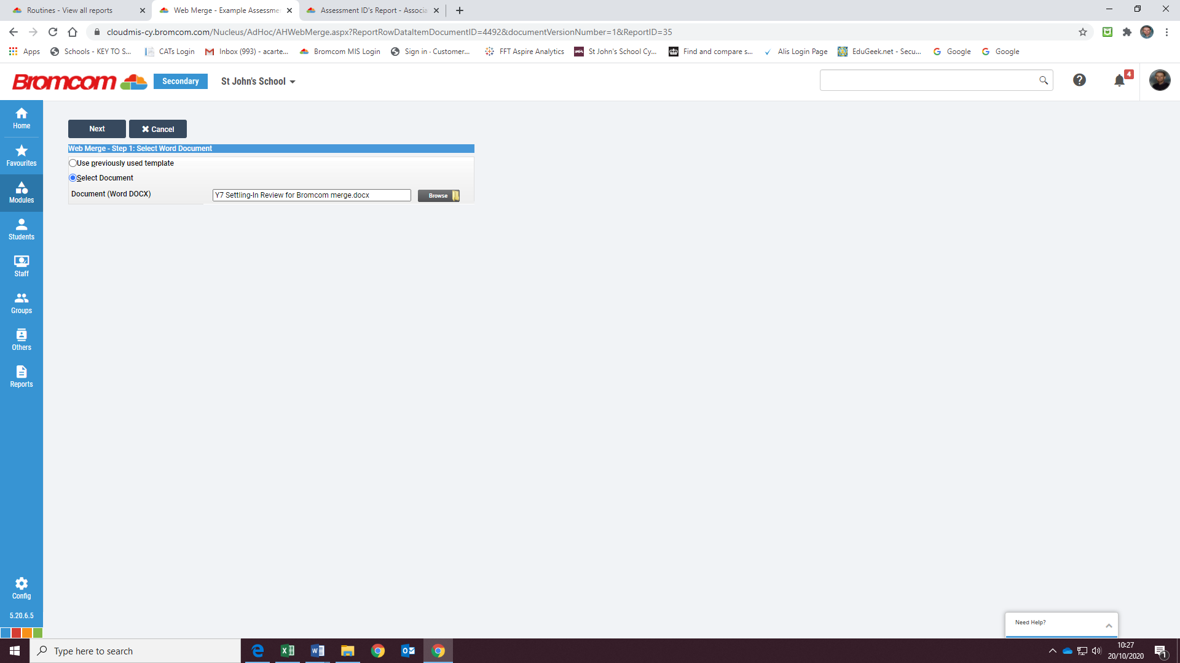

Clicking on ‘Next’ produces the following:
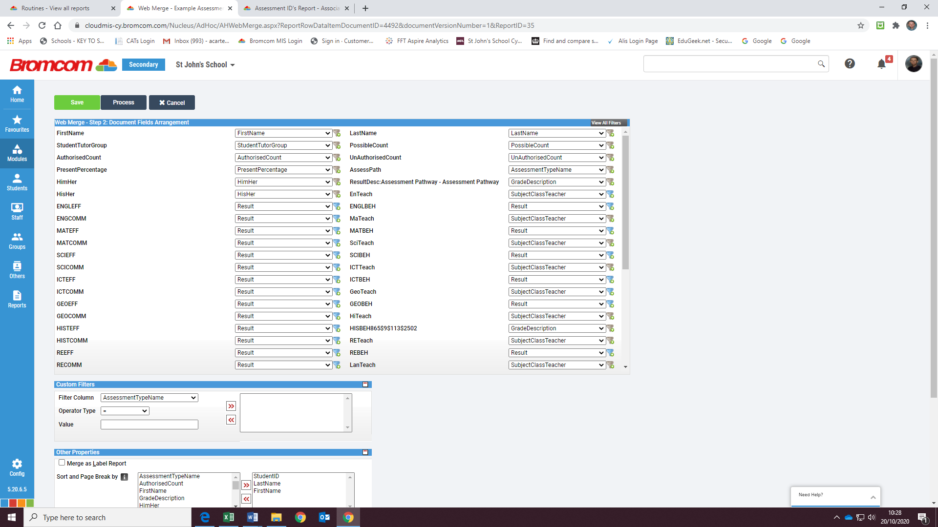

The changes I previously made to ENGLEFF & ENGLBEH have definitely not saved. 