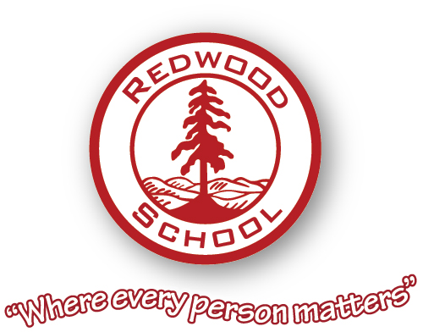

Staff Recruitment

The Governing Body of Redwood School wish to appoint an enthusiastic and committed person to a permanent post as

ICT MANAGER

Permanent - All Year Round
Grade 7, SCP 25-29
Actual Salary £29,577-£32,910

To reflect the growth of the school, Redwood Secondary School are seeking an outstanding, dynamic and friendly ICT Manager to be responsible for the management, maintenance and ongoing development of all ICT equipment and infrastructure, as well as the provision of ICT support to staff and pupils throughout the organisation.
The position will be based across our four school sites in Rochdale and Middleton. The role is supported by a full time ICT Technician.
The successful candidate will be an enthusiastic, experienced and committed Infrastructure and Data Manager to ensure that all our ICT systems are managed effectively for the demands of a modern SEND school. You will have experience of a range of software and network management systems, combined with the ability to lead and develop your team to ensure excellent customer service to the school community.
You will work closely with the Senior Leadership Team and have direct input into the ICT developments of the school. You will be someone that can drive change and understand how emerging technologies can be best utilised to improve teaching and learning.
ICT lies at the very heart of our Learning and Teaching agenda as we seek to raise attainment within the school. You will help to promote this throughout the curriculum.
The Senior leadership value the importance of ICT throughout the school, in supporting the attainment of the young people and the development of its staff, and are committed to the expansion of this field.
The school works closely with the Local Authority and other schools, and is keen for the successful applicant to develop links with other ICT professionals across the region.
Redwood use multi platform systems (Windows, MacOS, iOS & Android) to give its young people a wide range of ICT skills to support their future ambitions, and give a valued contribution to society. Development and integration of these platforms is an area the Senior Leadership Team are particularly interested in.
COVID-19 has highlighted the importance of virtual and remote learning opportunities for pupils and staff. Communication to stakeholders has also been key via social media and website access. We are keen for our ICT manager to expand on the existing good practice that the school has developed.
Application forms, job description and person specification can be found at www.redwood-school.com

To apply for this position please download the application form and supporting documentation and send completed applications to vacancies@redwood-school.com by 12pm on Monday 2nd November.

Interview Date TBC

The school is committed to safeguarding and promoting the welfare of children and young people and expects all staff and volunteers to share this commitment.

Appointment to this post is subject to an enhanced Disclosure and Barring and background check
The ability to converse at ease with customers and service users and provide advice in accurate spoken English is an essential requirement of this post.

