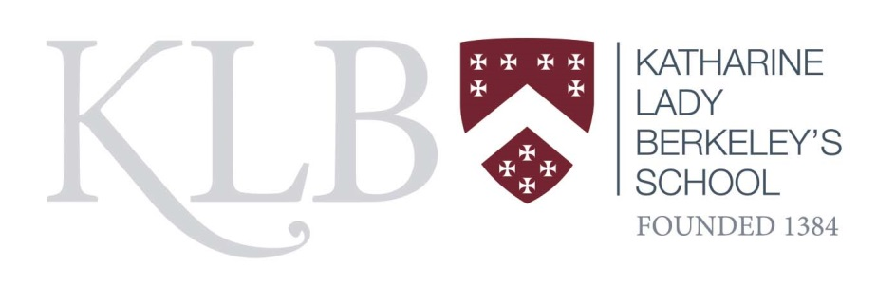

July 2020

Dear Colleague

Thank you for your interest in the permanent position of IT Technician at this school. The post is 37 hours per week all year round.

The application pack consists of the following:

- job description and person specification
- application form

Your application should include the completed application form and a covering letter outlining your relevant skills and personal qualities for the job.

The post will be subject to vetting procedures in line with the DFE guidance; including an Enhanced DBS check.

The closing date for applications is Friday 7 August.

If you have any queries about the position please contact Debbie Pavey at the school dpavey@klbschool.org.uk

I look forward to receiving your application.

Yours faithfully

Tim Rand
Headteacher

