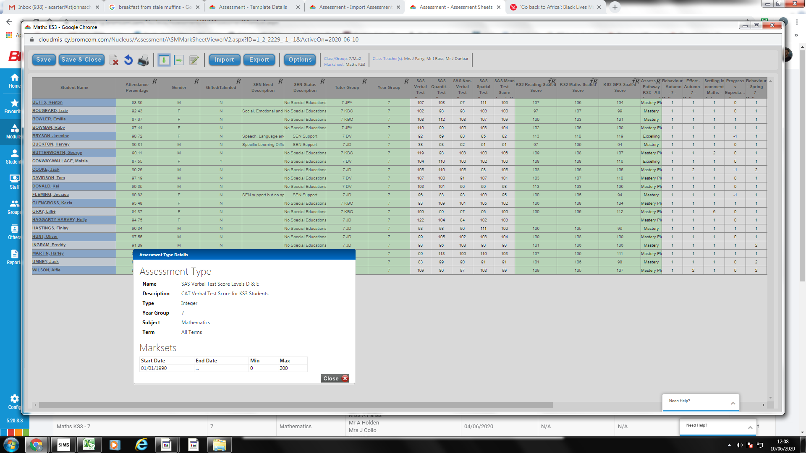
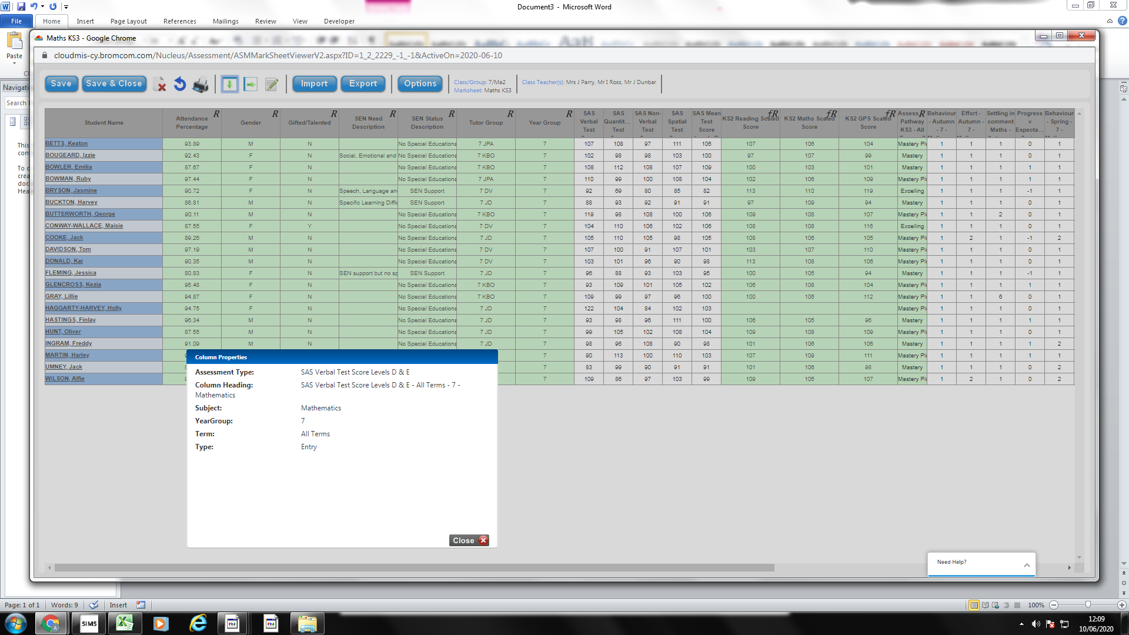

CAT Scores are showing as expected in this marksheet

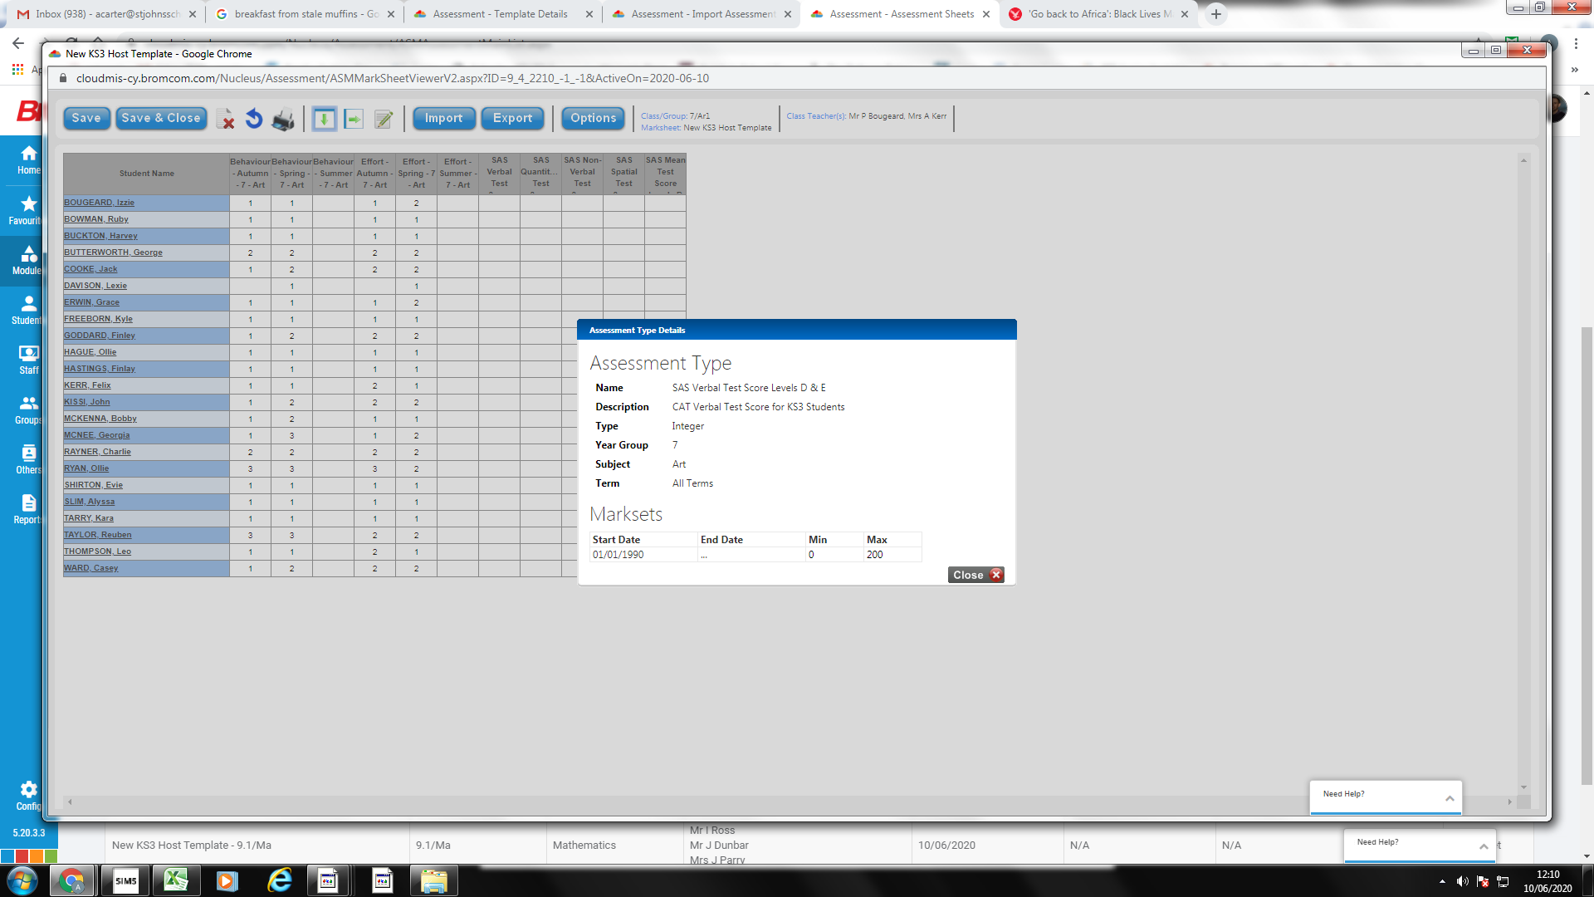
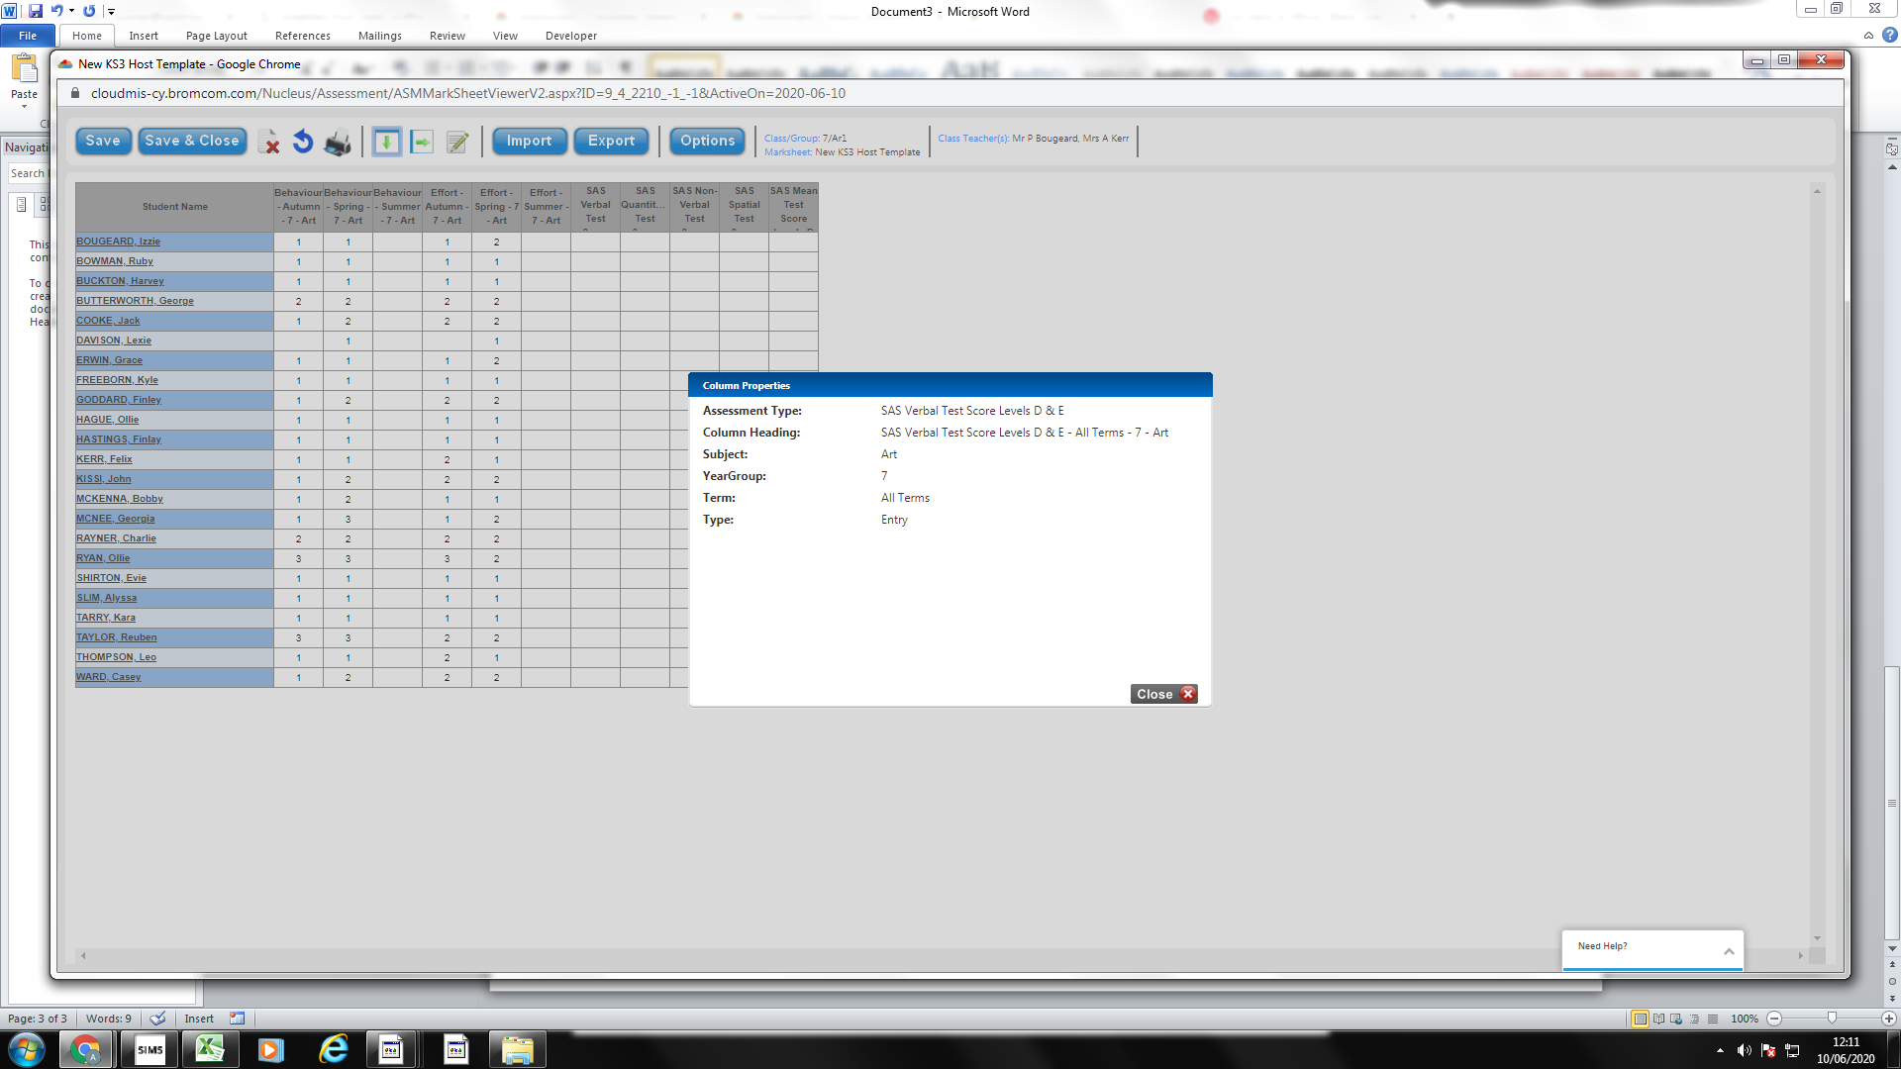

CAT Scores are not showing as expected in this sheet – because import of CAT Data was attached to Maths as the selected subject – system forced selection of subject at time of import.

Problem/issue – non-subject specific, or non-year specific data (i.e. CATs/KS2/Assessment Pathway) cannot be imported in bulk to all years/subjects as once, as import screen does not permit this (see below)

