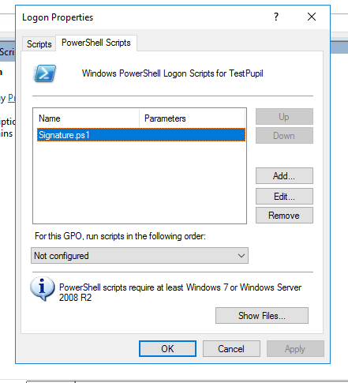

When testing, I didn't need any Parameters set, what I did do was put the ps1 file into the PowerShell folder for that GPO. (Clicking Show Files and pasting the ps1 file in that folder)

