Adding Updates from MS Catalogue
- Open WSUS 3.0
- On main screen make sure the server hosting WSUS is selected and the “Actions Bar” should have “Import Updates”
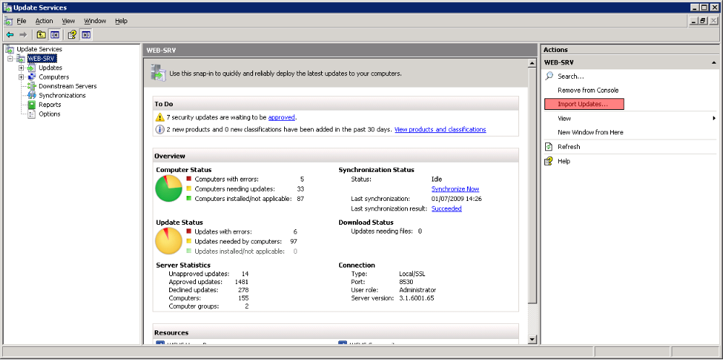
- Microsoft Update “Catalog” (Americans ) appears and you type the item you want
  - Name (Driver, Update, etc...)
  - KB Number
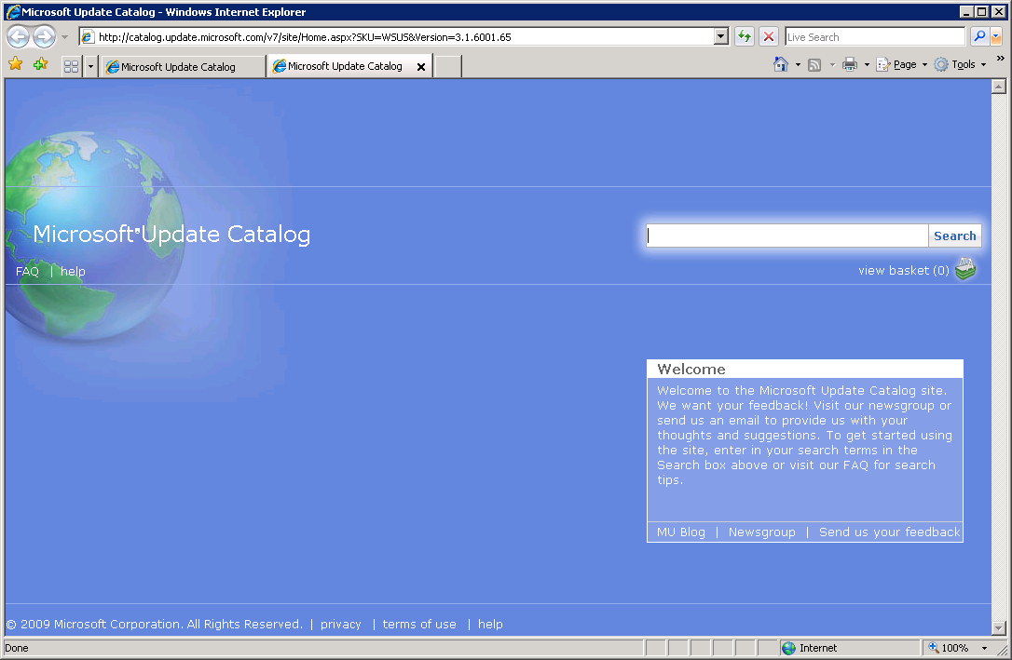
- Click “Add” next to the updates you require.
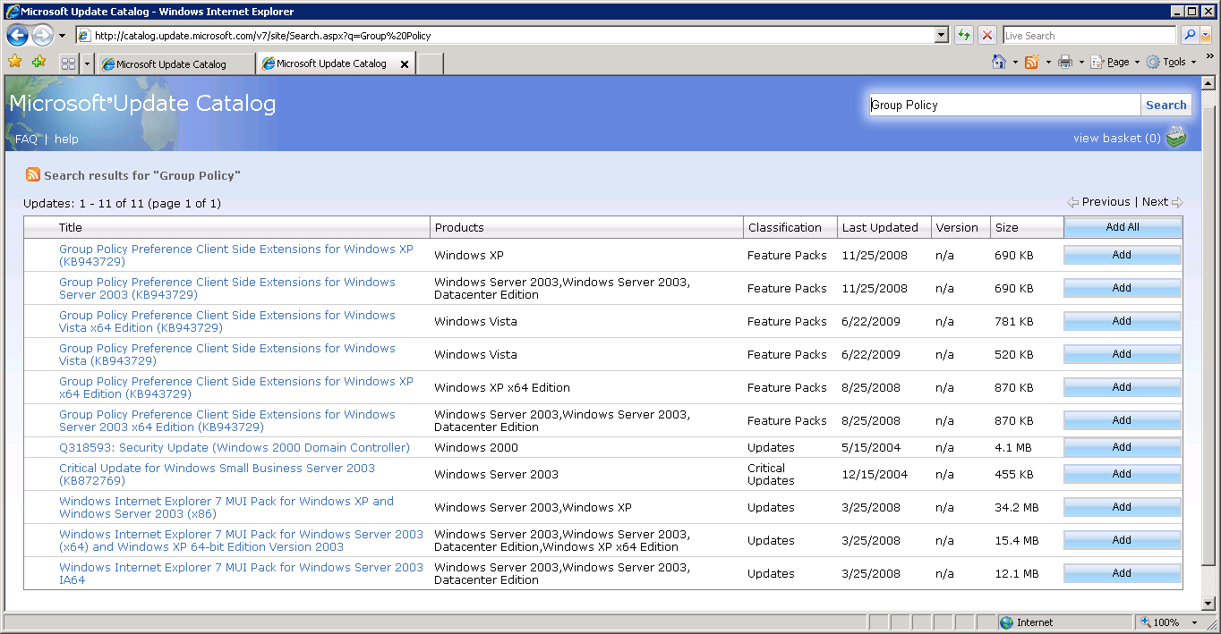
- Once all the updates you want are in the basket click “View Basket”
- Confirm what you have selected is there, click “Import...”
- Updates are imported

