Rebus Quiz: Christmas 2018

1 |  | Don’t look back in anger
2 |  | Green Mile
3 | 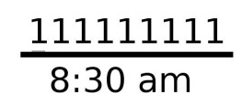 | Once upon a time
4 |  | No excuse
5 |  | Once in a blue moon
6 |  | Rake in the cash
7 |  | Boys are back in town
8 |  | Forty Winks
9 |  | Dig in the ribs
10 |  | Paperweight
11 |  | Nowhere to run
12 |  | Wide awake
13 |  | Just in case
14 |  | Missing link
15 |  | Nudist Colony
16 |  | Whole 9 yards
17 |  | Bad Blood
18 |  | Below par
19 |  | Grey area
20 | 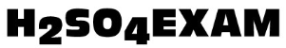 | Acid test
21 |  | The jig is up
22 |  | Lot of money
23 |  | Blanket
24 | 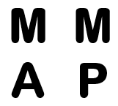 | Time’s up
25 | 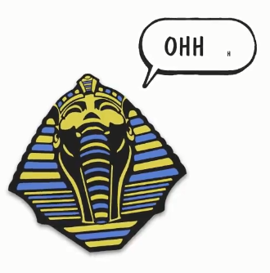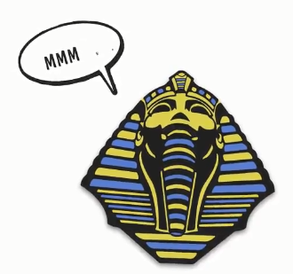 | Pheromones
26 | 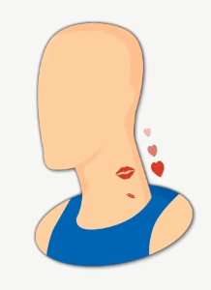 | Necromancer
27 | 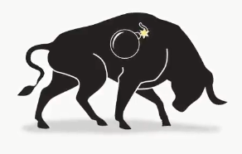 | Abominable
28 |  | Broken heart
29 | 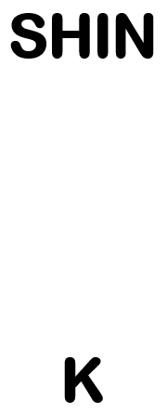 | Location
30 |  | Anyone for tennis
31 |  | Andes Mountains
32 |  | Bad influence
33 |  | Big Cheese
34 |  | Despair
35 |  | Divide and conquer
36 |  | Divide and rule
37 |  | Dominoes
38 |  | Don’t talk back
39 |  | Fill in the gaps
40 |  | Flippancy
41 |  | Foot in the door
42 |  | Friends Romans Countrymen
43 | 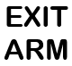 | Go out on a limb
44 |  | Good in parts
45 |  | Growing pains
46 |  | Gross injustice
47 |  | Half crown
48 |  | In a big way
49 |  | Jumble Sale
50 |  | Just in case
51 |  | Lake Ontario
52 |  | Left right and centre
53 |  | Love honour and obey
54 |  | Mixed up teenager
55 |  | Looking after number 1
56 |  | Peace be with you
57 |  | Play fair/Fair play
58 |  | No peace for the wicked
59 |  | See you in the morning
60 |  | The aftermath
61 |  | Tuna fish
62 |  | Won by a nose
63 |  | Turncoat

Objects/London Landmarks/Locations

Note: Includes a ‘red herring’ answer (an answer that is not a London landmark/location)

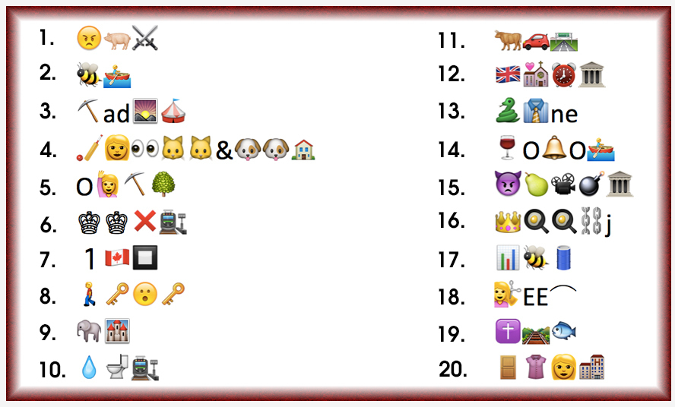

1 | Madame Tussauds
2 | Abbey Road
3 | Piccadilly Circus
4 | Battersea Cats and Dogs Home
5 | Olympic Park
6 | Kings Cross Station
7 | 1 Canada Square
8 | Walkie Talkie
9 | Elephant and Castle
10 | Waterloo Station
11 | Oxford Street
12 | National Maritime Museum
13 | Serpentine
14 | Portabello Road
15 | Imperial War Museum
16 | Royal Exchange
17 | Barbican
18 | Cutty Sark
19 | Crossrail Place (the shopping centre with a garden on top of Canary Wharf Crossrail)
20 | Dorchester Hotel

