Christmas Quiz 2018

1 | 
2 | 
3 | 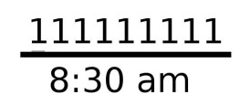
4 | 
5 | 
6 | 
7 | 
8 | 
9 | 
10 | 
11 | 
12 | 
13 | 
14 | 
15 | 
16 | 
17 | 
18 | 
19 | 
20 | 
21 | 
22 | 
23 | 
24 | 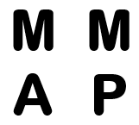
25 | 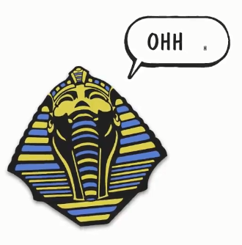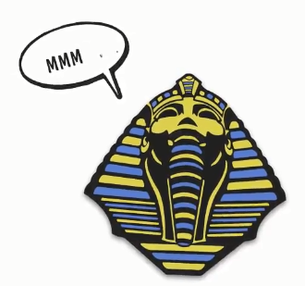
26 | 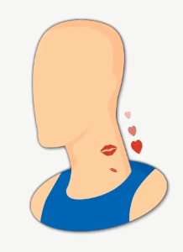
27 | 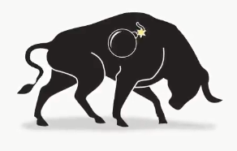
28 | 
29 | 
30 | 
31 | 
32 | 
33 | 
34 | 
35 | 
36 | 
37 | 
38 | 
39 | 
40 | 
41 | 
42
43 | 
44 | 
45 | 
46 | 
47 | 
48 | 
49 | 
50 | 
51 | 
52 | 
53 | 
54 | 
55 | 
56 | 
57 | 
58
59 | 
60 | 
61 | 
62 | 
63 | 

Objects/London Landmarks/Locations

Note: Includes a ‘red herring’ answer (an answer that is not a London landmark/location)

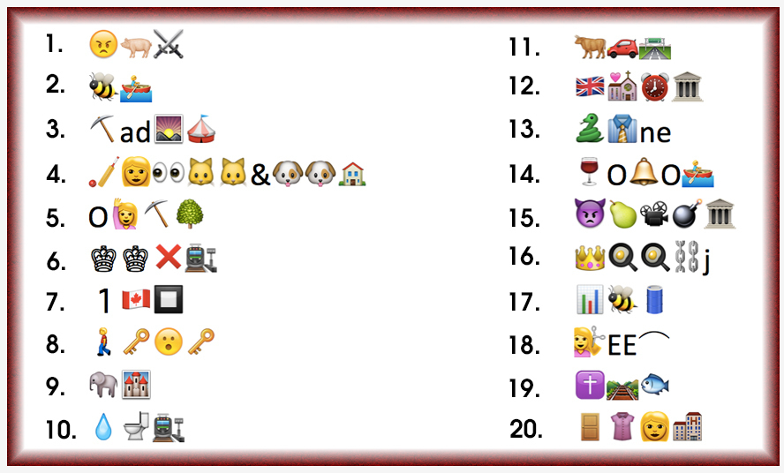

1
2
3
4
5
6
7
8
9
10
11
12
13
14
15
16
17
18
19
20

