Job Description
Head of IT and Digital Strategy

General
Oakham School was founded by Archdeacon Johnson in 1584 and is now one of the largest co-educational Boarding and Day Schools in the country. It has some 1,050 pupils ranging in age from 10 to 18 years, of whom 50% are boarders. These pupils are accommodated in eight boarding houses and four day houses, and four day/boarding Houses in Lower School. The School operates along the lines of a boarding school, seven days a week, 32 weeks of the year. Lessons are taught on Saturday mornings.

Reporting
To the Director of Operations and Strategic Planning DOSP (direct line manager) and Senior Leadership team (operational).

The Technical Environment
Oakham School has a large network, spanning multiple buildings linked via private fibre across a town wide site, based primarily around Microsoft server and clients. The majority of the servers are virtual, running on a VMWare platform, with a NetApp live and Disaster Recovery SAN providing server and user data storage. There are approximately 1,000 domain computers, including 200 MS Surface devices issued to staff. The extensive Aerohive wireless network typically supports 1,000 BYOD users each day, with Cisco switched providing wired connectivity. There are approximately 1500 staff and student users, with accounts in Active Directory and Office 365. The school, supported by three full-time developers, develops and maintains its own MIS system in house, based upon a Filemaker platform, which is used to manage almost every aspect of school life from initial admissions enquiries, through academic management and tracking, fundraising, medical records, accident reporting, maintenance tickets and room bookings. The Print Services department provides a central print and production service based on Ricoh production class devices, and also supports a fleet of Ricoh MFDs across the school. Telephony is primarily IP based, and runs on a Mitel platform.

Job Purpose
This is a key role providing a strategic and comprehensive oversight of all systems across the school as well as ensuring the smooth day to day running of IT services across the school. The Head of IT and Digital Strategy will have the following seven key areas of responsibility:
- Line Management of the Network Services team, Data Systems team, Print Services team and the Staff Trainer
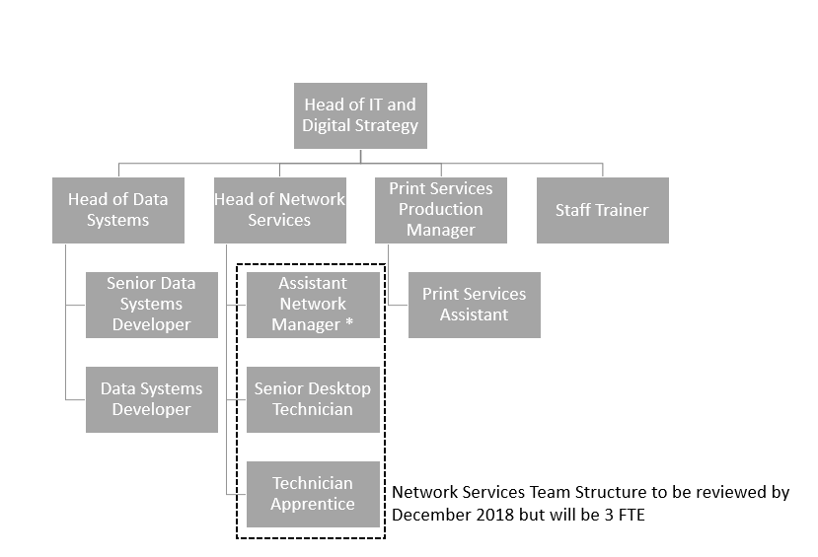
- Strategic planning for IT and budgetary management across the needs of Teaching Staff and Support Functions
- Ensuring the effective management of a fast-running, reliable computer network and systems that will offer a quality platform to support teaching and learning as well as the wider managerial and administrative needs of the school
- Ensuring the effective management and cost effective production of printed resources within the Print Services department, and wider fleet of print and MFD devices
- Working with academic colleagues to promote the use of technology in Teaching & Learning
- Staff and pupil training
- Digital security

Job Details
The duties and responsibilities of the Head of IT and Digital Strategy will include, but not be limited to:

Strategy

- To develop and implement a strategic plan for IT to include the current and future requirements of teaching & learning, support, administration, marketing, finance functions and to ensure that the School has the appropriate hardware and software to support these needs
- To maintain an up to date knowledge and thorough understanding of all relevant new and emerging IT technologies and ensure the Senior Leadership team is well informed of the benefits they could bring to the school if adopted
- To be a key member of the ICT Steering Group chaired by the Head and including Deputy Head Academic, Director of Teaching and Learning, Head of Network Services, Head of Data Systems
- To build a network of contacts across other independent schools to share ideas and understand best practice

Infrastructure, Systems and Data, Printed resources

Working closely with the Head of Network Services, Head of Data Systems and Print Services Production Manager:

- To ensure the effective management of a fast-running, reliable computer network that will offer a quality platform to support Teaching & Learning, as well as the wider administrative and managerial needs of the school
- To ensure that all data is held and transmitted securely on devices, and is backed up for both day-to-day recovery as well as longer term archives
- To make effective use of Cloud based services where appropriate to do so
- To ensure the effective management of a reliable telephone network and to manage mobile telephone requirements
- To ensure the in-house developed Oakham School Information Management System (OSIS) meets the needs of all sections of the community and development requirements are appropriately prioritised
- To ensure software licensing requirements are met
- To carry out regular updates of the disaster recovery plan, and to test recovery procedures
- To manage, resolve and report on faults and issues related to the IT and Data systems
- To ensure printed resources are produced to a high quality, and in a cost efficient manner, within the Print Services department and across the organisation

Leadership and communication

- To lead, motivate and enhance the Network Services team, Data Systems team, Print Services team and to line manage the Staff Trainer
- To deliver effective performance management, annual appraisals of direct reports including annual objective setting, and professional development for team members
- To embed a customer service oriented culture within the IS team
- To devise and manage a reporting framework to monitor the performance of the IT support function
- To champion e-safety and the responsible use of the internet by pupils and staff and to help develop the school’s acceptable use policies
- To be responsible for own personal development and continuously improve technical knowledge to maintain a sound technical insight into all current technologies and systems that are deployed across the schools
- To support the marketing of the school through digital means
- To communicate IT strategy to staff in simple to understand language and appropriate channels, providing guidance and assistance as required so users feel confident and secure and able to put IT provision to best use
- To be a member of the DOSP’s Support Heads of Department team

Financial

- Following consultation with senior staff, and in particularly the DOSP, draw up the proposed annual, whole school, IT budget, recommending the priorities for spending and investment over the short, medium and long term
- To efficiently and effectively manage the IT budget thereafter
- To ensure the school maximises its return on its significant investment in IT
- To monitor the performance of ICT suppliers and their supply chains with respect to the delivery of any ICT service
- To be the primary point of management with any ICT Supplier ensuring that projects meet the parameters and requirements of the school.
- To verify fees/payments to the ICT Supplier on behalf of the school including resolving any disputes regarding amounts to be paid
- To provide budgetary information to assist the school in the formulation of any Capital and Revenue funded programmes. To continuously monitor and provide statements of expenditure against the programme budget

Projects

- To own and manage the delivery of all hardware, systems and software changes across the school
- To work closely with the Estates Department for any requirements during projects with regard to the installation and maintenance of electrical and data cabling related to networking, audio visual and telephone systems
- To use recognised and industry standard project delivery methodologies to manage projects and ensure they are delivered on time and within budget
- To provide regular project management and project progress reports to stakeholders
- To proactively manage and mitigate risks and issues to ensure that project outcomes and expected benefits are fully realised

Supporting Teaching and Learning

- To support the whole school to embed technology into the teaching, learning and assessment process and to inspire them in the creative possibilities for technology across the curriculum
- To work to put in place training and development opportunities for staff to overcome any barriers to developing and delivering lessons in which technology is used to enhance pupil learning
- To work with the Deputy Head (Pastoral and Co-curricular) to ensure the digital health of pupils is maintained

Person Specification
Criteria | Essential | Desirable
Experience | Substantial experience of working in IT involving the delivery of technical change projects and on-going support of existing systems  Formulating, implementing and on-going evaluation of a successful digital strategy delivery within an organisation  Excellent and proven collaborative leadership qualities with an ability to turn strategy into practice  Leading a high-profile and successful delivery of a comprehensive IT strategy to streamline and overhaul the IT services offered within an organisation  Successfully managing a multi-skilled, cross-functional team  Proven track record of successful project management and delivery of technical change  Management or implementation of hardware and software business continuity arrangements  Management of a significant annual IT budget  Good knowledge of the MS Windows operating system and Office applications environment  Introducing, managing or supporting cloud-based technologies in an organisation | Significant experience of working in the Education Sector in general or schools in particular  Introducing, managing or supporting mobile and/or tablet technologies in an organisation  Running or managing a large, organisation-wide Information Management System (e.g. iSAMS or SIMS in education, SAP or Oracle in industry etc.)  Management of the IT support function within an organisation  Experience of working on or managing a customer-focussed service desk and hands on installation of hardware
Qualifications | Honours degree in a Computing-related discipline or significant relevant experience in Industry or Education | Project Management certification (PRINCE2, Agile, ITIL etc)  Microsoft or equivalent approved technical qualifications
Specialist Knowledge | Broad understanding and experience of wired and wireless networking hardware, configuration, Internet connectivity and troubleshooting  Broad understanding and experience of firewalls, virus and threat protection, Internet filtering and similar components  General understanding and experience of PC and server physical and virtualisation technology | In-depth knowledge of networking technologies and associated components; experience of network administration or management  General knowledge of network management IP technologies, AD, GPOs etc) and server applications/services(Exchange, WDS, SQL etc)  Experience of running or managing a Windows network  Experience of reporting from and managing large relational database systems  Experience of managing or supporting a range of software applications  In-depth knowledge of at least one school management information system  Experience of delivering VOIP, Skype and other communications technologies into an organisation
Skills / Abilities | Ability to think and plan strategically  Ability to inspire and motivate the IT team and manage its performance  Ability to procure and tender long term service contracts (eg multi-functional devices, telephony)  Commercial acumen
Personal Attributes / Competencies | Excellent communication skills (written and oral) with the ability to communicate technical matters effectively and in a way that is understood by non-IT specialists  Calm under pressure and able to prioritise multiple conflicting requirements  Able to work flexibly to meet the requirements of the post, including occasional evening and weekend work in term-time  Ability to manage user expectations to positive outcomes  Ability to motivate staff and build team reputation

Terms & Conditions
Salary
This will be in the range of £50-52,000 per annum, depending on relevant skills, experience and qualifications.

Hours

40 hours per week, to be worked between 08:00 and 18:00 Monday to Friday. Occasional presence on Saturday mornings in term-time may be required. Due to the leadership nature of the job additional work out of hours may be required in term-time.

Holidays

Five weeks’ paid annual leave are given.

Notice Period

The role is subject to probation of three months, during which time the notice period by either party will be one month. After satisfactory completion of the probation period, the notice period for each party shall be three months.

Other Benefits
- Pension Scheme - Flexible Retirement Plan run by The Pensions Trust: the School will double match the employee’s contribution up to 10%. Linked Death in Service Benefit is 4 x salary.
- Option to join Health Care Cashplan with ‘simplyhealth’ paid for by the School.
- Option to join BUPA Select Private Medical Insurance Scheme, to which the School would contribute 10% of the individual’s membership.
- Free lunches available during term time in the school dining room for staff with a contractual lunch break.
- Free use of school gym and pool at certain times.
- Childcare Voucher and Cycle to Work Schemes.
- Personal Accident Insurance.
- Free car parking on school campus.

Under current legislation, we are required to advise applicants that this appointment will be subject to a satisfactory Enhanced Disclosure with the Disclosure & Barring Service. Details of any criminal record (spent or unspent, due to exemption from the Rehabilitation of Offenders Act 1974) must be disclosed at interview. Only relevant convictions and other information will be taken into account so disclosure need not necessarily be a bar to obtaining a position at Oakham School.

DOSP
June 2018

