

Information for applicants

The Role

The Role

Department: Director of IT Operations
Responsible to: Senior Deputy Head
Hours of work: General working hours are 08.00-17.00, Monday to Friday, with some flexibility required in start and end times. However, working outside of these hours will be required including providing on-call cover. Occasional Saturday working will be expected to oversee critical operations.
Grade/Salary: Competitive – Based on qualifications and experience

Overall purpose of the post:
The post holder will be responsible for working with the Whole School Leadership Team (WSLT) to construct and deliver the school's strategic vision for IT as well as the smooth day to day running of IT services across all three schools.
Key responsibilities:
Strategy
- To work with the WSLT to develop and implement a strategy of on-going IT improvement that delivers innovative and effective use of IT across the academic curriculum alongside resilient and efficient management of data across the schools
- To review, evaluate and update that strategy in the light of new teaching objectives, administrative requirements, emerging technologies and the needs of pupils, staff and parents
- To maintain an up-to-date knowledge and thorough understanding of all relevant new and emerging IT technologies and ensure the Whole School Leadership Team is well informed of the benefits they could bring to the schools if adopted
- To ensure the IT strategy is communicated in a way that motivates, inspires and excites staff and pupils at all levels and helps them understand the benefits of and reasons behind technical changes
- To build a network of contacts across other Independent Prep and Senior schools to allow the school to share ideas and learn from the experiences of others
- To ensure the schools use of IT is fully compliant with all relevant legal regulations and inspection guidelines, and is aligned with the school's stated aims and ethos
Leadership
- To develop, motivate and enhance the capability of the existing IT team
- To support the professional development of members of the IT team
- To embed a customer service orientated culture within the IT team
- To negotiate and manage external support services and contracts
- To manage the smooth running of all IT services across the schools
- To build confidence amongst staff and pupils in the capability of the IT team and create a culture where technical change is seen as a positive opportunity to do new things

- To devise and manage a reporting framework to monitor the performance of the IT support function
- To organise and support Co-Curricular activities to inspire pupils in their knowledge, understanding and use of IT
- To champion e-safety and the responsible use of the internet by pupils and staff help develop the school’s acceptable IT use policies.

Communication
- To represent and be an ambassador for IT to all its customers - from briefing governors and defending budgets to training support staff and answering the IT support phone
- To maintain a high-level of confidentiality at all times
- To ensure staff and pupils are kept fully aware and understand the consequences of all IT service upgrades, issues and planned outages in plain language
- To inspire, encourage and help all staff and pupils get the most from their use of IT
- To build excellent working relationships with all staff and pupils across the 3 schools
- To consolidate and manage an up-to-date and comprehensive set of technical documentation for all systems and their configuration
Technology
- To own and be responsible for all hardware and software across all the schools (including the school's telephone system)
- To be recognised by staff and pupils as a technical Subject Matter Expert (SME) regarding the best use of IT in both the academic and administrative life of the schools
- To be responsible for your own personal development and continuously improve your own technical knowledge to maintain a sound technical insight into all the current technologies and systems that are deployed across the schools
- To ensure that the infrastructure is robust and that all data is held and transmitted securely on all devices
- To ensure thorough business continuity plans and other technical solutions are in place to guarantee the resilience of the school's IT services and data
- To ensure all software systems are kept up-to-date and are deployed and used in line with suppliers' recommendations
Financial
- To ensure the schools maximise their return on investment in IT
- To introduce and manage Service Level Agreements for regular IT tasks
- To efficiently and effectively manage the IT budget
Projects
- To own and manage the delivery of all hardware and software changes across the schools
- To use recognised and industry-standard project delivery methodologies to manage projects and ensure that they are delivered on time and within budget
- To provide regular project management and project progress reports to stakeholders
- To proactively manage and mitigate risks and issues to ensure that project outcomes and expected benefits are fully realised

The School is committed to safeguarding and promoting the welfare of children and young people and expects all staff and volunteers to share this commitment. The successful applicant will be required to undergo checks with the Disclosure and Barring Service.
All staff at St Peter’s School are required to observe all relevant Health and Safety, Equality and Data Protection legislation and procedures.
Note: This job description is not a comprehensive definition of the post and the post holder will be expected to undertake any other tasks commensurate with the duties and responsibilities of the post. The job description will be reviewed as part of the cycle of appraisal, and it may be subject to modification or amendment at any time after consultation with the post holder.

Person specification
Criteria | Essential | Desirable | Assessment
Experience | Substantial experience of working in IT involving the delivery of technical change projects and on-going support of existing systems.  Formulating, implementing and on-going evaluation of a successful digital strategy delivery within an organisation  Excellent and proven collaborative leadership qualities with an ability to turn strategy into practice  Successfully managing a multi-skilled, cross-functional team  Proven track record of successful project management and delivery of technical change  Management or implementation of hardware and software business continuity arrangements  Management of a significant annual IT budget  Experience of working on or managing a customer-focussed service desk | Significant experience of working in the Education Sector in general or schools in particular  Leading a high-profile and successful delivery of a comprehensive IT strategy to streamline and overhaul the IT services offered within an organisation  Introducing, managing or supporting cloud-based technologies in an organisation  Introducing, managing or supporting mobile and I or tablet technologies in an organisation  Running or managing a large, organisation-wide Information Management System (e.g. iSAMS or SIMS in education, SAP or Oracle in industry etc.)  Running or managing a Virtual Learning Environment (VLE)  Management of the IT support function within an organisation | Application  Interview  References
Qualifications | Honours degree in a Computing-related discipline or significant relevant experience in Industry or Education | Project Management certification (PRINCE2, Agile etc)  Microsoft or equivalent approved technical qualifications | Application
Specialist Knowledge | Broad understanding and experience of wired and wireless networking hardware, configuration, Internet connectivity and troubleshooting  High level understanding and experience of firewalls, virus and spyware protection, proxy servers, Internet filtering and similar components  High level understanding and experience of PC and server virtualisation technologies  Extensive experience of running or managing a Windows network  Experience of reporting from a managing large relational database systems  Extensive experience of managing or supporting a range of software applications  Experience of managing and / or developing web- based applications  Programming experience | In-depth knowledge of networking technologies and associated components; experience of network administration or management  Hands on knowledge of the use and maintenance of the VMWare virtualisation platform with SAN and NAS storage technologies  Hand on knowledge of at least one a relational database platform (SQL Server, Oracle, MySQL) and compound script construction.  In-depth knowledge of at least one school management information system, preferably ISAMS  Experience of a web-based server-side (PHP, ASP) and a client-side (Javascript, Puery) scripting languages  Significant experience of at least one web server (Apache, IIS)  Experience of delivering VOIP, Skype and other communications technologies into an organisation  Experience supporting open source or bespoke web-based applications  Veeam backup and replication technology | Interview  Testing
Skills / Abilities  . | Ability to think and plan Strategically  Ability to inspire and motivate the IT team and manage its performance |  | Application  Interview  References
Personal Attributes / Competencies | A commitment to safeguarding and protecting children and young people  Able to work flexibly to meet the requirements of the post, including occasional evening and weekend work  Excellent communication skills (written and oral) with the ability to communicate technical matters effectively and in a way that is understood by non-IT specialists  Calm under pressure and able to prioritise multiple conflicting requirements  Ability to manage user expectations to positive outcomes  Ability to motivate staff and build team reputation |  | Application  Interview  References

How to Apply

To apply for this post, submit a school application form, completed in full, with a covering letter. Please do not send CVs, either in place of or as an attachment to the application.

For an informal chat about the post, contact: Paul Hewitt, Staffing Advisor on 01904 527404

The closing date for applications is Tuesday 5th June 2018 at 10.00a.m.

It is likely that interviews will be held w/c 11th June 2018.

About St Peter’s

Background

St Peter’s School, York comprises three schools: St Peter’s School (pupils aged 13 – 18), St Olave’s School (pupils aged 8 – 13) and Clifton School and Nursery (pupils aged 3 – 8 years). The school is fully co-educational with 1,100 pupils, of whom 158 are full time boarders and 231 are in the Sixth Form. There are over 300 teaching and support staff. It is one of very few schools in the North of England to offer three distinct phases of education, each sharply identified and focused towards the needs of its pupils at each age group and set within an overall context of trust, confidence-building, inspiration and opportunity.

St Peter’s is one of Europe’s oldest schools, founded in 627AD, and is ranked in the top 100 schools in the country for its academic results. The school is located within a short walk of York city centre, with its thriving cultural, educational and commercial life. Many of St Peter’s facilities are modern and spacious, with playing fields adjacent to the main building that stretch down to the River Ouse.


Clifton School and Nursery

Clifton School and Nursery, for day girls and boys aged rising 3 to 8 years, has its own building with use of extensive play areas, sports hall and swimming pool. Under the leadership of the Head, teachers use the attractive buildings and play areas to maximum advantage, teaching a broad and balanced curriculum which gives a wide variety of experiences, and emphasises the importance of basic skills. The curriculum is based on the National Curriculum and Primary Strategy, but goes far beyond this, both within the school day and during the wide range of co-curricular activities and visits outside of School.

Clifton enjoys separateness, a clear identity and its own House system. It allows smooth academic progression and provides tailor-made approaches and facilities for each age group.


St Olave’s School

St Olave’s School (pronounced ‘olives’), for girls and boys aged 8 to 13 years, is adjacent to the main campus of St Peter’s and introduces boarding as an element of the School. Under the leadership of the Master, the teaching staff provide expertise in the 8 to 13 range, guaranteeing subject specialism to challenge and support every pupil.

The curriculum is wide and challenging with expert teaching from the earliest age. There are many opportunities for recreational and competitive sport with girls’ and boys’ teams enjoying success both regionally and nationally. There are numerous co-curricular activities to choose from on a weekly basis. Music plays a central role in school life, involving the full range of orchestral instruments.

Boarding is an integral element of the School and is accommodated in Wentworth, a boarding house on the main school campus.

St Olave’s has retained its own identity – a school within a school – giving all pupils a sense of pride and identity. It is recognised as a school in its own right, playing a vital role in the success of Clifton and St Peter’s.



St Peter’s School

St Peter’s School, for children aged 13 to 18 years, is underpinned by academic rigour and challenge. Through outstanding teaching, first rate facilities, high expectations and sheer determination on the part of its pupils, St Peter’s achieves considerable success across a broad curriculum.

The four vibrant and successful boarding houses for boys and girls lend vitality to the pastoral life of the School. Inspiration from living in close proximity to a cultured and historic city adds further richness to the pupils’ lives. The Ofsted inspection of Boarding in December 2010 found the School’s provision to be Outstanding.

The School Chapel stands at the centre of the campus and regular services (three mornings a week) give pupils and staff the opportunity to reflect together on the spiritual values of the community and on the meaning and significance of what is happening locally, nationally and globally.

Music, Art and Drama are central to the cultural and academic depth of the School. The Sports programme is extensive, providing a wide range of choice for both girls and boys. Results are excellent, and St Peter’s pupils’ co-curricular achievements are considerable. The excellence of the teaching and facilities allows pupils to thrive.

The school’s website can be visited at www.stpetersyork.org.uk. The most recent inspection report is available on the ISI website.

About York

St Peter’s School is situated five minutes’ walk away from York’s compact city centre. York is one of the oldest and most beautiful cities in Europe, famous for its gothic Minster and winding medieval streets. York has won a number of tourist awards and further details are available on the Visit York website. York is regularly voted as one of the best places to live in the UK. Such is the size and layout of York, walking and cycling are ideal ways to get around, including taking in the famous sights of this historic city; an ancient Roman and Viking capital.

York is a central rail hub between Edinburgh, London and Manchester. The main railway station is only a 15 minute walk from the School. In addition it has a large variety of restaurants, pubs, theatres, cinemas, parks, museums and galleries, and life in York is always interesting, by day or by night.

Finding somewhere to live is also comparatively easy. York’s rental sector is in good health, though demand remains high. If you are trying to buy you will find York prices are around the national average.

York is a family friendly city. Attractions such as the Jorvik Viking Centre, the Barley Hall, the York Dungeons, the National Railway Museum and the York Chocolate Story are immensely popular with people of all ages.

The city lies in the Vale of York, a valley that runs north to south between the heathery North Yorkshire Moors to the east and the famous Yorkshire Dales to the west. Both areas offer an excellent escape for walkers, cyclists, climbers – indeed anyone with a love of fresh air and rolling countryside.

A guide to the City of York can be found at http://www.visityork.org/

Employee benefits

Our vision is to be a happy, thriving 3-18 co-educational day and boarding school community that combines a classical, high quality, all-round education with a forward-looking and exciting approach to learning.

Our staff are the key to our success. It is their expertise, enthusiasm and commitment that is reflected in our high standards and continued success. In return, we offer all our colleagues a competitive total reward package from day one of their employment with us.

Annual Leave

Employees on all-year round contracts are entitled to a basic entitlement of 25 days paid annual leave each year plus public holidays (public holidays occurring when the School is in session are working days). Part-time or term time employees receive a pro-rata allowance of annual leave. This rises to 27 days after 5 years of service.

Childcare Vouchers

Eligible employees can join our Childcare Voucher Scheme that allows tax and National Insurance savings through a salary sacrifice arrangement. This scheme is available for employees with children up to fifteen years old (or sixteen years old for disabled children).
A salary sacrifice arrangement is an agreement between an employer and an employee to change the terms of the employment contract to reduce the employee’s entitlement to cash pay. This sacrifice of cash entitlement is in return for some form of non-cash benefit. Salary sacrifice is financially beneficial for the employee as tax and national insurance contributions are not paid on the non-cash benefit.

Cycle to Work Scheme

Eligible employees can join our Cycle to Work Scheme (also a salary sacrifice arrangement) that allows tax and National Insurance savings on the purchase of a bicycle (and related equipment).

Discounted school fees

A discount on school fees is offered to eligible staff for a maximum of two children at a time, if a place is available and entry requirements are met. The discount is offered for children at St Peter’s and St Olave’s Schools only.

For part-time staff the discount would be pro-rata based on the employee’s working hours.

Fee concessions may be granted at the absolute discretion of the School and are subject to amendment or withdrawal.

Enhanced Maternity Pay
After one year’s continuous service with the School by the 11th week before the EWC, you will be entitled to receive enhanced maternity benefits as well as Statutory Maternity Pay (SMP).
You will receive the following benefits for a fixed period of 39 weeks:

First four weeks of absence Full pay

Following two weeks 90% of average weekly earnings

Following 12 weeks Half pay, plus Statutory Maternity Pay (SMP)

Following 21 weeks Statutory Maternity Pay (SMP)

Free School Lunches

Staff can enjoy a free meal during the lunch period in the School Dining Room. Lunch is provided on normal working days during term time. A selection of hot and cold food, beverages and sandwiches are available.

Parking
There is extensive free parking available to staff on the school site.

Pension

Eligible support staff are automatically enrolled into the St Peter’s School Pension Scheme. Those who do not meet the government criteria for eligibility will be given the option to join/opt in. The School pays a contribution of 12% of the monthly salary and the employee is required to pay 6%.

School Chapel

School Chapel is available to former pupils, staff and people connected the school for weddings, christenings and other appropriate events. Extensive grounds and gentle green lawns provide an excellent location for a marquee or champagne reception. The School is licensed for regulated entertainment and the Memorial Hall is ideal for evening functions.
Sick Pay

Where employees are unable to attend work due to sickness, there is a provision for sick pay. The amount of sick pay increases according to the employee’s length of service and current contract.
Sports Facilities

All staff can use the school sports facilities free of charge when they are not in use by the pupils. This includes a modern gym and swimming pool.

Training and Development

Our employees are encouraged to continually develop their skills and knowledge. Training and development opportunities may include gaining a professional qualification and other learning opportunities.

How to find us

You can find St Peter’s School, York, at YO30 6AB.
The School is less than fifteen minutes on foot from York Railway Station.

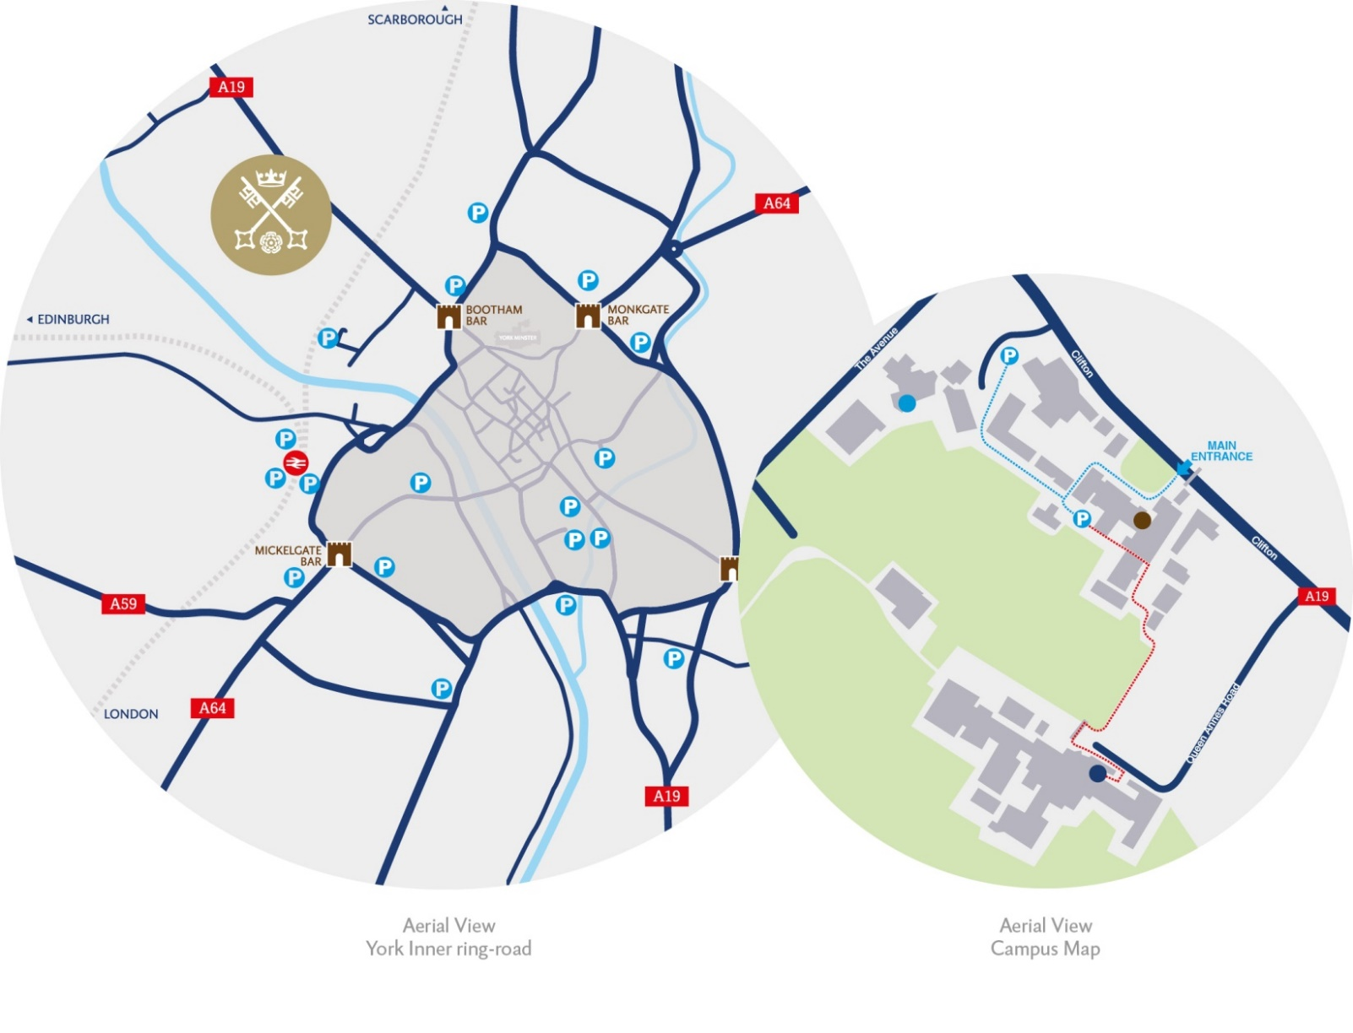
By car:

From York City Centre: Take the Thirsk Road (A19) at the Bootham Bar traffic lights. The school is 700m on the left, immediately after the footbridge.

From the A64: Take the Northern Ring Road (A1237). At the A19 roundabout turn towards the city centre. The school is two miles on the right, 300m after Clifton Green. Turn right into the school immediately before the footbridge that crosses the road.

Parking is available on site.

