1) perform a SIMS “Validate Memberships” accessible within SIMS from the “Tools” menu. This is a supported SIMS action, and will not cause any SIMS downtime, and resolves membership related issues, where perhaps students have changed classes, or have left the school

2) performs a SIMS Tidy and Merge Addresses maintenance task. From SIMS.NET \ Tools \ Housekeeping \ Bulk Address Tools \ Tidy and merge Addresses.
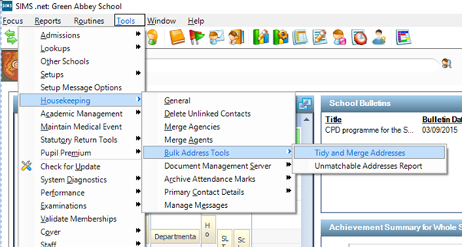

3) Delete unlinked contacts Some times Guardians can become orphaned in SIMS.NET which can seem as though they are duplicated. SIMS.NET support have suggested doing the following task from within SIMS.NET - Tools \ Housekeeping \ Delete unlinked Contacts

4) Run the report within SIMS.NET (GCX_MLS_OnRoll or GCX_MLS_Guardians) which is causing the issue watch the bottom left hand corner “Exclamation mark” symbol, as it will flash yellow and indicate any duplicates.

5) Capita support provided the following:
The duplicate Primary Key value is given in the line under the exception: 7188-7173 X 2. Using the Quick Search on the SIMS Homepage, enclose each value in curly braces to perform a search i.e. {7188} This returns the contact for whom there is duplicate information. Then they were able to identify the problem and remove the extraneous contact details.

- Capita 2nd line support provided the following Jan-2017 for duplicate student ID appearing in their SIMS.net system :
KB400677 Duplicate ID xxxx for xxxx - when previewing a SIMS .net report
KBA-464975-P2H4V6
Problem
Duplicates appearing within a third party application that imports data from an XML file, which was created by running a SIMS .net report (e.g. ParentPay).
'Duplicate ID xxxx for xxxx' is displayed at the bottom of the SIMS .net window when previewing a report.
For example:
Duplicate ID 8404 for 8404
Solution
You can identify what student has been duplicated by running a report that is filter by the 'ID' field from under the 'CESThirdPartyFields...' section or you can download a report that does this from the Private Files section on our SupportNet site.
You can download this report by doing the following:
1) Login to SupportNet (http://support.capitaes.co.uk/)
2) Go to: User Posts > Private Files
3) Click 'Retrieve File' from the right side of the page.
4) Please enter the code SRRJ/8720 and click 'Submit'.
5) Please download the file entitled 'Duplicated Student Data by ID.RptDef'.
6) If you then import this into SIMS .net by going through Reports > Import > Open > Locate and select the downloaded report definition file and then import it into SIMS.
7) You can then run this report from: Reports > Run Report > Focus > Student and it should be called 'Duplicated Student Data by ID'.
Once you have identified the student by their ID number, please could you go to Focus | Student | Student details - Tab 6 and Tab 11 - Meal Patterns and School History and please ensure the students who are duplicated do not have overlapping meal patterns set within this route. Also ensure the student who are duplicated do not have overlapping dates set for school history (e.g. 2 entries that have no end dates).
Additional Comments
This can also be resolved by following the advice in KBA-11293-Y3W1D4 once the affected student has been identified.

- Finally if all else fails you must contact Capita SIMS.NET Support to investigate the issue with their data - this IS a data issue with SIMS.NET Support will need to correct - there is nothing else MLS Support can do.

