Raspberry Pi & The Internet of Things
In this lesson, you will build a working Internet of Things system that publishes temperature, humidity and light data to the Internet.
You can use any resources at your disposal to complete the tasks, this may include the internet and your notes from previous lessons.
All hardware that you require has been provided.
The Raspberry Pi has already been setup for you with a monitor, keyboard and mouse, network cable and required Python libraries.
The Raspberry Pi should not be powered up, until you have built your circuit. Had it checked by a member of staff and all connections have been completed.

Task 1
The first task is to construct the circuit which will sense light, temperature and humidity data.
The circuit diagram is below.
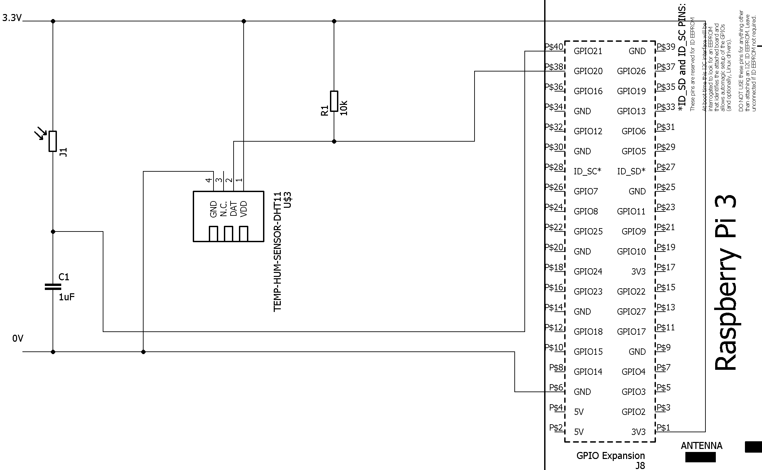

You are provided with the following components to help you build the circuit:
A small Breadboard
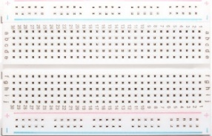
A T Cobbler Interface to connect the Raspberry Pi to the Breadboard
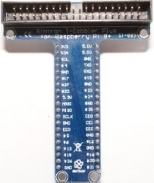
A Light Dependent Resistor

A 1µ Farad Capacitor
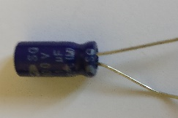
A DHT 11 Temperature Sensor Module (includes pull up resistor R1)
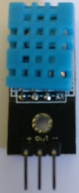
Male to Male Jumper wires (Assorted Colours)
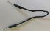

Task 1A
The bread board has connections between the holes.
In the centre, the columns are connected in groups of 5 rows.
There is no connection across the centre gap.
The two rows at the top and bottom of the board are connected length wise and can be used to provide power. These are called power rails.

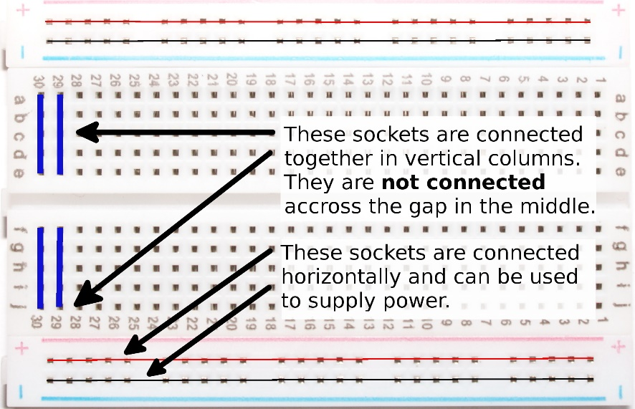

Install the T Cobbler interface onto the breadboard, so that none of the pins are connected.

Task 1B
The circuit we are building today requires 3.3Volts power and 0V GND connections.
Using the breadboard, T Cobbler and jumper wires. Setup the power busses.

Task 1C
Install the DHT11 sensor module onto the breadboard and connect it up to the T Cobbler and power rails using jumper wires.
if you look closely at the circuit board on the module you can see that the 3 pins are marked up +, - and OUT. The OUT pin should be connected to a numbered GPIO pin on the cobbler interface.
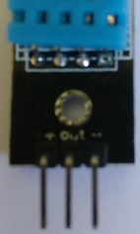
You probably want to steer clear of the rows connected to the T Cobbler interface and connect the sensor module further down the board using a jumper wire.
You don’t need a resistor as its already installed on the module circuit board.

Task 1D
Install the light dependent resistor and capacitor onto the breadboard to make up the light sensing part of the circuit.
The two legs of the light dependent resistor shouldn’t be connected.
Locate the resistor and capacitor away from the T Cobbler and use jumper wires to hook it up.
Leave a gap between the capacitor and the resistor so you can connect a jumper wire to one of the numbered GPIO pins.
The capacitor has a stripe down one side, the leg adjacent to the stripe should be connected to the negative or ground power rail or it will not charge up.
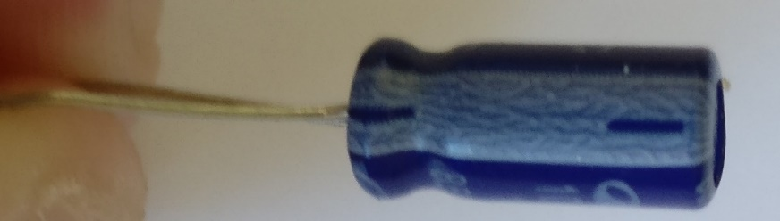

How It Works
The light sensor is a device called a light dependent resistor. It restricts the flow of electrical current much like a tap restricts the flow of water into a bucket.
When it is dark the electrical current flows through at a slow rate. To use our water illustration the tap is barely open and the water is dripping one drop at a time into the bucket.
When it is in very bright light electrical current flows freely. In the water illustration, the tap is fully open and water is pouring into the bucket.

The Raspberry Pi can’t measure the flow through the light dependent resistor as it can only accept signals that are either be on or off. Where on is 3.3 Volts and off is 0 volts.

Going back to our bucket and tap illustration we could measure whether the bucket is full or empty.
This could be represented as off for empty and on for full. If we time how long it takes to fill the bucket then we can work out whether the tap was on full or dripping.

The electrical equivalent of a bucket it a capacitor which stores electrical charge. At first it is empty and all the electrical current flows into the capacitor. The effect of this is that the voltage across it stays low.
When it is full, it now has a positive charge relative to the ground rail. The Raspberry Pi GPIO pin sees this a voltage and goes high. We can write a Python program to time how long this takes.
You have now completed the circuit build.
Ensure that the Raspberry Pi is disconnected from its power supply.
Connect the Ribbon Cable from the T-Cobbler interface to the Raspberry Pi, so that the cable flows away from the breadboard.
Get a member of staff to check your circuit now.

Task 2
In this task, we will setup the cloud service to receive data from the Raspberry Pi and publish it to the internet.
You may use the Raspberry Pi to connect to the Internet if required.
To accomplish this you will need to:
- Register for Thingspeak @ www.thingspeak.com
You will need an email address that you can access now to confirm your registration
- Create a Channel in Thingspeak
- Add 4 Fields to the Channel
  - Temp °C
  - Temp °F
  - Relative Humidity %
  - Light Level
There is an online Thingspeak tutorial at the link below: https://uk.mathworks.com/help/thingspeak/collect-data-in-a-new-channel.html
Hint - You will need the Write API key from Thingspeak for the next task, make a note of it now.

Task 3
In this task, you are going to write a Python 2 program which will read data from the sensor and publish it to the internet.
The basic structure of the program will be:
- Initialize Sensors & Variables Required
- Loop forever:
  - Read Temperature and Humidity
  - Time how long the Capacitor takes to fill
  - Publish these values to Thingspeak
  - Wait 15 seconds – this is the minimum time Thingspeak will accept postings.
  - Go Back to the start of the Loop
Your program should stop, if an error occurs or the user presses <CTRL> + <C> on the keyboard. This is known as the break keys.
If the program stops then then it should reset the GPIO interface.
You will find the following Python modules useful in constructing the program:
- RPi.GPIO – Used to access and configure the GPIO interface
- time & sleep in the time module – for delays
- Adafruit_DHT – Allows data to be read from the Temp / Humidity Sensor
Modules can be included in your program using import statements

Task 3A
Initialise the GPIO library so that it uses the Broadcom pin numbering scheme which matches the numbering scheme on the T Cobbler.
You can use the GPIO.setmode() function.
Set some variables up to store the pin numbers of the GPIO pins you used for the sensors and your Thingspeak write API Key you wrote down earlier.

Task 3B
Write a Python function that reads data from the Temperature sensor and returns three string values containing the Temperature in °C, the Temperature in °F and the relative humidity.
The AdaFruit_DHT Library contains the following function which you may find useful.
Adafruit_DHT.read_retry(Adafruit_DHT_DHT11, pinNumber)
This will read data from the sensor, if it fails it will retry until it gets data. The pinNumber parameter is the pinNumber you connected the sensor’s output to.
The function will return two numeric values: the relative humidity and the temperature in °C in that order.
Write some code to convert the temperature in °C to °F
You can convert from °C to °F using the formula below.
$$F=\left(\frac{9}{5}*C\right)+32$$
The Thingspeak web api will need these values converting to a string, you can do this with the build in str(expresion) function.

Task 3C
Write a function that will generate a number dependent on how long the capacitor takes to charge.
The darker the room, the higher the number.
The number should be converted to a string and returned from the function.
Your code should follow this structure:
- Initialize a counter variable
- Discharge the Capacitor by pulling the GPIO pin down to 0 volts (LOW)
- Wait 1/10th of a second for the capacitor to discharge
- Set the GPIO pin to read mode
- Loop while the GPIO pin is low
  - Increment the counter
- Return the counter converted to a string when the loop stops due to the GPIO pin being high
You may find the following functions useful
GPIO.setup(<pin number>, GPIO.IN | GPIO.OUT) – sets a GPIO pin for input or output
GPIO.input(<pin number>) – reads from the specified GPIO pin possible return values as GPIO.HIGH (3.3V) & GPIO.LOW (0V)
time.sleep(<number of seconds>) - wait for a period of time, e.g. time.sleep(0.5) will wait for half a second.

Task 3D
Write a function called main which performs the following:
- Loop forever
  - Call the function to read the temp / humidity sensor
  - Call the function to get the light value
  - Print these values to the console
  - Open a connection to Thingspeak website and publish the data
  - Print the result from the web connection to the console
  - Close the web connection
  - Wait 15 Seconds
The main function should stop execution if <CTRL> + <C> break key sequence is pressed on the keyboard or an error occurs.
You will need to build up the Thingspeak url in a string.
The base Url is: https://api.thingspeak.com/update
You can pass parameters to the web service by using a query string.
This uses the format ?<paramName>=<value>
Additional parameters can be added with an &<paramName> = <value>
e.g. http://www.google.com/search?q=bbc+tv&rlz=1C1CHBD_en-GBGB748GB748
Here there are two parameters: q = bbc+tv&rlz= 1C1CHBD_en-GBGB748GB748
To build up your Thingspeak url you will need to add the following parameters and values to the string:
- api_key=<YourAPIKey>
- field1=<TempC>
- field2= <TempF>
- field3=<RH>
- field4=<LightValue>
Your URL string should look similar to the one below where it is all joined together.
https://api.thingspeak.com/update?api_key=ADSD15454SADS&field1=21.0&field2=53.0&field3=60.0&field4=245
You may find the following functions useful to establish and internet connection.
urllib2.open(<URL>) - takes the URL in the form of a string and returns a file stream object.
e.g f=urllib2.open(“www.mywebsite.com”)
f.read() returns reads the web response from the stream. For Thingspeak this should be a unique serial number
f.close() closes the file stream
You can detect the break sequence being pressed and errors occurring by using a try, except block. The code inside the try block will run until an error occurs. If an error occurs the code in the except block is run.
You can have multiple except blocks to trap different errors.
The except keyword on its own will catch all errors that have not already been caught and should be last in the except blocks.
You can trap the break key sequence using except KeyboardInterrupt:
See the Python documentation for more information.
https://docs.python.org/2/tutorial/errors.html
You should wrap the code inside the loop within a try block and setup traps for KeyboardInterrupt and other errors.
In the except blocks you should clean up the GPIO using the GPIO.CleanUp() function and stop execution. You can stop execution using the break keyword.
You may also want to consider giving the user some feedback.
The following code will call your main function when the program starts.
# Call Main
if __name__ == '__main__':
main()
Save and run your program. If you need help with something not working ask a member of staff for assistance.
The output of the working program should look like below:
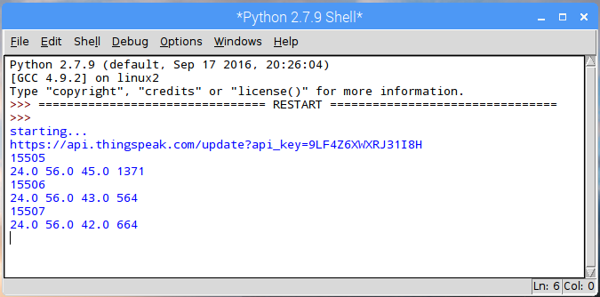
If you go back to Thingspeak and view your channel, you should now see the graphs starting to form as data is collected.
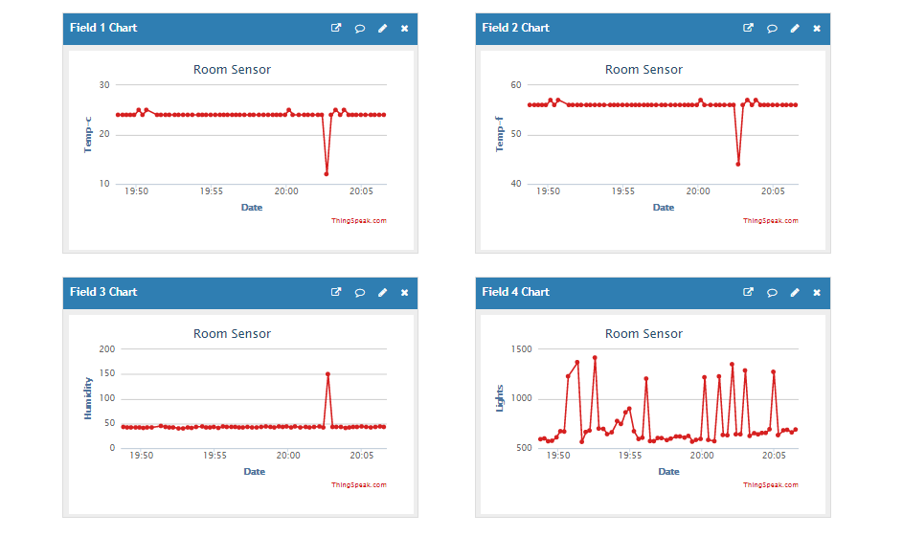

This tutorial was based on the online tutorial by Soldering Sunday on Instructables.com website. The link to the original tutorial can be found below.
http://www.instructables.com/id/Build-Your-First-IOT-with-a-Raspberry-Pi-DHT11-sen/

