Raspberry Pi & The Internet of Things
In this lesson, you will build a working Internet of Things system that publishes temperature, humidity and light data to the Internet.
If in doubt about anything during the lesson, please ask a member of staff.
You will need:
- Raspberry Pi 3 Model B connected to the Internet with a monitor, keyboard and mouse. The Pi should already have a micro SD Card with Raspbian and the AdaFruit DHT libraries pre-installed.
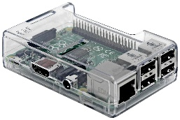
This should have already been setup for you by the technicians.

- A 5V Raspberry Pi Power Adapter
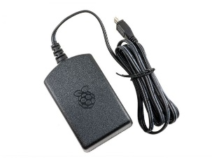

- A T Cobbler Interface to connect the Raspberry Pi to the Breadboard
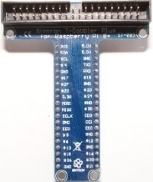
- A 40 pin Ribbon Cable to connect the Raspberry Pi to the T Cobbler
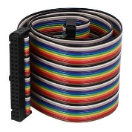
- A small Breadboard
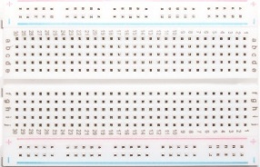
- A Light Dependent Resistor
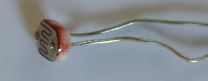
- A 1µ Farad Capacitor
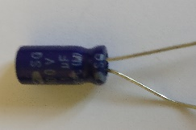
- A DHT 11 Temperature Sensor Module (includes pull up resistor)
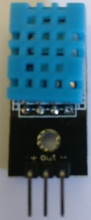
- Male to Male Jumper wires (Assorted Colours)
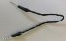
It is not time yet to power up the Raspberry Pi
If it is already powered up please shut it down by clicking on the Raspberry in the top left of the screen and selecting the Shutdown option from the menu.
Once the screen has gone blank you can safely unplug the power adapter.
The circuit diagram is shown below. Don’t worry if you don’t fully understand it. Step by step instructions are given in the next section of this tutorial.
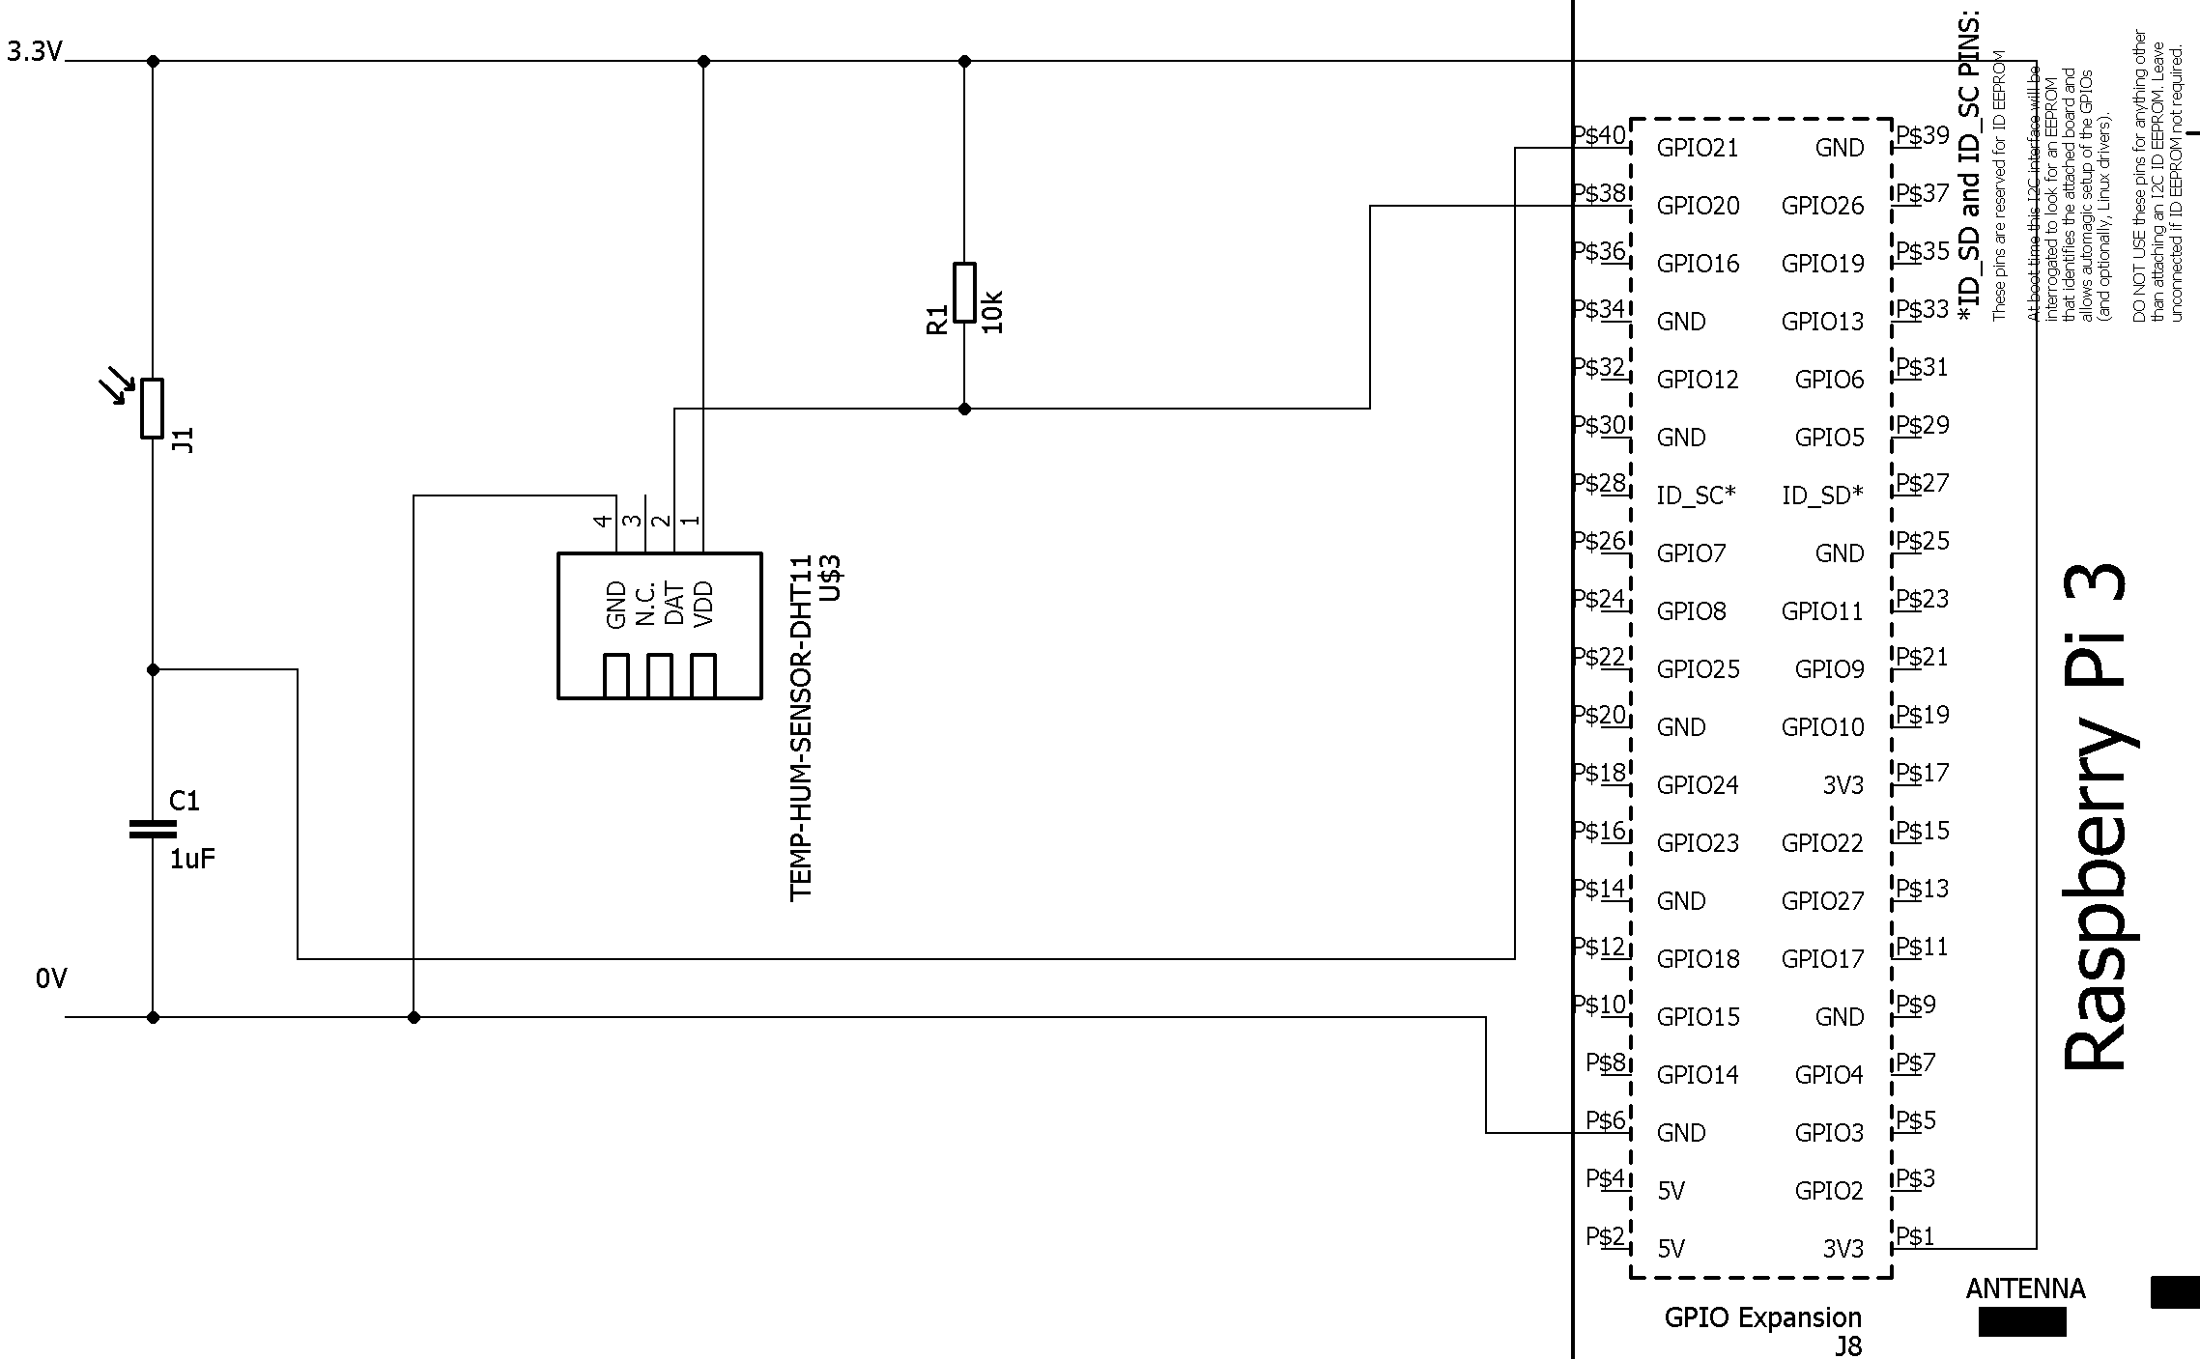

To Build the Circuit
- You will need the T Cobbler interface and the breadboard
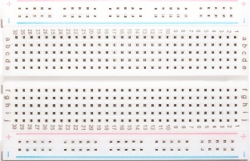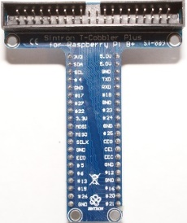
The T Cobbler interface has pairs of pins on the back of it.
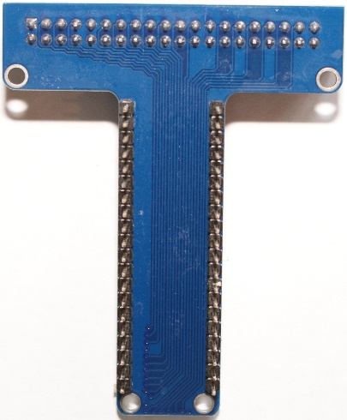
Line up the first pair of pins so that they line up with the first column of
Holes on the bread board. The interface should straddle the gap in the middle of the breadboard. See picture below.

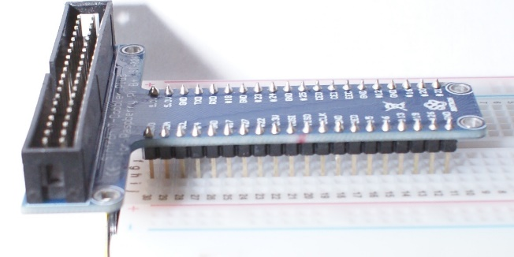

Once alignned push down on the interface to install it.
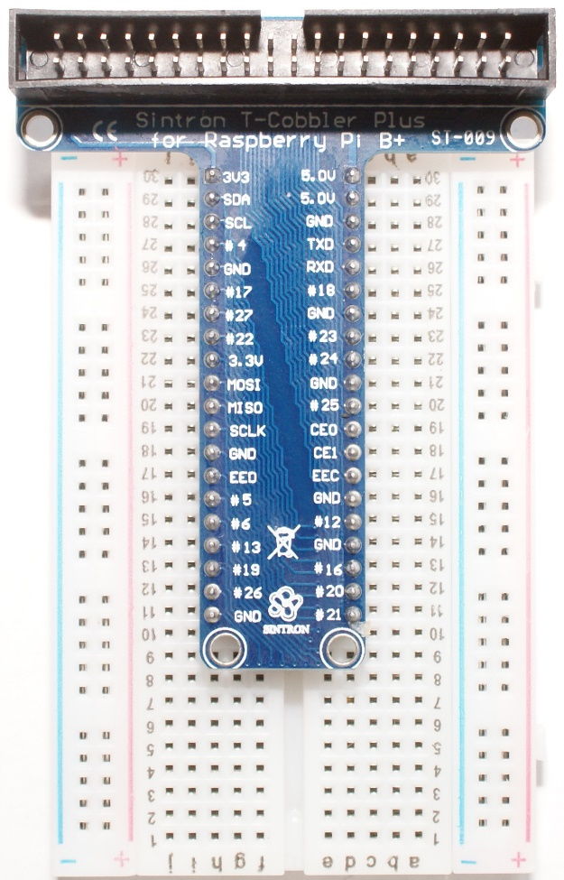
The picture above shows the T – Cobbler installed correctly onto the breadboad.
Note the number of holes on each side of the interface will not be the same, this is OK.
As long as there are at least 2 hole on each side to make connections then it is OK.
- The bread board has connections between the holes.
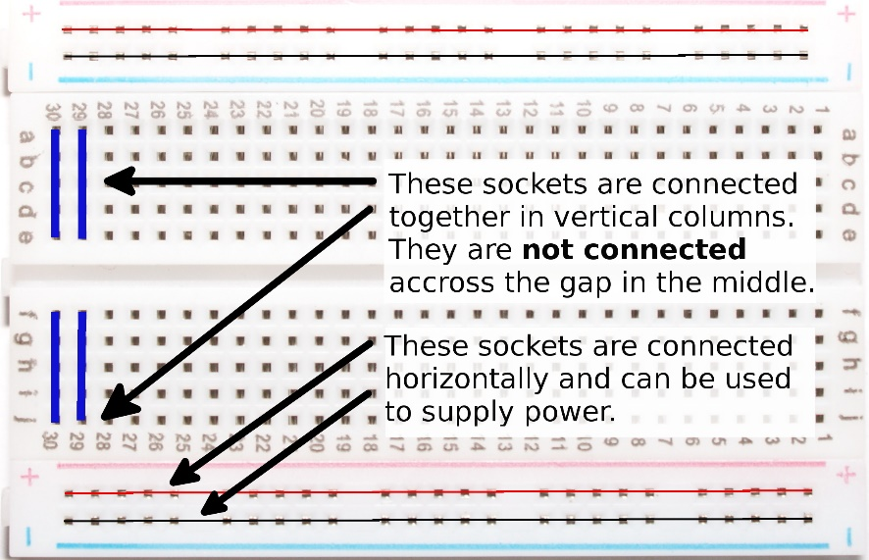
In the centre, the columns are connected in groups of 5 rows.
There is no connection across the centre gap.
The two rows at the top and bottom of the board are connected length wise and can be used to provide power.

The first thing our circuit needs in 3.3 Volts power and a GND connection.
These are like the + and – connections of a battery, the 3.3 Volts being the +, the GND being the minus.

Turn your breadboard so that the text on the Pi Cobbler Interface is the right way up.

Connect a red jumper wire from the 3V3 pin to the left hand + power rail. Indicated by a + sign and a red line.
Connect a black jumper wire from the GND pin to the right hand – power rail.
Indicated by a - sign and a blue line.
Note: There are several connections on the cobbler marked GND and 3V3. Any of these can be used provided they are connected to the correct power rail.

Your circuit should now look like the one below:
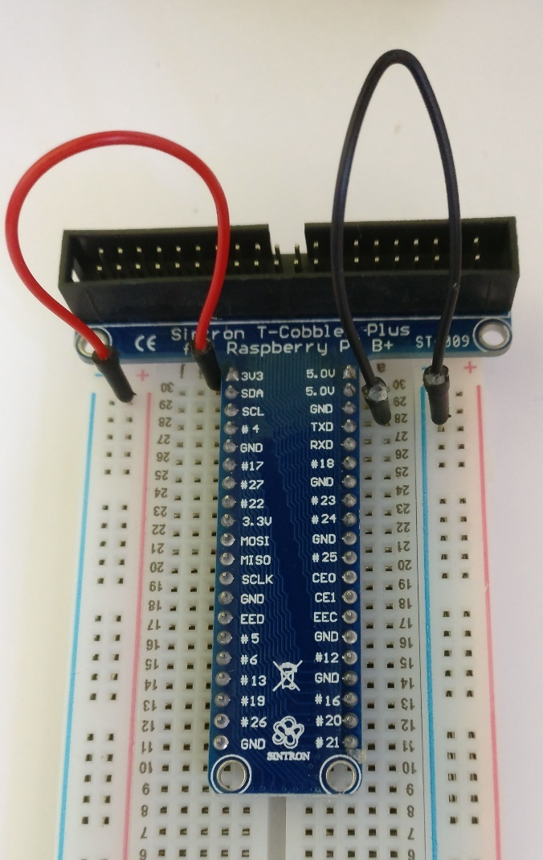

- We are now going to install the DHT 11 sensor module into the bread board.
With the breadboard still facing you so that you can read the text on the T Cobbler Interface.
Locate the bottom of the T Cobbler interface.

Install the sensor module so that its pins are clear of the bottom of the interface and it is on the right-hand side of the centre gap.

Each pin should be in its own row on the breadboard.
The blue plastic grill should be facing to the right.
It may help to turn the breadboard so that you can see where the pins are being installed to.
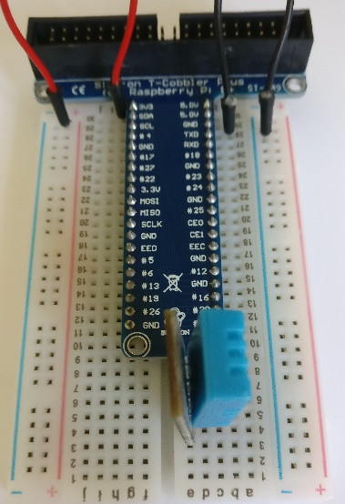 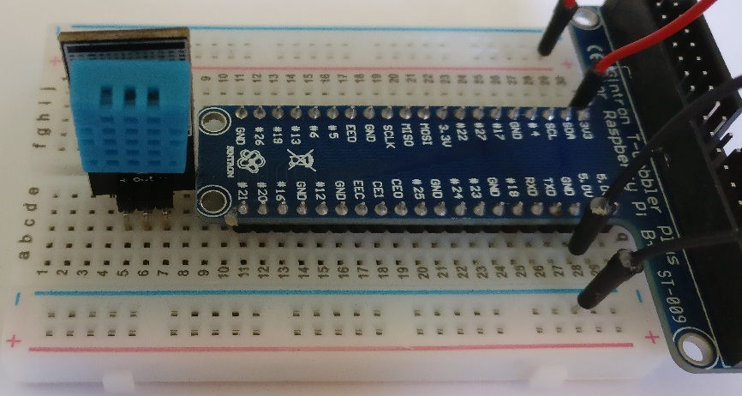
There should still be spare holes below the sensor so that the jumper wires can be installed.

- The sensor module has 3 pins labelled + , Out and -
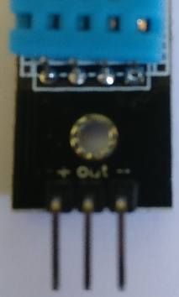
Look at the sensor from the side with the blue plastic grill
The left pin is +, the centre pin is out or data, the right pin is -
With the breadboard length ways and the blue grill on the sensor facing towards you connect the following jumper wires.
Connect a black Jumper wire from the right most pin labelled - to the blue / -power rail on the bottom of the breadboard.
Connect an orange Jumper wire from the middle pin labelled out to the column on the breadboard connected to #20 on the cobbler interface
Connect a red jumper wire from the left pin labelled + to the red / + power rail at the top of the breadboard.
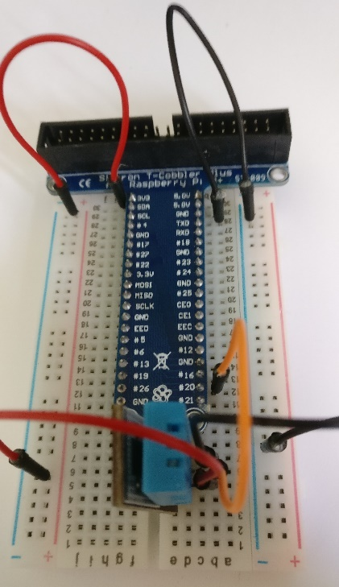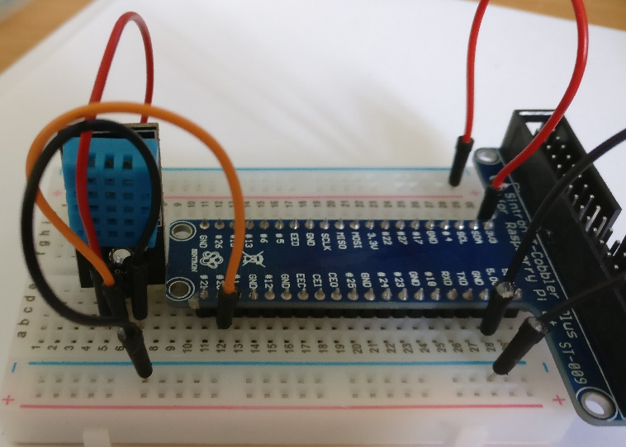
- We are now going to build the part of the circuit which detects light.
For this we need the light dependent resistor and the capacitor.
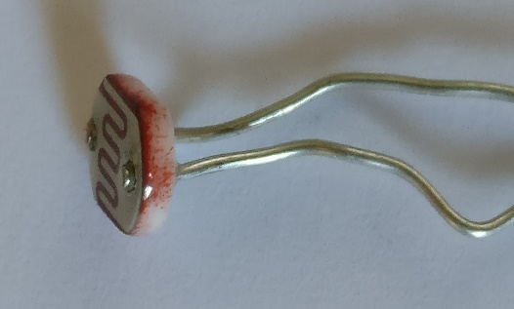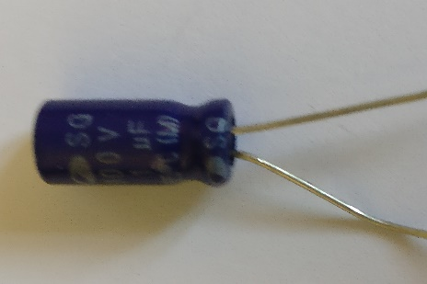

Rotate the bread board so that it is in the vertical orientation and you can read the writing on the T Cobbler interface.
Insert the light dependent resistor into an unused row at the bottom of the breadboard. Each of its legs is either side of the central gap. It does not matter which way round it goes.
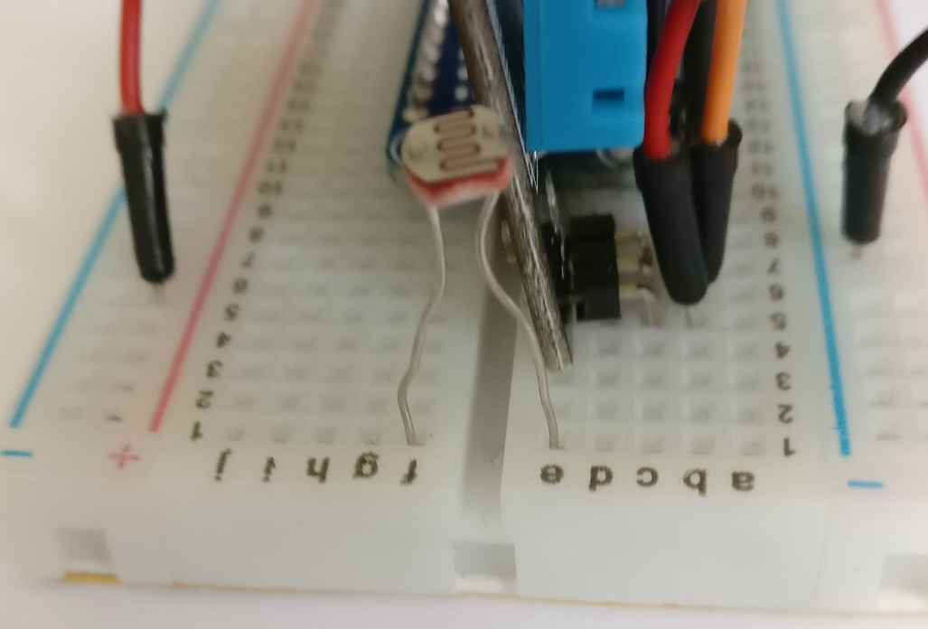

Take the capacitor and locate the leg next to the white stripe on its body, this is the negative leg.
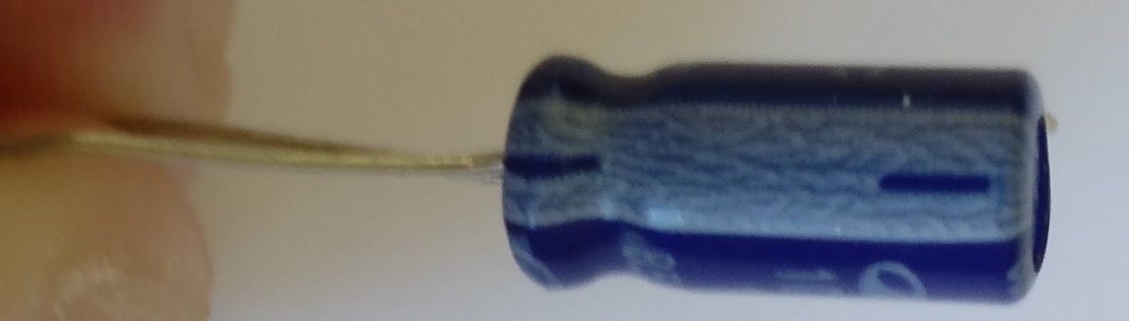
Next insert the capacitor into the breadboard so that the leg adjacent to the white stripe is inserted into the negative power rail coloured blue.
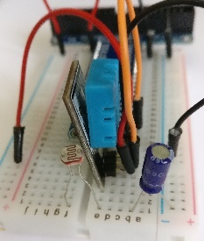

Attach a red jumper wire from the left hand red power rail to the row of holes left of the light dependent resistor. This provides power to the circuit.

Finally insert a green jumper wire into one of the holes in between the light dependent resistor and capacitor. Insert the other end into the row adjacent to the pin numbered #21 on the Pi Cobbler Interface. This will be used to tell the Raspberry Pi when the capacitor is full.

The other leg should be inserted into the same row as the light dependent resistor. You need to leave at least one hole free between the resistor and capacitor.

How It Works
The light sensor is a device called a light dependent resistor. It restricts the flow of electrical current much like a tap restricts the flow of water into a bucket.
When it is dark the electrical current flows through at a slow rate. To use our water illustration the tap is barely open and the water is dripping one drop at a time into the bucket.
When it is in very bright light electrical current flows freely. In the water illustration, the tap is fully open and water is pouring into the bucket.

The Raspberry Pi can’t measure the flow through the light dependent resistor as it can only accept signals that are either be on or off. Where on is 3.3 Volts and off is 0 volts.

Going back to our bucket and tap illustration we could measure whether the bucket is full or empty.
This could be represented as off for empty and on for full. If we time how long it takes to fill the bucket then we can work out whether the tap was on full or dripping.

The electrical equivalent of a bucket it a capacitor which stores electrical charge. At first it is empty and all the electrical current flows into the capacitor. The effect of this is that the voltage across it stays low.

When it is full, it now has a positive charge relative to the ground rail. The Raspberry Pi GPIO pin sees this a voltage and goes high. We can write a Python program to time how long this takes.
- Now get a member of staff to check your circuit before proceeding to the next step.
- Take the ribbon cable
Hold the cable with the plug on the end facing toward you and the cable flowing away from you. Locate the end of the cable where you cannot see the raised bump in the middle and the two slots at either side of the connector.
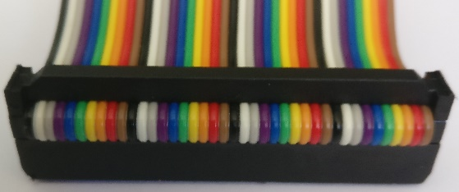 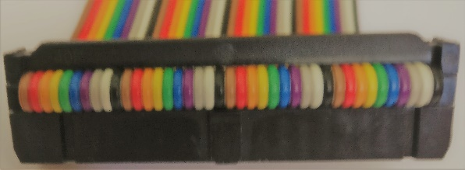
Right End Wrong End
Line the bump in the centre of the connector up with the notch on the T Cobbler interface and push the connector down. The cable should flow away from the bread board, not over the top of it.
Align the connector on the other end of the ribbon cable with the GPIO connector on the Raspberry Pi.
The cable should flow away from the Raspberry Pi not over it. Make sure that the connector is properly aligned with all the pins before pushing down.
If the connector is not aligned properly it can bend the pins of the Raspberry Pi.
If in doubt get a member of staff to assist.
Once you are sure that it is properly aligned push down on the connector.
If you haven’t already done so, get a member of staff to check your circuit and connections.
The pictures below show a properly attached ribbon cable going away from the bread board and Raspberry Pi.
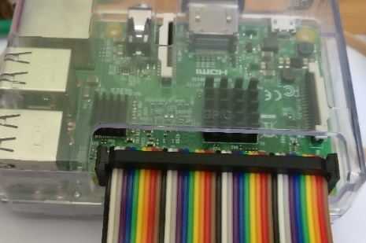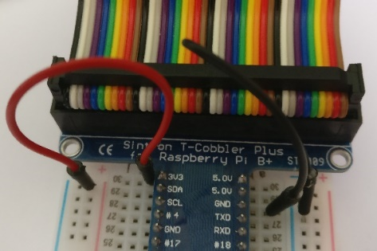
- If you are sure that everything is connected as it should be and you’ve had your circuit checked by a member of staff, then it is now time to switch on the Raspberry Pi.
Connect the Raspberry Pi power supply to the Raspberry Pi using the Micro USB connector and connect the other end to the power socket.
- Your Raspberry Pi should now start up and boot in the Pixel graphical environment. Your screen should look similar to the one below.
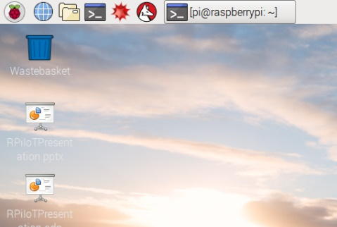
- We are now going to setup the Internet part of the project.
Launch Firefox web browser and type enter the address www.thingspeak.com into the address bar.

Click the Get Started for Free Button
- On the next screen enter your email address.
It needs to be an email address that you have access to now.
Make up a user id and password.
Enter your First Name and Last name.
Click the continue button.
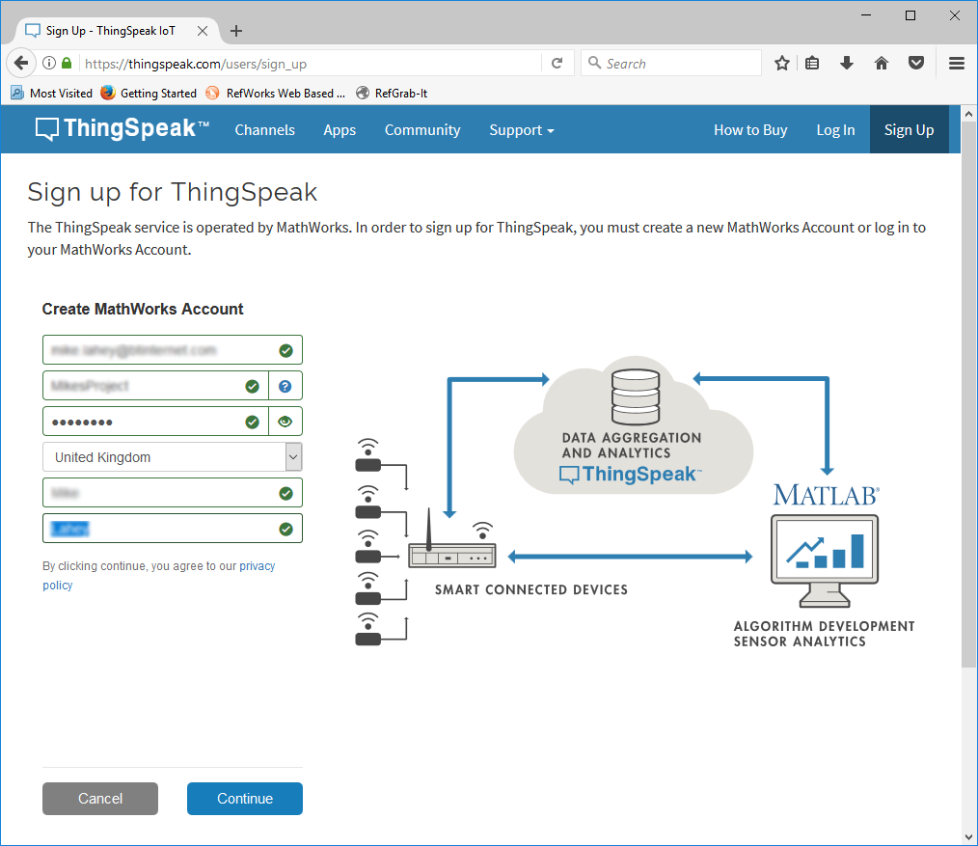
Make a note of your username and password for later.
- You will now see the screen below.
Do not click continue until you have completed the next step.
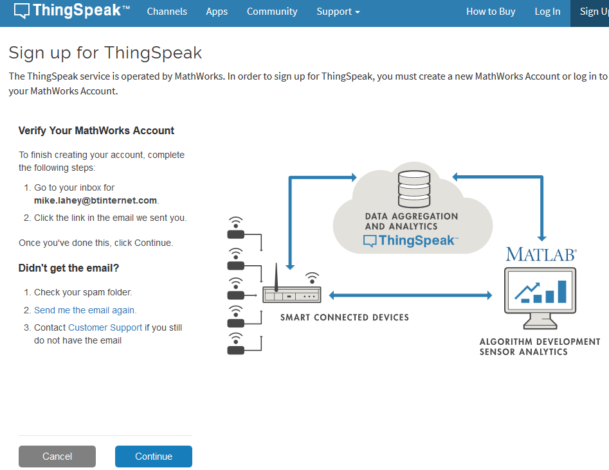

- You should have received an email with from MathWorks with a button to Verify Your Email Address.
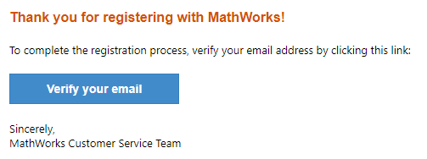
Click on the button to continue your registration. This will open a new web browser window to verify your account.
You should see the message below in your web browser.

- You can now click on continue, on the registration screen.
You should see this confirmation screen.
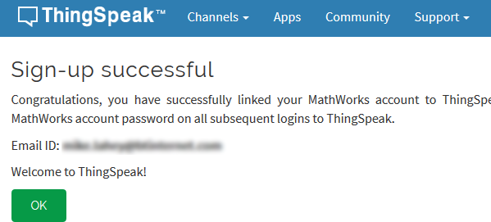
- From the top menu bar select My Channels.
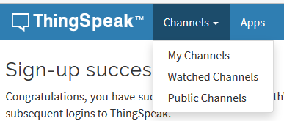
- On the next screen click Agree To Terms
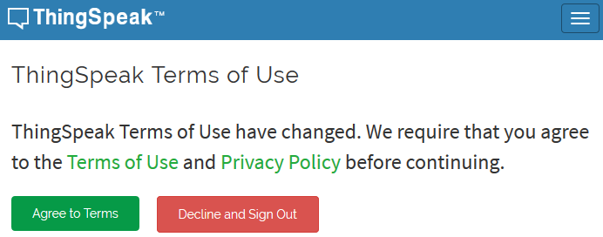
- You should now see an empty channel list.
Click on new Channel.
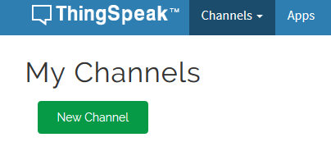
- You should now see the channel creation screen.
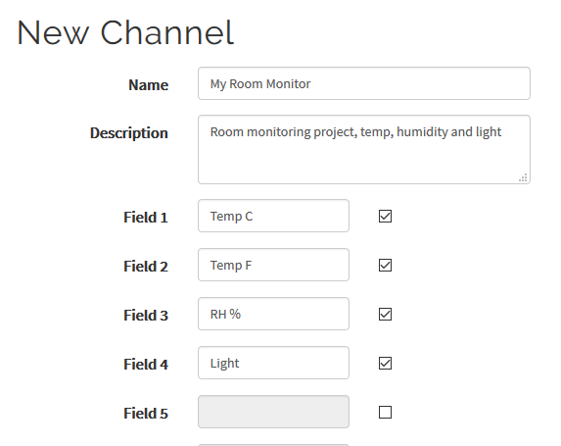
Enter a name and description for your project.
Tick the boxes for Field 1, 2, 3 and 4
Overwrite the labels of the fields 1 – 4 with these new values:
Temp C, Temp F, RH %, Light
All the other fields are fine with their default values.
Scroll to the bottom of the screen and click the green Save Channel button.
- You will now see a screen with 4 empty graphs.
This is OK, as we haven’t sent any data yet from the Raspberry Pi.
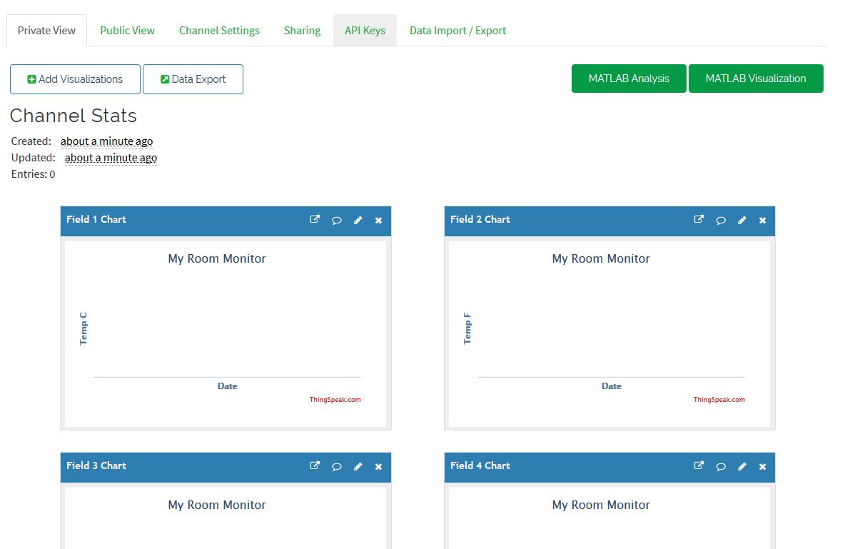
- Click on the API Keys Tab.
You will now see the API Key screen.
There are two unique keys here, one for sending data to the internet and one for retrieving data.
For our Raspberry Pi to send data to the internet we need the Write API Key.
Make a note of this Write API Key for later.
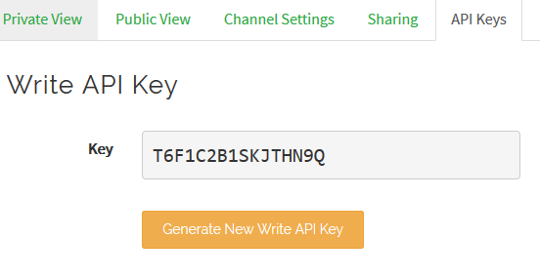
Note: If you use the one in the screen shot above it will not work. You must use your own API Key.
Do not close Thingspeak.com web site.
Click on the Private View tab and return to the empty graphs.
We are now going to write the Python code that will read the data from the sensors and post it to the Internet.
On the Raspberry PI, Open IDLE for Python 2
Click on the Raspberry Icon, then select Programming, Python 2 (IDLE) from the menu.
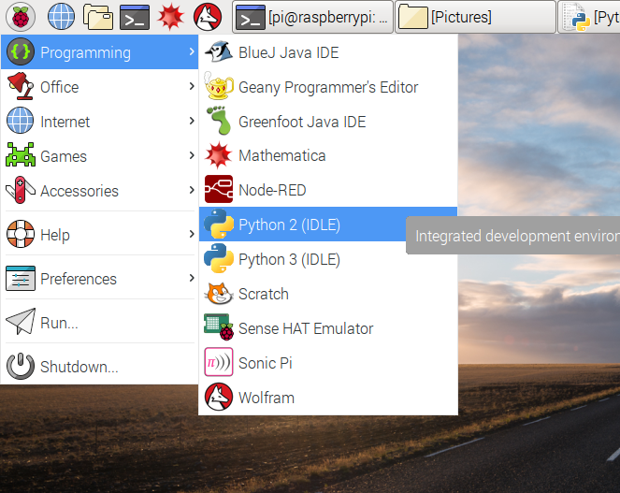
- A new window will open titled Python 2.7.9 Shell.
From the File Menu, select New File.
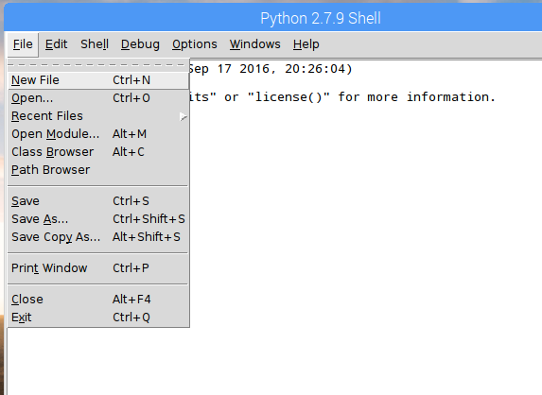
- This will open a new code editor window.
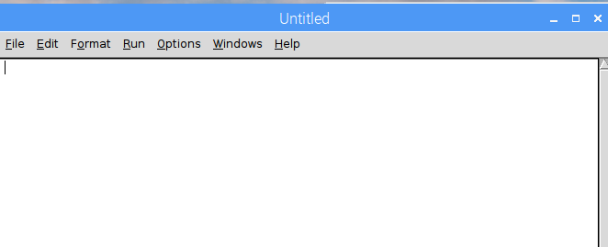
- We can now start writing some code.
First we need to add the line which will tell the system that this is a Python script:
#!/usr/bin/python
- We need to import some libraries to allow us to talk to the sensors, communicate with the internet and perform timing.

# Import all the libraries we need
import RPi.GPIO as GPIO
import time # Allows us to do timing
from time import sleep # For time delays
import Adafruit_DHT # Driver for the DHT11 Sensor
import urllib2 # Internet access via Http
- We need set up some variables to control program.
First we are going to tell the Raspberry Pi what pins the sensors are connected to.
The DHT 11 sensor is connected to pin 20
The Light Sensor is connected to pin 21
# Define GPIO to Sensor mapping
DHTpin = 20 # Temp / Humidity Sensor
RCpin = 21 # Light Sensor and Capacitor
Next we need to tell the Pi our Write API key that we got earlier from ThingSpeak and how often we want it to send updates.
#Setup our API and delay
myAPI = "<API KEY GOES HERE>"# API Key from ThingSpeak!
myDelay = 15 #how many seconds between updates, min = 15s
Note: This should be the Write API key you wrote down earlier.
- The pin labels on the T Cobbler interface use the Broadcom chip pin numbering rather than the physical pin numbering.
We need to initialise the GPIO and tell the GPIO library that we are using the Broadcom numbering scheme.
GPIO.setmode(GPIO.BCM) #Set Broadcom Pin Numbering
- Now we need a function to read the data from the Temperature and Humidity sensor. Getting data from this sensor is quite complicated.
Fortunately for us AdaFruit have provided a driver library which does all the hard work for us. One line of code will get us the temperature in °C and the percentage relative humidity.
Note: The indent is important to denote a block of code
# Function to read temp / humidity sensor
# Returns three string values – %RH, °C and °F
def getSensorData():
# Read from the Sensor
# We get two values
# RHW contains the humidity
# TW contains the Temperature in °C
RHW, TW = Adafruit_DHT.read_retry(Adafruit_DHT.DHT11, DHTpin)
# TW contains the Temperature in °C
TWF = 9/5*TW+32 # Convert to °F by using formula
#Convert to strings ready to pass to internet and return values
return (str(RHW), str(TW),str(TWF))
- Next, we are going to create a function which times how long the capacitor takes to fill. The longer it takes to fill, the darker it is.
# Function to time how long it takes the capacitor to fill
# Returns a string containing the number of loops executed
# The number is arbitrary, but the bigger the number
# The darker it is.
def RCTime():
# Initialize Counter
count = 0
# We are going to place the GPIO pin into output mode
# and pull it down Low to 0 Volts / GND
# this ensures that the capacitor is discharged
GPIO.setup(RCpin,GPIO.OUT) #Output Mode
GPIO.output(RCpin,GPIO.LOW) #Pull pin down to 0V
time.sleep(0.1) #Wait for 1/10 second to allow for discharge
# Change the GPIO Pin back to input mode
GPIO.setup(RCpin,GPIO.IN)
# Count until the pin goes high
while (GPIO.input(RCpin) == GPIO.LOW):
count += 1 #Increment Counter
return (str(count)) #Pin is now high return number of loops
- We are going to create a main function which loops forever. It will stop when the break key combination <CTRL> + <C> is pressed on the keyboard or a runtime error occurs.
Note the call to urlib2.open is all one line.
# Main function, loops until break is pressed or exception occurs
# Sequence of events
# Read Temp / Humidity Sensor
# Count how many loops it takes the capacitor to charge
# Send data to the Internet
# Wait however long the delay is then repeat
def main():
# Provide some console feedback to let them know we’re starting up
print 'starting...'
# Add the Write API Key to the internet address and store it
baseURL = 'https://api.thingspeak.com/update?api_key=%s' % myAPI
# We are going to turn off GPIO Warnings so we don’t alarm people
GPIO.setwarnings(False)
print baseURL #Write the complete web address to the console
# This is the main loop that will read the data and publish it
while True: #Loop forever
# We’re using a try block here so we can catch the break signal
# And any errors which crop up along the way.
try:
RHW, TW, TWF = getSensorData()#Get the temp and humidity
LT = RCtime(RCpin) #Get the light value
# Open the internet connection and pass it the URL with
# the data we want to send to Thingspeak
# Data is passed through the query string
# Using name value pairs which match the field names
# in the Thingspeak channel we set up.
# urllib2.urlOpen opens the connection to the internet
tempQueryStr = "&field1=%s&field2=%s" %(TW,TWF)
humidQueryStr = "&field3=%s" % RHW
lightQueryStr = "&field4=%s" %LT
f = urllib2.urlopen(baseURL + tempQueryStr + humidQueryStr +
lightQueryStr)
# print the web request response, we should get a number back
# from Thingspeak which increments.
print f.read()
f.close() # Close the connection
# print readings to console
print TW + " " + TWF+ " " + RHW + " " + LT
# Wait x seconds / minimum delay is 15 for Thingspeak
sleep(int(myDelay))

- The next thing to do is deal with any errors and the user pressing break.
Still in the main function.
Note that the indent is decreased because we are no longer in the try block. It is important to maintain the rest of the indent level as we are still in the while loop.
except KeyboardInterrupt:
# User Pressed Break
GPIO.cleanup() #Reset GPIO
break #Stop Program
except:
# Something went wrong, maybe connection failed.
print 'error - exiting.' # Inform user
GPIO.cleanup() #Reset GPIO
raise #Tell user what went wrong
break #Stop Program
It is important we clean up the GPIO before exiting or the program may not run properly next time or we may leave something powered up.
- The last thing to do is add the call to the main function when the program starts. This is at the zero indent level as we’re back in the main code.
# Call Main
if __name__ == '__main__':
main()
Save the program by selecting File, Save and enter a file name.

- Run the program, if you have entered the code successfully then it should start logging data to you Thingspeak website and the current readings should appear on the Python Shell console windows.
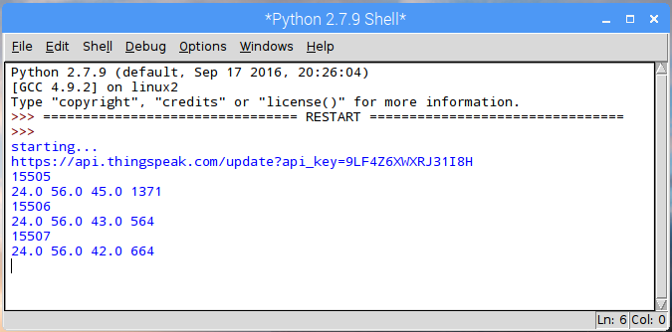
- Switch back to your Thingspeak website, if you logged out, then log back in with your email address and password.
If you stayed logged into the Thingspeak website you can skip to the next section.

The website is www.thingspeak.com if you need it again.

The login link is at the top right of the screen.
Enter your email address and password that you set up when you registered and click the Sign In button.

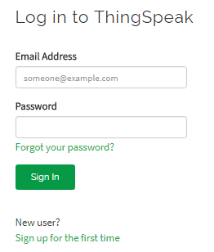

If you have just logged into the Thingspeak website you will see a screen like the one below. Click on the word Private.
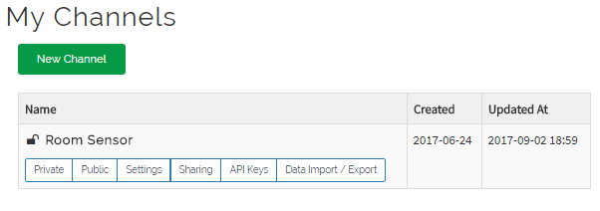

- With any luck you should now see some data plots like the ones below.
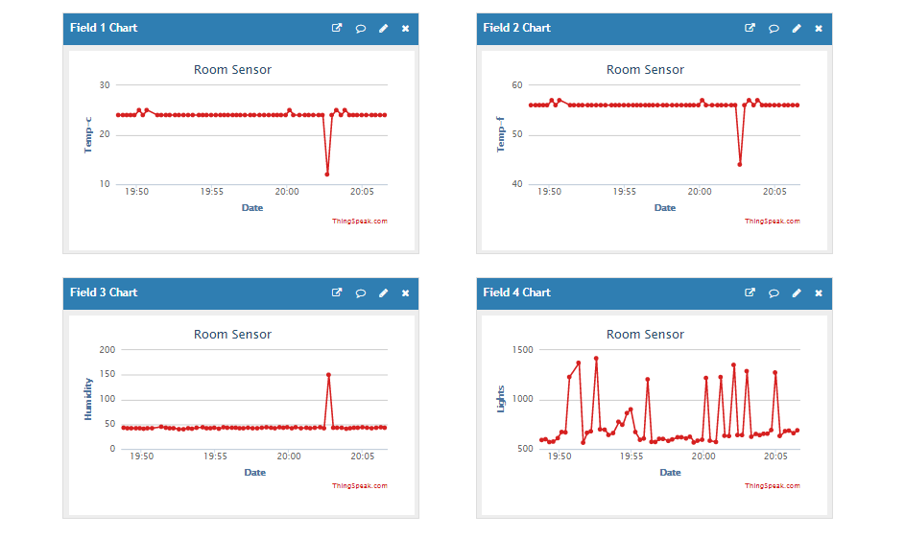
This tutorial was based on the online tutorial by Soldering Sunday on Instructables.com website. The link to the original tutorial can be found below.
http://www.instructables.com/id/Build-Your-First-IOT-with-a-Raspberry-Pi-DHT11-sen/
If you need help using Thingspeak see:
https://uk.mathworks.com/help/thingspeak/collect-data-in-a-new-channel.html

