Raspberry Pi & The Internet of Things
Leaders Notes

Setup
Raspberry Pi 3 computer should be setup with keyboard, mouse and monitor.
A micro SD card pre-loaded with Raspbian which boots into Pixel should be installed into the Raspberry Pi.
The Raspberry Pi 3 will need a wired or wireless internet connection.
The Python AdaFruit DHT module should be preinstalled, by running the following shell commands in a terminal window:
- git clone https://github.com/adafruit/Adafruit_Python_DHT.git
- cd Adafruit_Python_DHT
- sudo apt-get update
- sudo apt-get install build-essential python-dev python-openssl
- sudo python setup.py install
See: https://learn.adafruit.com/dht-humidity-sensing-on-raspberry-pi-with-gdocs-logging/software-install-updated
The Python GPIO module should be preinstalled by running the following commands:
- sudo apt-get install python-dev
- sudo apt-get install python-rpi.gpio
In addition, the students will need the following components:
- Small breadboard
- Sintron T Cobbler Interface
- 40 Pin Ribbon Cable to connect interface to the Pi GPIO
- DHT 11 Sensor Module – Circuit board mounted, can use plain sensor but you will need a 10kΩ pull up resistor.
- Light Dependent Resistor – ORP 12 recommended but others will do
- 1µF Electrolytic Capacitor
- Assorted male to male jumper wires of various lengths and colours.

Lesson Structure
The less is broken down into 3 Tasks
- Build the hardware
- Setup the Thingspeak Internet of Things web service
- Write the Python Code
The lesson should build on previous hardware and Python skills gained in previous lessons.
A full step by step guide is available to use alongside this document
Students should try to work off their own initiative with help given along the way.
It is assumed the tutor has a working knowledge of the Python library and a basic level of knowledge of electronic theories relating to capacitors, resistors and the Raspberry Pi GPIO.
Below is an indication of how the lesson may be structured the lesson:
15 Mins | Introduce topic and explain the circuit that is being built
10 Mins | Explain about the capacitor and resistor circuit
35 Mins | Task 1: Students build hardware
10 mins Break
10 Mins | Give an overview of Thingspeak and what they are going to do
20 Mins | Task 2: Students setup Thingspeak website
5 min Break
10 Mins | Introduce and outline Python Programming task
50 Mins | Task 3: Python Programming
15 Mins | Feedback and wrap up

Task 1
It is anticipated that students may need help with the hardware build.
The circuit diagram is below for reference:
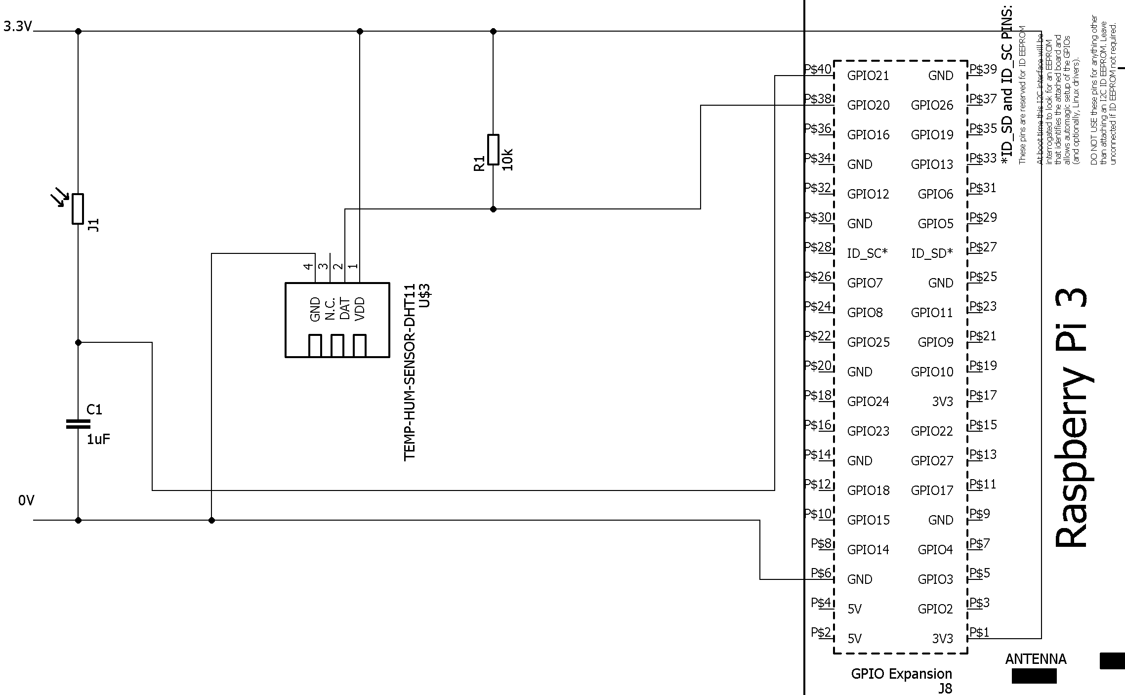
Note: The pull-up resistor on the DHT11 module is already fitted to the circuit board and not required
The student worksheet uses a water and bucket analogy to explain how the Resistor Capacitor part of the circuit works.
How It Works
The light sensor is a device called a light dependent resistor. It restricts the flow of electrical current much like a tap restricts the flow of water into a bucket.
When it is dark the electrical current flows through at a slow rate. To use our water illustration the tap is barely open and the water is dripping one drop at a time into the bucket.
When it is in very bright light electrical current flows freely. In the water illustration, the tap is fully open and water is pouring into the bucket.

The Raspberry Pi can’t measure the flow through the light dependent resistor as it can only accept signals that are either be on or off. Where on is 3.3 Volts and off is 0 volts.

Going back to our bucket and tap illustration we could measure whether the bucket is full or empty.
This could be represented as off for empty and on for full. If we time how long it takes to fill the bucket then we can work out whether the tap was on full or dripping.

The electrical equivalent of a bucket it a capacitor which stores electrical charge. At first it is empty and all the electrical current flows into the capacitor. The effect of this is that the voltage across it stays low.
When it is full, it now has a positive charge relative to the ground rail. The Raspberry Pi GPIO pin sees this a voltage and goes high. We can write a Python program to time how long this takes.

A more detailed explanation of how RC Circuits work can be found here:
http://www.electronics-tutorials.ws/rc/rc_1.html

As a minimum, the following checks should be carried out before connecting the breadboard to the Raspberry Pi.
- The Raspberry Pi is switched off
- There is 3.3V connected to the +ve power rail.
- There is GND connected to the -ve power rail.
- There are no short circuits from 3.3V to GND
- The DHT 11 sensor output is connected to an appropriate GPIO pin labelled #xx where xx is the pin number
- The DHT 11 power supply + pin is connected to 3.3V
- The DHT 11 power supply – pin is connected to GND
- The light dependent resistor pins are not connected
- One of the light dependent resistor pins is connected to 3.3V
- The capacitor is oriented the correct way with the leg adjacent to the stripe connected to GND
- The other capacitor leg should be connected to the leg of light dependent resistor pin that is not connected to 3.3V.
- The GPIO connection is taken from between the capacitor and the resistor
- The other end of the connection is connected to an appropriate GPIO pin labelled #yy where yy is the pin number
- No other GPIO pins are connected and there are no other connections present
- The ribbon cable is correctly inserted with the cable flowing away from the breadboard, not over it.
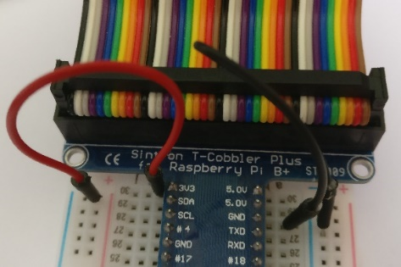
- The other end of the ribbon cable is correctly attached to the Raspberry Pi with no pins showing and the cable flowing away from the Raspberry Pi board.
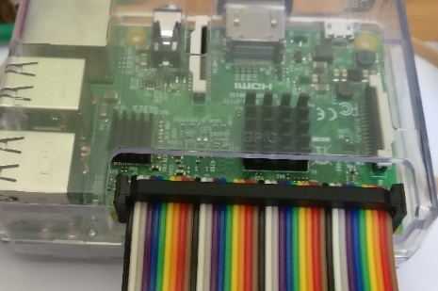

Task 2
Students will need access to the Internet and an email account which will allow them to respond to the Thingspeak registration email.
The Thingspeak registration setup is straight forward. See the step by step guide for more information.
More help on the Thingspeak website if needed:
https://uk.mathworks.com/help/thingspeak/collect-data-in-a-new-channel.html
The important thing is that the student generates a unique Write API key.
Without the API Key, the Raspberry Pi will not be able to send data to Thingspeak

Task 3
The Python programming task is broken down into sections.
- Write the code to read the temp / humidity
- Write the code to generate an arbitrary number based on the time for the capacitor to fill.
- Write the main loop and the code to publish data and wait 15 seconds
- Implement exception handling and trapping <CTRL> <C>
The task of reading data from the DHT 11 module has been vastly simplified by the ADAFruit DHT library. All the complex signalling has been abstracted into a single call.
The task of getting a number to represent the light level is harder. It requires the following steps and directly control the GPIO pins.
- Set a counter to 0
- Write a LOW to the GPIO pin to discharge the capacitor
- Wait for it to discharge
- Switch GPIO pin to read mode
- Loop while the pin is low
  - Increment the counter
- When the capacitor has charged the pin will go high and the loop will exit
- Convert the counter to a string and return it to the caller
Sample code is provided in the detailed instructions.
Thingspeak uses a REST API which passes data to the server in a web request. It uses the query string to pass the API key and the data to the service. The student must build up the URL with their API key and the data from the sensor.
The following parameters need to be passed via the URL.
- api_key=<YourAPIKey>
- field1=<TempC>
- field2= <TempF>
- field3=<RH>
- field4=<LightValue>
The base URL is: https://api.thingspeak.com/update?
The complete URL should look something like:
https://api.thingspeak.com/update?api_key=ADSD15454SADS&field1=21.0&field2=53.0&field3=60.0&field4=245
For more info on REST APIs see:
http://www.drdobbs.com/web-development/restful-web-services-a-tutorial/240169069
Sample code is provided in the detailed instructions.
Try – except blocks are used to capture the break keyboard sequence and errors. If you are not familiar with this construct then please refer to the Python manual.
https://docs.python.org/2/tutorial/errors.html

Working Code Listing
An example of working Python code is provided below:
#!/usr/bin/python
# Import all the libraries we need
import RPi.GPIO as GPIO
import time # Allows us to do timing
from time import sleep # For time delays
import Adafruit_DHT # Driver for the DHT11 Sensor
import urllib2 # Internet access via Http
# Define GPIO to Sensor mapping
DHTpin = 20 # Temp / Humidity Sensor
RCpin = 21 # Light Sensor and Capacitor
#Setup our API and delay
myAPI = "<API KEY GOES HERE>"# API Key from ThingSpeak!
myDelay = 15 #how many seconds between updates, min = 15s
GPIO.setmode(GPIO.BCM) #Set Broadcom Pin Numbering
# Function to read temp / humidity sensor
# Returns three string values – %RH, °C and °F
def getSensorData():
# Read from the Sensor
# We get two values
# RHW contains the humidity
# TW contains the Temperature in °C
RHW, TW = Adafruit_DHT.read_retry(Adafruit_DHT.DHT11, DHTpin)
# TW contains the Temperature in °C
TWF = 9/5*TW+32 # Convert to °F by using formula
#Convert to strings ready to pass to internet and return values
return (str(RHW), str(TW),str(TWF))
# Function to time how long it takes the capacitor to fill
# Returns a string containing the number of loops executed
# The number is arbitrary, but the bigger the number
# The darker it is.
def RCTime():
# Initialize Counter
count = 0
# We are going to place the GPIO pin into output mode
# and pull it down Low to 0 Volts / GND
# this ensures that the capacitor is discharged
GPIO.setup(RCpin,GPIO.OUT) #Output Mode
GPIO.output(RCpin,GPIO.LOW) #Pull pin down to 0V
time.sleep(0.1) #Wait for 1/10 second to allow for discharge
# Change the GPIO Pin back to input mode
GPIO.setup(RCpin,GPIO.IN)
# Count until the pin goes high
while (GPIO.input(RCpin) == GPIO.LOW):
count += 1 #Increment Counter
return (str(count)) #Pin is now high return number of loops

# Main function, loops until break is pressed or exception occurs
# Sequence of events
# Read Temp / Humidity Sensor
# Count how many loops it takes the capacitor to charge
# Send data to the Internet
# Wait however long the delay is then repeat
def main():
# Provide some console feedback to let them know we’re starting up
print 'starting...'
# Add the Write API Key to the internet address and store it
baseURL = 'https://api.thingspeak.com/update?api_key=%s' % myAPI
# We are going to turn off GPIO Warnings so we don’t alarm people
GPIO.setwarnings(False)
print baseURL #Write the complete web address to the console
# This is the main loop that will read the data and publish it
while True: #Loop forever
# We’re using a try block here so we can catch the break signal
# And any errors which crop up along the way.
try:
RHW, TW, TWF = getSensorData()#Get the temp and humidity
LT = RCtime(RCpin) #Get the light value
# Open the internet connection and pass it the URL with
# the data we want to send to Thingspeak
# Data is passed through the query string
# Using name value pairs which match the field names
# in the Thingspeak channel we set up.
# urllib2.urlOpen opens the connection to the internet
tempQueryStr = "&field1=%s&field2=%s" %(TW,TWF)
humidQueryStr = "&field3=%s" % RHW
lightQueryStr = "&field4=%s" %LT
f = urllib2.urlopen(baseURL + tempQueryStr + humidQueryStr +
lightQueryStr)
# print the web request response, we should get a number back
# from Thingspeak which increments.
print f.read()
f.close() # Close the connection
# print readings to console
print TW + " " + TWF+ " " + RHW + " " + LT
# Wait x seconds / minimum delay is 15 for Thingspeak
sleep(int(myDelay))
except KeyboardInterrupt:
# User Pressed Break
GPIO.cleanup() #Reset GPIO
break #Stop Program
except:
# Something went wrong, maybe connection failed.
print 'error - exiting.' # Inform user
GPIO.cleanup() #Reset GPIO
raise #Tell user what went wrong
break #Stop Program
# Call Main
if __name__ == '__main__':
main()
The code is based on the code that can be found on the Instructables website:
http://www.instructables.com/id/Build-Your-First-IOT-with-a-Raspberry-Pi-DHT11-sen/

Sample Output
When working correctly the program will produce the following output
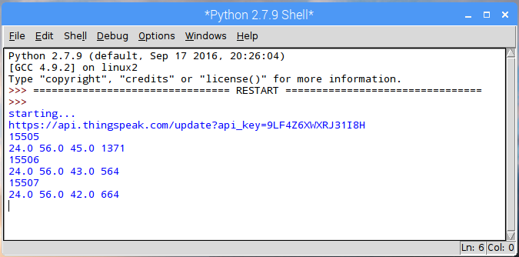
The student should also be able to see graphs on the Thingspeak website.
