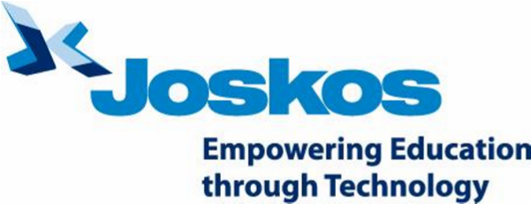

2nd Line Support Technician
We are looking for a proactive and passionate ICT Support Engineer with a strong customer focus. You will be joining an exciting team where you will have high levels of ownership and enjoy a culture of supportiveness and co-operation. You will be receiving circa £3,500 of training during the first year as part of your salary and benefits package.
Joskos is one of the UK’s fastest growing education technology businesses and esteemed winner of multiple ICT support awards. Our company prides itself on providing exceptional end to end ICT solutions fit for education businesses.
Key Responsibilities:
- Providing 2nd Line Technical Support to education sector customers
- Remote management and maintenance of client network environments
- Reporting / Assisting with Project Work and Implementations
- Build key relationships with key technical contacts at client sites and third parties.
Requirements:
Essential:
- Enhanced DBS/CRB cleared or willing to undergo enhanced DBS clearance.
- Configuring and managing Active Directory, Group Policy, DNS and DHCP
- Good knowledge and/or experience with Server 2008/2012
- Experience in Virtualisation technologies (VMware, HyperV)
- Experience with desktop operating systems from Windows XP to Windows 8
- Self-Motivated and accountable with a high attention to detail
- Excellent Time Management, and Planning & Control
- Excellent written and verbal communication skills, along with the ability to communicate at all levels.
Desirable Skills:
- Experience in supporting a school network environment or previous experience working in the education sector
- Driving licence.
*Please note that if you are successful you will be required to satisfy pre-employment screening checks.

