- To open the School Calendar, open Microsoft Outlook and click on Calendar


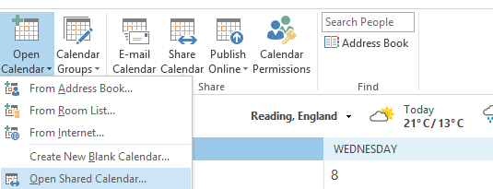
- At the top toolbar, click on Open Calendar, then Open Shared Calendar

- Another window will open. Type in SchoolCalendar and press OK.
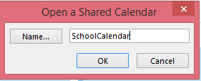

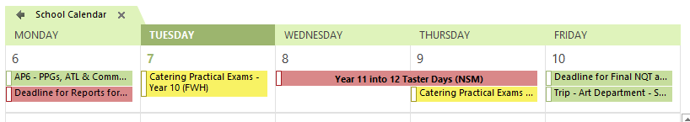
The School Calendar will now appear.

