
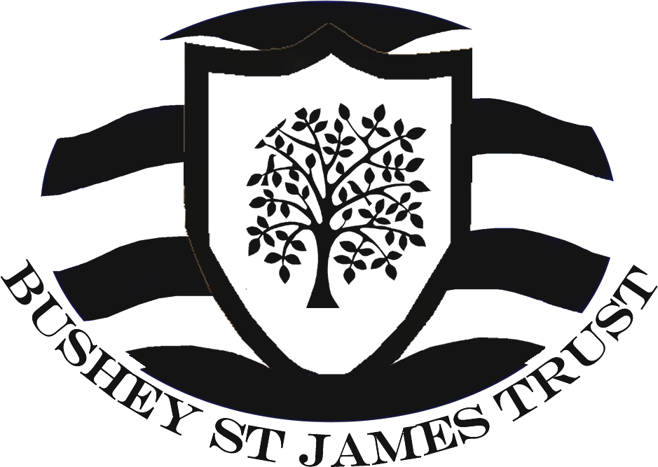

Bushey Meads School
Job Description – Senior IT Technician

Post Title | Senior IT Technician
Purpose | - To provide exceptional third, second and first line support to staff and students, and to enable effective use of the school’s IT systems.  - To maintain a professional and ‘can do’ attitude at all times, and to deliver an impeccable standard of working.  - Develop and maintain the web and content platforms across the Trust. Ensure websites promote the school’s ethos and vision as governed by the senior leadership team, and meet with Ofsted requirements.  - To provide and lead appropriate technical training to staff on allocated training days, and provide one to one training on technologies as required.  - To deputise for the IT Manager on occasion and be able to manage delegated key projects through to completion.  - Act as a mentor and coach to junior members of the IT team.  - Learn new technologies as appropriate and be prepared to take a leading role in the delivery of IT change  - Maintain, support and undertake troubleshooting and diagnostics on network infrastructure, including servers and switches, routers, network cabling and wireless infrastructure.  - To support and trouble shoot issues with Windows servers both physical and virtual (VMware), Windows Desktops 7/10, Apple Mac/iOS, Google Apps for Education, Veeam Backup and Replication, SIMS (Management Information System), Biostore (Biometrics/Cashless), and PS Financials accounting systems.  - To play a key role in maintaining records and documentation of servers, switches and network infrastructure critical to the running of the school’s IT systems.
Reporting to | IT Manager
Liaising with | Governors, Executive Principal/Senior Leadership Team, teaching and associate staff, LA representatives, external agencies, students and parents.
Working Time | 37 hours per week. All year.
Salary/Grade | APT & C Points 23-26 + Fringe allowance, dependent on skills and experience.
Disclosure Barring Service | Enhanced
MAIN (CORE) DUTIES
Strategy | - Ensure the Trust’s IT infrastructure is current and future proofed as far as possible and fully supports the latest curriculum initiatives.  - Plan for major developments of the ICT provision across the Trust, and project manage their  implementation.  - To lead technical training sessions under direction of the IT Manager for teaching and associate staff across the Trust.  - Identify software, hardware and working practices required to fulfil functional  specifications as defined by school staff.  - Maintain an overall view of the capabilities of the school’s ICT service and contribute  to continuous improvement to meet future needs.
Operational, Strategic Planning: | - Provide first, second and third line fault finding, diagnostic and repair services to support IT users.  - To liaise with third party contacts, arrange warranty repairs, and perform diagnostics. Able to escalate where necessary to Local Authority Support Services and Internet Service Provider.  - Deputise for the IT Manager as necessary.  - Drive IT change and development across the Trust  - Make effective use of the school’s IT helpdesk system to respond to support requests, and to maintain records of diagnosis and resolution. Identify where support requests should be escalated internally, or to a third party to achieve resolution.  - Assist with the installation, appropriate configuration and maintenance of IT equipment, infrastructure and software in accordance with relevant regulations, copyright and legal requirements. Ensure change is documented and follows a set configuration procedure where available. Ensure work carried out complies with health and safety requirements.  - Monitor the school’s systems to ensure they are secure and available, and use is in accordance with the respective school’s ICT Acceptable Usage Policy.  - Develop and maintain the web and content platforms of Trust IT systems. To keep the website, learning platform, and digital signage screens up to date and develop aspects as required.  - Maintain an awareness of developments in the IT industry and actively seek to develop and broaden knowledge and skills relevant to the post.  - To perform routine maintenance tasks on the school’s ICT equipment to include computers, printers and other peripherals.  - To monitor, manage and plan for changes in the school’s ICT resource for safe, effective use by students and staff.  - To update and maintain the Asset Database and ensure high value assets are security marked and recorded to comply with financial auditing procedures.  - To install, configure, maintain and administer IT equipment and systems for safe, effective use.  - Management of data backups and archiving of critical systems and data.  - Supporting the management of servers, both physical and virtual including systems upgrades, backups and development of existing systems.
Curriculum Provision and Development: | - To contribute to raising standards of achievement and maximising student attainment with particular regard to IT provision and usage across the Trust.  - To share and support the School’s and Trust’s responsibility to provide and monitor opportunities for personal and academic growth.  - To facilitate and encourage a learning experience which provides students with the opportunity to achieve their individual potential with particular regard to IT provision and usage across the Trust.
Staffing, Staff Development, Recruitment and Deployment of Staff: | - To take part in the school’s staff development programme by participating in arrangements for further training and professional development.  - To work as a member of a designated team and to contribute positively to effective working relations within the school.  - To engage actively in the Performance Appraisal Review process.  - To follow school safeguarding procedures and undertake training as necessary to fulfil this role.
Quality Assurance: | - To adhere to and to help to implement school quality procedures.  - To contribute to the process of monitoring and evaluation of the use of IT in line with school procedures.  - To implement modifications and improvement where required.  - Monitor external contracts to ensure service providers meet or exceed their obligations.
Management Information: | - To maintain appropriate records and to provide relevant, accurate and up-to-date information for the school’s management information system.  - Ensure the Trust’s data is adequately protected and that systems are used in accordance with applicable school policies and legal requirements.  - Ensure systems are secure and documented.  - Review, develop and contribute to the implementation of the Trust’s e-Safety, Data Security and other IT related policies.
Communication: | - To communicate effectively with all stakeholders as required.  - Where appropriate, communicate and co-operate with persons or bodies outside the school.  - To follow agreed policies for communications in the school.  - Attend meetings as required.  - To prepare and provide reports as required.
Marketing and Liaison: | - To support the Trust’s websites and e-learning platforms.
Management of Resources: | - To ensure the stock of consumables and parts are monitored and replenished as necessary.

Other Specific Duties:
- To play a full part in the life of the school community, to support its Strategic Commitment, Purpose and Intent and to encourage students and staff to follow this example.
- To actively promote the school’s policies.
- To continue personal, professional development.
- To actively engage in the school’s self-review and evaluation processes.
- To actively engage in the school’s Appraisal of Performance processes.
- To comply with the school’s Health and Safety Policy and undertake risk assessments as appropriate.
- To attend meetings as determined in the meetings policy and as directed by the Executive Principal.
- To comply with the school’s procedures concerning safeguarding and to ensure that training is accessed.
Whilst every effort has been made to explain the main duties and responsibilities of the post, each individual task undertaken may not be identified. Employees will be expected to comply with any reasonable request from a manager to undertake work of a similar level that is not specified in this job description. Employees are expected to maintain a standard of dress conducive to their position as professionals and in setting an example to students.
This job description is current at the date shown, but following consultation with you, may be changed by Management to reflect or anticipate changes in the job which are commensurate with the salary and job title.

June 2016

