Rebus Quiz: Christmas 2015

1 | 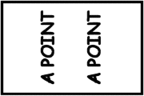
2 | 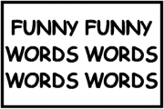
3 | 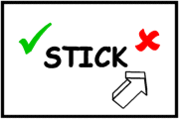
4 | 
5 | Oz & c
6 | 
7 | YALP
8 | important=important
9 | DOX DOX
10 | LEM  ADE
11 | ESROH Riding
12 | R+R
13 | RADANCINGIN
14 | ELEPHANT
15 | SPIBRED
16 | VICE+VICE
17 | ATTENTION
18 | R+R Nacl
19 | Meta Meta Meta Meta
20 | I'M YOU
21 | SOIUDTE
22 | 1. glance  2.  3. glance  4. glance  5. glance
23 | C HIJKLMNO
24 | BIG BIG  IGNORE IGNORE
25 | Pot OOOOOOOO
26 | i<—>i
27 | .__________RANGE
28 | CHAWHOWHORGE
29 | JANOB
30 | POD POD POD
31 | EVELORAT
32 | YOUR YOUR YOUR YOUR YOUR  YOUR YOUR YOUR YOUR YOUR
33 | ci ii
34 | DEEF
35 | FLUGOODENCE
36 | ADNST
37 | KNEE  LIGHT
38 | SUGAR x SUGAR x SUGAR
39 | NNNNSICK
40 | scope
41 | MEDIA MEDIA MEDIA MEDIA MEDIA MEDIA MEDIA MEDIA MEDIA MEDIA MEDIA MEDIA
42 | 10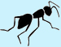
43 | ABCDEFGHIJKLMNOPQRSTVWXYZ
44 | FAMILYYYYYYYY
45 | LANNNNGUAGE
46 | AID AID AID
47 | GOT  GOT  GOT  GOT | HEROES HEROES HEROES HEROES HEROES HEROES HEROES HEROES HEROES HEROES
48 | LEM  S
49 | 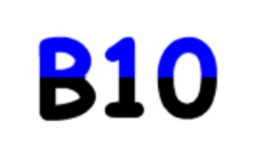
50 | GIVE GIVE GIVE GIVE  GET GET GET GET
51 | NA NA FISH
52 | T RN
53 | 10AC
54 | MEREPEAT

