Battle of Agincourt
From Wikipedia, the free encyclopedia
Battle of Agincourt
Part of the Hundred Years' War
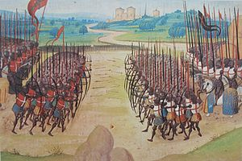
The Battle of Agincourt, 15th-century miniature
Date | 25 October 1415 (Saint Crispin's Day)
Result | Decisive English victory

Belligerents
England | France
Commanders and leaders
- Henry V of England  - Edward of York †  - Humphrey of Lancaster | - Charles d'Albret †  - Jean Le Maingre (POW)  - Charles d'Orleans (POW)
Strength
Modern estimates range from 6,000^{[1]} to 9,000^{[2]}  About ⁵⁄₆ longbow archers, ¹⁄₆ dismounted knights and men-at-arms in heavy armour. | Modern estimates range from 12,000 (outnumbering the English 4–3).^{[2]} to 36,000 (outnumbering the English 6–1;^{[3]} see Numbers at Agincourt.)  About 10,000 knights and men-at-arms (of which about 1,200 were mounted), unknown thousands of other infantry, crossbowmen and archers.
Casualties and losses
At least 112 dead, unknown wounded^{[3]} | 7,000–10,000 (mostly killed) and about 1,500 noble prisoners^{[4]}

The Battle of Agincourt was a major English victory in the Hundred Years' War.^{[a]} The battle occurred on Friday, 25 October 1415 (Saint Crispin's Day), near modern-day Azincourt, in northern France.^{[5][b]} Henry V's victory at Agincourt, against a numerically superior French army, crippled France and started a new period in the war during which Henry married the French king's daughter and Henry's son, Henry VI, was made heir to the throne of France.
Henry V led his troops into battle and participated in hand-to-hand fighting. The French king of the time, Charles VI, did not command the French army himself as he suffered from severe, repeating illnesses and moderate mental incapacitation. Instead, the French were commanded by Constable Charles d'Albret and various prominent French noblemen of the Armagnac party.
This battle is notable for the use of the English longbow in very large numbers, with English and Welsh archers forming most of Henry's army. The battle is also the centrepiece of the play Henry V by William Shakespeare.

Contemporary accounts
The battle of Agincourt is well documented from at least seven contemporary accounts, three of them by eyewitnesses. The approximate location of the battle has never been in dispute and the place remains relatively unaltered even after almost 600 years. Immediately after the battle, Henry summoned the heralds of the two armies who had watched the battle together, and with the principal French herald, Montjoie, settled on the name of the battle as Agincourt, after the nearest fortified place.^{[6]} Two of the most frequently cited accounts come from Burgundian sources: one from Jean Le Fevre de Saint-Remy, who was present at the battle, and the other from Enguerrand de Monstrelet. The English eyewitness account comes from the anonymous Gesta Henrici Quinti, believed to have been written by a chaplain in the King's household, who would have been in the baggage train at the battle.^{[7]} A recent reappraisal of Henry's strategy of the Agincourt campaign incorporates these three accounts, and argues that war was seen as a legal due process for solving the disagreement over claims to the French throne.^{[8]}

Campaign
Main article: Hundred Years War
Henry V invaded France following the failure of negotiations with the French. He claimed the title of King of France through his great-grandfather Edward III, although in practice the English kings were generally prepared to renounce this claim if the French would acknowledge the English claim on Aquitaine and other French lands (the terms of the Treaty of Bretigny).^{[9]} He initially called a Great Council in the spring of 1414 to discuss going to war with France, but the lords insisted that he should negotiate further and moderate his claims. In the following negotiations Henry said that he would give up his claim to the French throne if the French would pay the 1.6 million crowns outstanding from the ransom of John II (who had been captured at the Battle of Poitiers in 1356), and concede English ownership of the lands of Normandy, Touraine, Anjou, Brittany and Flanders, as well as Aquitaine. Henry would marry Princess Catherine, the young daughter of Charles VI, and receive a dowry of 2 million crowns. The French responded with what they considered the generous terms of marriage with Princess Catherine, a dowry of 600,000 crowns, and an enlarged Aquitaine. By 1415, negotiations had ground to a halt, with the English claiming that the French had mocked their claims and ridiculed Henry himself.^{[10]} In December 1414, the English parliament was persuaded to grant Henry a "double subsidy", a tax at twice the traditional rate, to recover his inheritance from the French. On 19 April 1415, Henry again asked the Great Council to sanction war with France, and this time they agreed.^{[11]}
Henry's army landed in northern France on 13 August 1415 and besieged the port of Harfleur with an army of about 12,000. The siege took longer than expected. The town surrendered on 22 September, and the English army did not leave until 8 October. The campaign season was coming to an end, and the English army had suffered many casualties through disease. Rather than retire directly to England for the winter, with his costly expedition resulting in the capture of only one town, Henry decided to march most of his army (roughly 9,000) through Normandy to the port of Calais, the English stronghold in northern France, to demonstrate by his presence in the territory at the head of an army that his right to rule in the duchy was more than a mere abstract legal and historical claim.^{[12]} He also intended the manoeuvre as a deliberate provocation to battle aimed at the dauphin, who had failed to respond to Henry's personal challenge to combat at Harfleur.^{[13]}
The French had raised an army during the siege which assembled around Rouen. This was not strictly a feudal army, but an army paid through a system similar to the English. The French hoped to raise 9,000 troops, but the army was not ready in time to relieve Harfleur. After Henry V marched to the north the French moved to blockade them along the River Somme. They were successful for a time, forcing Henry to move south, away from Calais, to find a ford. The English finally crossed the Somme south of Péronne, at Béthencourt and Voyennes ^{[14][15]} and resumed marching north. Without the river protection, the French were hesitant to force a battle. They shadowed Henry's army while calling a semonce des nobles,^{[16]} calling on local nobles to join the army. By 24 October both armies faced each other for battle, but the French declined, hoping for the arrival of more troops. The two armies spent the night of 24 October on open ground. The next day the French initiated negotiations as a delaying tactic, but Henry ordered his army to advance and to start a battle that, given the state of his army, he would have preferred to avoid, or to fight defensively: that was how Crécy and the other famous longbow victories had been won. The English had very little food, had marched 260 miles (420 km) in two and a half weeks, were suffering from sickness such as dysentery, and faced much larger numbers of well equipped French men at arms. The French army blocked Henry's way to the safety of Calais, however, and delaying battle would only further weaken his tired army and allow more French troops to arrive.^{[17]}

Battle

Preparation
The battle was fought in the narrow strip of open land formed between the woods of Tramecourt and Agincourt (close to the modern village of Azincourt). The French army was positioned at the northern exit so as to bar the way to Calais.^{[citation needed]}
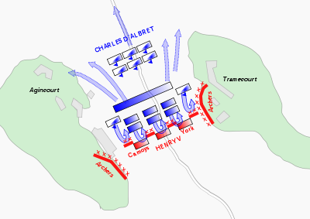
English deployment
Early on the 25th, Henry deployed his army (approximately 1,500 men-at-arms and 7,000 longbowmen; see Numbers at Agincourt) across a 750-yard (690 m) part of the defile. The army was organised into three "battles" or divisions: the vanguard, led by the Duke of York; the main battle led by Henry himself; and the rearguard, led by Lord Camoys. In addition, Sir Thomas Erpingham, one of Henry's most experienced household knights, had a role in marshalling the archers.^{[18]} It is likely that the English adopted their usual battle line of longbowmen on either flank, with men-at-arms and knights in the centre. They may also have deployed some archers in the centre of the line. The English men-at-arms in plate and mail were placed shoulder to shoulder four deep. The English and Welsh archers on the flanks drove pointed wooden stakes, or palings, into the ground at an angle to force cavalry to veer off. This use of stakes may have been inspired by the Battle of Nicopolis of 1396, where forces of the Ottoman Empire used the tactic against French cavalry.^{[c]}
The English made their confessions before the battle, as was customary.^{[19]} Henry, worried about the enemy launching surprise raids, and wanting his troops to remain focused, ordered all his men to spend the night before the battle in silence, on pain of having an ear cut off. He told his men that he would rather die in the coming battle than be captured and ransomed.^{[20]} The men-at-arms on both sides were high-ranking men who knew that if captured they could expect to be ransomed. The English archers, on the other hand, as "commoners", knew they could expect to be killed out of hand by the French if they were defeated, as they were not worth ransoming.^{[citation needed]}
Henry made a speech emphasising the justness of his cause, and reminding his army of previous great defeats the kings of England had inflicted on the French. The Burgundian sources have him concluding the speech by telling his men that the French had boasted that they would cut off two fingers from the right hand of every archer, so that he could never draw a longbow again. Whether this was true is open to question; as previously noted, death was the normal fate of any soldier who could not be ransomed.^{[21]}

French deployment
The French force was not only larger than the English, their noble men-at-arms would have considered themselves superior to the large number of archers in the English army, whom the French (based on their experience in recent memory of using and facing archers) considered relatively insignificant.^{[22]} For example, the chronicler Edmond de Dyntner stated that there were "ten French nobles against one English", ignoring the archers completely.^{[22]} Several French accounts emphasise that the French leaders were so eager to defeat the English (and win the ransoms of the English men-at-arms) that they insisted on being in the first line; as one of the contemporary accounts put it: "All the lords wanted to be in the vanguard, against the opinion of the constable and the experienced knights."^{[23]}
The French were arrayed in three lines or "battles". The first line was led by Constable d'Albret, Marshal Boucicault, and the Dukes of Orléans and Bourbon, with attached cavalry wings under the Count of Vendôme and Sir Clignet de Brebant. The second line was commanded by the Dukes of Bar and Alençon and the Count of Nevers. The third line was under the Counts of Dammartin and Fauconberg.^{[24]} The Burgundian chronicler, Jean de Wavrin, writes that there were 8,000 men-at-arms, 4,000 archers and 1,500 crossbowmen in the vanguard, with two wings of 600 and 800 mounted men-at-arms, and the main battle having "as many knights, esquires and archers as in the vanguard", with the rearguard containing "all of the rest of the men-at-arms".^{[25]} The Herald of Berry uses somewhat different figures of 4,800 men-at-arms in the first line, 3,000 men in the second line, with two "wings" containing 600 mounted men-at-arms each, and a total of "10,000 men-at-arms",^{[26]} but does not mention a third line.
Approximately 8,000 of the heavily armoured French men-at-arms fought on foot, and needed to close the distance to the English army to engage them in hand-to-hand fighting. If they could close the distance, however, they outnumbered the English men-at-arms by more than 5-to-1, and the longbowmen would not be able to shoot into a mêlée without risking hitting their own troops.^{[citation needed]}
Thousands of troops appear to have been in the rearguard, containing servants and commoners whom the French were either unable or unwilling to deploy. Wavrin gives the total French army size as 50,000: "They had plenty of archers and crossbowmen but nobody wanted to let them fire [sic]. The reason for this was that the site was so narrow that there was only enough room for the men-at-arms."^{[27]} A different source says that the French did not even deploy 4,000 of the best crossbowmen “on the pretext they had no need of their help".^{[28]} The rearguard played little part in the battle; English and French accounts agree that many in the French army fled after seeing so many French nobles killed and captured in the fighting.^{[citation needed]}

Terrain
The field of battle was arguably the most significant factor in deciding the outcome. The recently ploughed land hemmed in by dense woodland favoured the English, both because of its narrowness, and because of the thick mud through which the French knights had to walk.^{[29][30]} An analysis by Battlefield Detectives has looked at the crowd dynamics of the battlefield.^{[31]} The 1,000–1,500 English men-at-arms are described as shoulder to shoulder and four deep, which implies a tight line about 250–300 men long (perhaps split in two by a central group of archers). The remainder of the field would have been filled with the longbowmen behind their palings. The French first line contained men-at-arms who had no way to outflank the English line. The French, divided into the three battles, one behind the other at their initial starting position, could not bring all their forces to bear: the initial engagement was between the English army and the first battle line of the French. When the second French battle line started their advance, the soldiers were pushed closer together and their effectiveness was reduced. Casualties in the front line from longbow arrows would also have increased the congestion, as the following men would have to walk around (or over) the fallen.^{[citation needed]}
The Battlefield Detectives episode states that when the density reached four men per square metre, soldiers would not even be able to take full steps forward, lowering the speed of the advance by 70%.^{[31]} Accounts of the battle describe the French engaging the English men-at-arms before being rushed from the sides by the longbowmen as the mêlée developed. The English account in the Gesta Henrici says: "For when some of them, killed when battle was first joined, fall at the front, so great was the undisciplined violence and pressure of the mass of men behind them that the living fell on top of the dead, and others falling on top of the living were killed as well."^{[32]}
Although the French initially pushed the English back, they became so closely packed that they are described as having trouble using their weapons properly. The French monk of St. Denis says: "Their vanguard, composed of about 5,000 men, found itself at first so tightly packed that those who were in the third rank could scarcely use their swords,"^{[33]} and the Burgundian sources have a similar passage. In practice there was not enough room for all these men to fight, and they were unable to respond effectively when the longbowmen joined the hand-to-hand fighting. By the time the second French line arrived, for a total of about eight thousand men (depending on the source), the crush would have been even worse. The press of men arriving from behind actually hindered those fighting at the front.^{[citation needed]}
As the battle was fought on a recently ploughed field, and there had recently been heavy rain leaving it very muddy, it proved very tiring to walk through in full plate armour. The French monk of St. Denis describes the French troops as "marching through the middle of the mud where they sank up to their knees. So they were already overcome with fatigue even before they advanced against the enemy". The deep, soft mud particularly favoured the English force because, once knocked to the ground, the heavily armoured French knights had a hard time getting back up to fight in the mêlée. Barker states that some knights, encumbered by their armour, actually drowned in their helmets.^{[34]} Their limited mobility made them easy targets for the volleys from the archers. The mud also increased the ability of the much more lightly armoured archers to join in hand-to-hand fighting against the French men-at-arms.^{[citation needed]}

Fighting

Opening moves
On the morning of 25 October, the French were still waiting for additional troops to arrive. The Duke of Brabant (about 2,000 men),^{[35]} the Duke of Anjou (about 600 men),^{[35]} and the Duke of Brittany (6,000 men, according to Monstrelet),^{[36]} were all marching to join the army. This left the French with a question of whether or not to advance towards the English.^{[citation needed]}
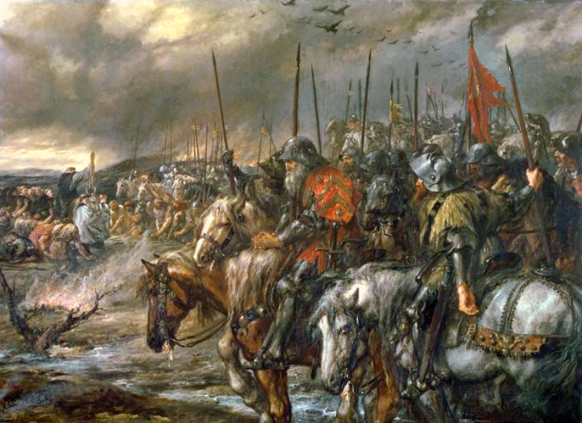
"Morning of the Battle of Agincourt, 25th October 1415", painted by Sir John Gilbert.
For three hours after sunrise there was no fighting. Military textbooks of the time stated: "Everywhere and on all occasions that foot soldiers march against their enemy face to face, those who march lose and those who remain standing still and holding firm win."^{[37]} On top of this, the French were expecting thousands of men to join them if they waited. They were blocking Henry's retreat, and were perfectly happy to wait for as long as it took. There had even been a suggestion that the English would run away rather than give battle when they saw that they would be fighting so many French princes.^{[38]}
Henry's men, on the other hand, were already very weary from hunger, illness and marching. Even though Henry knew as well as the French did that his army would perform better on the defensive, he was eventually forced to take a calculated risk, and move his army farther forward to start the battle.^{[17]} This entailed abandoning his chosen position and pulling out, advancing, and then re-installing the long sharpened wooden stakes pointed outwards toward the enemy, which helped protect the longbowmen from cavalry charges.^{[39]} (The use of stakes was an innovation for the English: during the Battle of Crécy, for example, the archers had been instead protected by pits and other obstacles.^{[40]}) If the French cavalry had charged before the stakes had been hammered back in, the result would probably have been disastrous for the English, as it was at the Battle of Patay. However, the French seem to have been caught off guard by the English advance.^{[citation needed]}
The tightness of the terrain also seems to have restricted the planned deployment of the French forces. The French had originally drawn up a battle plan that had archers and crossbowmen in front of their men-at-arms, with a cavalry force at the rear specifically designed to "fall upon the archers, and use their force to break them,"^{[41]} but in the event, the French archers and crossbowmen were deployed behind and to the sides of the men-at-arms (where they seem to have played almost no part, except possibly for an initial volley of arrows at the start of the battle). The cavalry force, which could have devastated the English line if it had attacked while they moved their stakes, charged only after the initial volley of arrows from the English. It is unclear whether the delay occurred because the French were hoping the English would launch a frontal assault (and were surprised when the English instead started shooting from their new defensive position), or whether the French mounted knights instead did not react quickly enough to the English advance. French chroniclers agree that when the mounted charge did come, it did not contain as many men as it should have; Gilles le Bouvier states that some had wandered off to warm themselves and others were walking or feeding their horses^{[42]}
In any case, within extreme bowshot from the French line (approximately 300 yards (270 m)), the longbowmen dug in their stakes and then opened the engagement with a long range barrage of arrows.^{[citation needed]}

French cavalry attack
The French cavalry, despite being somewhat disorganised and not at full numbers, charged the longbowmen, but it was a disaster, with the French knights unable to outflank the longbowmen (because of the encroaching woodland) and unable to charge through the forest of sharpened stakes that protected the archers. John Keegan argues that the longbows' main influence on the battle at this point was injuries to horses: armoured only on the head, many horses would have become dangerously out of control when struck in the back or flank from the high-elevation long range shots used as the charge started.^{[43]} The mounted charge and subsequent retreat churned up the already muddy terrain between the French and the English. Juliet Barker quotes a contemporary account by a monk of St. Denis who reports how the wounded and panicking horses galloped through the advancing infantry, scattering them and trampling them down in their headlong flight from the battlefield.^{[44]} The Burgundian sources also say that the mounted cavalry retreated back into the forward ranks of French men-at-arms advancing on foot.^{[citation needed]}

Main French assault
The Constable of France himself led the attack of the dismounted French men-at-arms. French accounts describe their vanguard alone as containing about 5,000 men-at-arms, which would have outnumbered the English men-at-arms by more than 3 to 1, but before they could engage in hand-to-hand fighting they had to cross the muddy field under a bombardment of arrows.^{[citation needed]}
The plate armour of the French men-at-arms allowed them to close the 300 yards or so to the English lines while being under what the French monk of Saint Denis described as "a terrifying hail of arrow shot". A complete coat of plate was considered such good protection that shields were generally not used,^{[45]} although the Burgundian contemporary sources specifically distinguish between Frenchmen who used shields and those who did not, and Rogers has suggested that the front elements of the French force may have used axes and shields.^{[46]} Modern historians are somewhat divided on how effective the longbow fire would have been against plate armour of the time, with some modern texts suggesting that arrows could not penetrate, especially the better quality steel armour, but others suggesting arrows could penetrate, especially the poorer quality wrought iron armour. Rogers suggests that the longbow could penetrate a wrought iron breastplate at short range and penetrate the thinner armour on the limbs even at 220 yards (200 m). He considers a knight in the best quality steel armour would have been more or less invulnerable to an arrow on the breastplate or top of the helmet, but would still have been vulnerable to shots hitting the limbs, particularly at close range.^{[47]} In any case, to protect themselves as much as possible from the arrows the French had to lower their visors and bend their helmeted heads to avoid being shot in the face—the eye and air-holes in their helmets were among the weakest points in the armour. This head lowered position restricted both their breathing and their vision. Then they had to walk a few hundred yards through thick mud, a press of comrades and wearing armour weighing 50–60 pounds (23–27 kg). Increasingly they had to walk around or over fallen comrades.^{[48]}
The surviving French men-at-arms reached the front of the English line and pushed it back, with the longbowmen on the flanks continuing to shoot at point blank range. When the archers ran out of arrows they dropped their bows and using hatchets, swords and the mallets they had used to drive their stakes in, attacked the now disordered, fatigued and wounded French men-at-arms massed in front of them. The French could not cope with the thousands of lightly armoured longbowmen assailants (who were much less hindered by the mud and weight of their armour) combined with the English men-at-arms. The impact of thousands of arrows, combined with the slog in heavy armour through the mud, the heat and lack of oxygen in plate armour with the visor down, and the crush of their numbers meant the French men-at-arms could "scarcely lift their weapons" when they finally engaged the English line.^{[49]} The exhausted French men-at-arms are described as being knocked to the ground by the English and then unable to get back up. As the mêlée developed, the French second line also joined the attack, but they too were swallowed up, with the narrow terrain meaning the extra numbers could not be used effectively. Rogers suggests that the French at the back of their deep formation would have been attempting to push forward and quite literally add their weight to the advance, without realising that they were hindering the ability of those at the front to manoeuvre and fight, actually pushing them into the English formation of lancepoints. After the initial wave, the French would have had to fight over and on the bodies of those who had fallen before them. In such a "press" of thousands of men, Rogers finds it plausible that a significant number could have suffocated in their armour, as is described by several sources, and is also known to have happened in other battles.^{[50]}
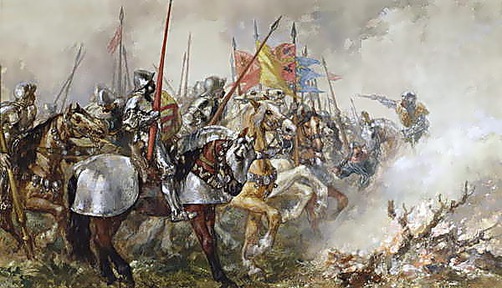King Henry V at the Battle of Agincourt, 1415, by Sir John Gilbert.

The French men-at-arms were taken prisoner or killed in their thousands. The fighting lasted about three hours, but eventually the leaders of the second line were killed or captured, as those of the first line had been. The English Gesta Henrici describes three great heaps of the slain around the three main English standards.^{[32]} According to contemporary English accounts, Henry was directly involved in the hand-to-hand fighting. Upon hearing that his youngest brother Humphrey, Duke of Gloucester had been wounded in the groin, Henry took his household guard and stood over his brother, in the front rank of the fighting, until Humphrey could be dragged to safety. The king received an axe blow to the head which knocked off a piece of the crown that formed part of his helmet.^{[51]}

Attack on the English baggage train
The only French success was an attack on the lightly protected English baggage train, with Ysembart d'Azincourt (leading a small number of men-at-arms and varlets plus about 600 peasants) seizing some of Henry's personal treasures, including a crown.^{[52]} Whether this was part of a deliberate French plan or an act of local brigandage is unclear from the sources. Certainly, d'Azincourt was a local knight but he may have been chosen to lead the attack because of his local knowledge and the lack of availability of a more senior soldier.^{[53]} In some accounts the attack happened towards the end of the battle, and led the English to think they were being attacked from the rear. Barker, following the Gesta Henrici, believed to have been written by an English chaplain who was actually in the baggage train, concludes that the attack happened at the start of the battle.^{[53]}

Henry orders the killing of the prisoners
Regardless of when the baggage assault happened, at some point after the initial English victory Henry became alarmed that the French were regrouping for another attack. The Gesta Henrici places this after the English had overcome the onslaught of the French men-at-arms and the weary English troops were eyeing the French rearguard ("in incomparable number and still fresh"^{[32]}). Le Fevre and Wavrin similarly say that it was signs of the French rearguard regrouping and "marching forward in battle order" which made the English think they were still in danger.^{[54]}
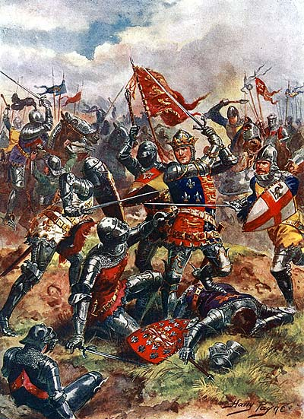Henry V at the Battle of Agincourt : The King wears on this surcoat the Royal Arms of England, quartered with the Fleur de Lys of France as a symbol of his claim to the throne of France.
In any event, Henry ordered the slaughter of what were perhaps several thousand French prisoners, sparing only the most high ranked (presumably those most likely to fetch a large ransom under the chivalric system of warfare). According to most chroniclers, Henry's fear was that the prisoners (who, in an unusual turn of events, actually outnumbered their captors) would realize their advantage in numbers, rearm themselves with the weapons strewn about the field and overwhelm the exhausted English forces. Although ruthless, Henry's decision was thus arguably justifiable given the situation of the battle; even the French chroniclers do not criticise him for it.^{[55]} In his study of the battle, John Keegan ^{[56]} argued that the main aim was not to actually kill the French knights but rather to terrorise them into submission and quell any possibility they might resume the fight, which would probably have caused the uncommitted French reserve forces to join the fray, as well. Such an event would have posed a mortal risk to the still-outnumbered English and could have easily turned a stunning victory into a mutually-destructive defeat, as the English forces were now largely intermingled with the French and would have suffered grievously from the arrows of their own longbowmen had they needed to resume shooting. Keegan also speculated that due to the relatively low number of archers actually involved in killing the French knights (roughly 200 by his estimate), together with the refusal of the English knights to assist in a duty they saw as distastefully unchivalrous and combined with the sheer difficulty of killing such a large number of prisoners in such a short space of time, the actual number of French knights killed might not have even reached the hundreds before the reserves fled the field and Henry called an end to the slaughter.^{[57]}
This action marked the end of the battle, as the French reserves, having seen so many of their nobility captured and killed, lost all hope of victory and promptly fled the battlefield.^{[citation needed]}

Aftermath
The lack of reliable sources makes it impossible to give a precise figure for the French and English casualties. However, it is clear that though the English were outnumbered, their losses were far lower than those of the French. The French sources all give 4,000–10,000 French dead, with up to 1,600 English dead. The lowest ratio in these French sources has the French losing six times more men than the English. The English sources vary between about 1,500 and 11,000 for the French dead, with English dead put at no more than 100.^{[58]}
Barker identifies from the available records "at least" 112 Englishmen who died in the fighting (including Edward of Norwich, 2nd Duke of York, a grandson of Edward III),^{[3]} but this excludes the wounded. One widely used estimate puts the English casualties at 450, not an insignificant number in an army of about 8,500, but far fewer than the thousands the French lost, nearly all of whom were killed or captured. Using the lowest French estimate of their own dead of 4,000 would imply a ratio of nearly 9 to 1 in favour of the English, or over 10 to 1 if the prisoners are included.^{[59]}
The French suffered heavily. Three dukes, at least eight counts, a viscount, and an archbishop died, along with numerous other nobles. Of the great royal office holders, France lost her Constable, Admiral, Master of the Crossbowmen and prévôt of the marshals.^{[60]} The baillis of nine major northern towns were killed, often along with their sons, relatives and supporters. In the words of Juliet Barker, the battle "cut a great swath through the natural leaders of French society in Artois, Ponthieu, Normandy, Picardy." ^{[61]} Estimates of the number of prisoners vary between 700 and 2,200, amongst them the Duke of Orléans (the famous poet Charles d'Orléans) and Jean Le Maingre (known as Boucicault) Marshal of France.^{[62]} Almost all these prisoners would have been nobles, as the less valuable prisoners were slaughtered.^{[citation needed]}
Although the victory had been militarily decisive, its impact was complex. It did not lead to further English conquests immediately as Henry's priority was to return to England, which he did on 16 November, to be received in triumph in London on the 23rd.^{[63]} Henry returned a conquering hero, in the eyes of his subjects and European powers outside France, blessed by God. It established the legitimacy of the Lancastrian monarchy and the future campaigns of Henry to pursue his "rights and privileges" in France.^{[64]} Other benefits to the English were longer term. Very quickly after the battle, the fragile truce between the Armagnac and Burgundian factions broke down. The brunt of the battle had fallen on the Armagnacs and it was they who suffered the majority of senior casualties and carried the blame for the defeat. The Burgundians seized on the opportunity and within 10 days of the battle had mustered their armies and marched on Paris.^{[65]} This lack of unity in France would allow Henry eighteen months to prepare militarily and politically for a renewed campaign. When that campaign took place, it was made easier by the damage done to the political and military structures of Normandy by the battle.^{[66]}
It took several years' more campaigning, but Henry was eventually able to fulfil all his objectives. He was recognised by the French in the Treaty of Troyes (1420) as the regent and heir to the French throne. This was cemented by his marriage to Catherine of Valois, the daughter of King Charles VI. However, Henry died at the age of thirty-six, two months before King Charles, thus he never actually became King of France. His infant son Henry VI technically became King of France on the death of Charles two months later, but the English regency only had effective control of the north of the country, with the Dauphin based in the south and also claiming the throne.^{[citation needed]}

Notable casualties

French
Notable casualties (most named by Enguerrand de Monstrelet^{[67]}) include:^{[68]}
Leading officers:^{[citation needed]}
- Charles I d'Albret, Count of Dreux, the Constable of France^{[69]}
- Jacques de Châtillon, Lord of Dampierre, the Admiral of France
- David de Rambures, the Grand Master of Crossbowmen
- Guichard Dauphin, Master of the Royal Household
Three dukes:
- Antoine of Burgundy, Duke of Brabant and Limburg, and consort Duke of Luxembourg^{[69]} (a brother of John the Fearless, Duke of Burgundy)
- John I, Duke of Alençon-Perche,^{[69]} the second-in-command after d'Albret.
- Edward III, Duke of Bar^{[69]} (along with his brother and nephew)
Seven counts (eight with d'Albret):^{[citation needed]}
- Philip of Burgundy, Count of Nevers and Rethel (another brother of John the Fearless)
- Frederick of Lorraine, Count of Vaudémont (brother of Charles II, Duke of Lorraine)
- Robert of Bar, Count of Marle and Soissons (nephew of Edward III, Duke of Bar).
- John VI, Count of Roucy
- Waleran III of Luxembourg, Count of Ligny and Saint-Pol (called "Count of Fauqemberg" in the chronicles)
- Edward II, Count of Grandpré
- Henry II, Count of Blâmont
and some 90 bannerets and others, including:^{[citation needed]}
- Jean de Montaigu, Archbishop of Sens
- John of Bar, Lord of Puisaye (brother of Edward III of Bar)
- Jean I de Croÿ, Lord of Croÿ-d'Araines and two of his sons, John and Archambaud
- Jean de Béthune, Lord of Marueil.
- Jan I van Brederode

English
Notable casualties included:
- Edward of Norwich, 2nd Duke of York (b. 1373)^{[70]}
- Michael de la Pole, 3rd Earl of Suffolk^{[71]}
- Dafydd Gam (Davy Gam) Welsh hero who reputedly saved Henry V's life at Agincourt^{[72]}

Prisoners
Among the circa 1,500 prisoners taken by the English, were the following French notables:^{[citation needed]}
- Jean Le Maingre ("Boucicaut"), the Marshal of France.
- Charles of Artois (Count of Eu), the French Lieutenant of Normandy and Guyenne.
- John of Bourbon (Duke of Bourbon-Auvergne-Forez), probably the greatest lord of southern France
- Charles of Orleans (Duke of Orleans-Blois-Valois), a great lord of central France, titular head of the "Armagnac" party. (his brother, John of Orleans (Count of Angoulême-Périgord), another great lord, had been in English captivity since 1412).
- Louis de Bourbon (Count of Vendôme)
- Arthur de Richemont, brother of John VI, Duke of Brittany, step-brother of Henry V (he was the son of Joan of Navarre, dowager-queen of England).

Numbers at Agincourt
Anne Curry in her 2005 book Agincourt: A New History, argues (based on research into the surviving administrative records) that the French army was about 12,000 strong, and the English army about 9,000, giving odds of 4–3.^{[2]} By contrast, Juliet Barker in her Agincourt: The King, the Campaign, the Battle (also published in 2005) argues the English and Welsh were outnumbered "at least four to one and possibly as much as six to one".^{[73]} She suggests figures of about 6,000 for the English and 36,000 for the French, based on the Gesta Henrici '​s figures of 5,000 archers and 900 men-at-arms for the English, and Jean de Wavrin's statement "that the French were six times more numerous than the English".^{[74]} The 2009 Encyclopædia Britannica uses the figures of about 6,000 for the English and 20,000 to 30,000 for the French. The 1911 Britannica used somewhat different figures of 6,000 archers, 1,000 men-at-arms and "a few thousands of other foot" for the English, with the French outnumbering them by "at least four times".^{[citation needed]}
With one of the lowest estimates for the size of the French army and also one of the highest estimates for the size of the English army, Curry is currently in a minority in suggesting that the odds were as near equal as 4–3. While not necessarily agreeing with the exact numbers Curry uses, some historians have however given support to her assertion that the French army was much smaller than traditionally thought, and the English somewhat bigger. Bertrand Schnerb, a professor of medieval history at the University of Lille, has said that he thinks the French probably had 12,000–15,000 troops.^{[75]} Ian Mortimer, in his 2009 book 1415: Henry V's Year of Glory, notes how Curry "minimises French numbers (by limiting her figures to those in the basic army and a few specific additional companies) and maximises English numbers (by assuming the numbers sent home from Harfleur were no greater than sick lists)", but agrees that previous estimates have exaggerated the odds, and suggests that "the most extreme imbalance which is credible is fifteen thousand French troops against 8,100 English: a ratio of about two-to-one".^{[76]}
However, Clifford J. Rogers, professor of history at the United States Military Academy at West Point, has recently argued that archival records are too incomplete to substantially change his view that the English were outnumbered about 4–1.^{[75][77]} Juliet Barker also disagrees with Curry's arguments in the acknowledgements section of her 2005 book on Agincourt, saying: "Surviving administrative records on both sides, but especially the French, are simply too incomplete to support [Curry's] assertion that nine thousand English were pitted against an army only twelve thousand strong. And if the differential really was as low as three to four then this makes a nonsense of the course of the battle as described by eyewitnesses and contemporaries."^{[78]}
Those supporting a greater imbalance have generally put more store by contemporary (and especially eyewitness) accounts. The Gesta Henrici gives plausible figures for the English of 5,000 archers and 900 men-at-arms, but Mortimer notes it is "wildly inaccurate" in stating the English were outnumbered 30–1, and there have also been doubts as to how much it was written as propaganda for Henry V. The proportions also seem incorrect, as from surviving records we know that Henry set out with about four times as many archers as men-at-arms, not five and a half times as many. Those who have supported the Gesta figures for the English army have generally thought that although the English army may have left Harfleur with eight or nine thousand men, it is plausible that after weeks of campaigning and disease in hostile territory they would have lost two or three thousand fighting men; however Mortimer states: "Despite the trials of the march, Henry had lost very few men to illness or death; and we have independent testimony that no more than 160 had been captured on the way." ^{[79]}
As Mortimer notes, the Burgundian numbers for the size of the French vanguard of 8,000 men-at-arms in the vanguard with 1,400 (or 2,400) men-at-arms in the wings correspond roughly with the figures of ten thousand men-at-arms recorded by the duke of Berry's herald. The Burgundians also recorded 4,000 archers and 1,500 crossbowmen in the "vanguard", which would suggest "fourteen or fifteen thousand fighting men".^{[79]} (It should be noted that the Burgundians actually give the total size of the French army as an implausible 50,000,^{[80]} and the numbers they use do not correspond closely to the odds they describe. Using very similar numbers, Jean Le Fevre states that the English were outnumbered 3–1, whereas Wavrin states that the English were outnumbered 6–1.^{[81]})
One particular cause of confusion may have been the number of servants on both sides. Mortimer suggests that because there were a much higher proportion of men-at-arms on the French side, the number of non-combatants was much higher. Each man-at-arms could be expected to have a page, who would have ridden one of his spare horses. If the French army had an extra 10,000 mounted men (as opposed to only 1,500 extra for the English), then "the English probably did see an army about three times the size of their own fighting force".^{[82]}
It is open to debate whether these should all be counted as non-combatants; Rogers (for example) accepts that the French probably had about 10,000 men-at-arms, but explicitly includes one "gros valet" (an armed, armoured and mounted military servant) per French man-at-arms in his calculation of the odds.^{[83]} There may therefore be less difference between some of these different historians' positions on the numerical odds than there initially appears, given that the various accounts generally agree that the battle was almost entirely fought between the French men-at-arms and the English army, with French crossbowmen, archers, and other infantry playing little or no part.^{[citation needed]}

Popular representations
Soon after the English victory at Agincourt, a number of popular folk songs were created about the battle, the most famous being the Agincourt Carol, produced in the first half of the 15th century.^{[84]} Other ballads followed, including King Henry Fifth's Conquest of France, raising the popular prominence of particular events mentioned only in passing by the original chroniclers, such as the gift of tennis balls before the campaign.^{[85]}
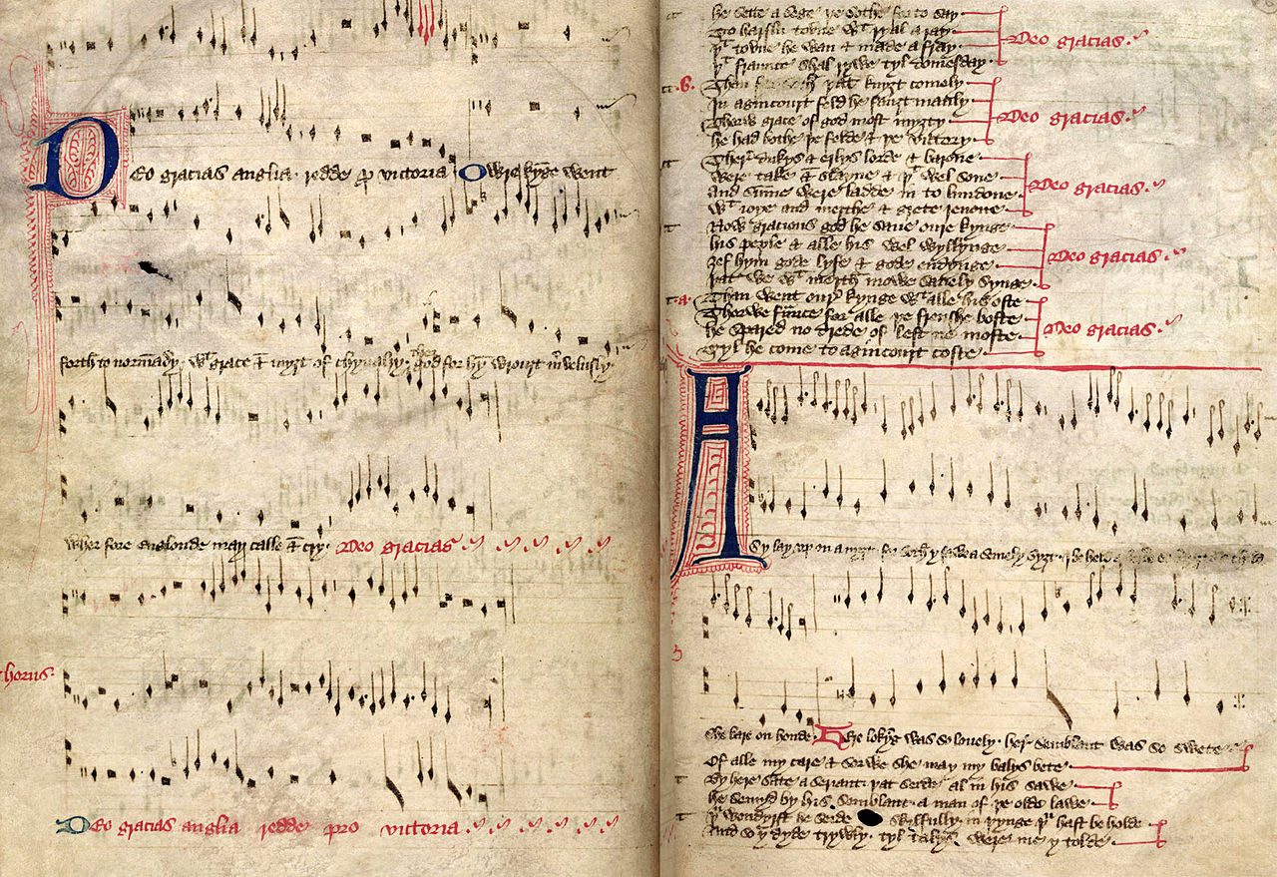 The 15th century Agincourt Carol
The most famous cultural depiction of the battle today, however, is through William Shakespeare's Henry V, written in 1599. The play focuses on the pressures of kingship, the tensions between how a king should appear – chivalric, honest and just – and how a king must sometimes act – Machiavellian and ruthless.^{[86]} These tensions are illustrated in the play by Shakespeare's depiction of Henry's decision to kill some of the French prisoners, whilst attempting to justify it and distance himself from the event – this moment of the battle is portrayed both as a break with the traditions of chivalry, and as key example of the paradox of kingship.^{[87]} Shakespeare's depiction of the battle also plays on the theme of modernity – Shakespeare contrasts the modern, English king and his army with the medieval, chivalric, older model of the French.^{[88]} Shakespeare's play presented Henry as leading a truly British force into battle, playing on the importance of the link between the monarch and the common soldiers in the fight.^{[89]} The original play does not, however, feature any scenes of the actual battle itself, leading critic Rose Zimbardo to characterise it as "full of warfare, yet empty of conflict."^{[90]}
The play introduced the famous St Crispin's Day Speech; Shakespeare has Henry give a moving narration to his soldiers just before the battle, urging his "band of brothers" to stand together in the forthcoming fight.^{[91]} One of Shakespeare's most heroic speeches, critic David Margolies describes how it "oozes honour, military glory, love of country and self-sacrifice", and it forms one of the first instances of English literature linking solidarity and comradeship to success in battle.^{[91][92]} Partially as a result, the battle was used as a metaphor at the beginning of the First World War, when the British Expeditionary Force's attempts to stop the German advances were widely likened to it.^{[93]}
Shakespeare's version of the battle of Agincourt has been turned into (several minor and) two major films – by Laurence Olivier in 1944, and by Kenneth Branagh in 1989. Made just prior to the invasion of Normandy, Olivier's gives the battle what Sarah Hatchuel has termed an "exhilarating and heroic" tone, with an artificial, cinematic look to the battle scenes.^{[94]} Branagh's version gives a longer, more Realist portrayal of the battle itself, drawing on both historical sources and images from the Vietnam and Falkland Wars.^{[95]} In his film adaptation, Peter Babakitis uses digital effects to exaggerate realist features during his battle scenes, producing a more avant-garde interpretation of the fighting at Agincourt.^{[96]} ^{[clarification needed]}
The battle remains an important symbol in popular culture. For example, a mock trial of Henry V for the crimes associated with the slaughter of the prisoners was held in Washington, D.C. in March 2010, drawing from both the historical record and Shakespeare's play. Participating as judges were Justices Samuel Alito and Ruth Bader Ginsburg. The trial ranged widely over whether there was just cause for war and not simply the prisoner issue. Although an audience vote was "too close to call", Henry was unanimously found guilty by the court on the basis of "evolving standards of civil society".^{[97][98][99]}

