Build Hyper-V Virtual Lab – Part 4 – Validate Hyper-V Lab Configuration
Posted on January 5, 2012 by mike
This article is the final part of a four part series describing how to build a Hyper-V Virtual Lab. In Part 1, we added the Hyper-V Role to our physical host and configured the Virtual Network. In Part 2, we added internet connectivity to our Hyper-V Virtual Lab by adding network address translation (NAT) functionality using Windows Server 2008 R2′s RRAS functionality. In Part 3, we created the server that will act as our domain controller. This server has the Active Directory Domain Services, DNS Server, and DHCP Server roles enabled.
Here is the outline for this article:

Part 4 – Validate Hyper-V Lab Configuration
- Hyper-V Domain Controller – Review Settings and Event Logs
- Hyper-V Domain Controller – Best Practice Analyzer
- Active Directory Domain Services Best Practices Analyzer
- DNS Server Best Practices Analyzer

Hyper-V Domain Controller – Review Settings and Event Logs
Now that the Active Directory Domain Services, DHCP Server, and DNS Server roles have been added to our Hyper-V Lab server, let’s look through some of the event logs and verify that everything is working properly.
There will be some errors and warnings in the event viewer, so let’s look at those.
- The Server Manager should already be up, but if not, run it with Start->Administrative Tools->Server Manager. The status screen looks a little scary with yellow explamation points and red X’s. Let’s look at each individual error to see what is really going on.
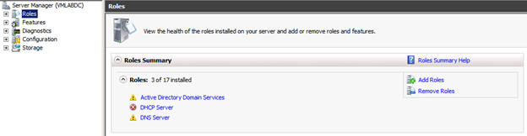
- Click “Active Directory Domain Services”. This will display a list of Events and running System Services. Notice the events since the last time you restarted this machine. There should be a few information messages, and one Warning. The warning should be Event ID 2886. Double Click on it.
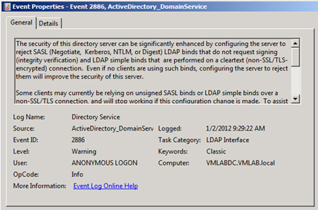
This warning is Windows Server 2008 R2 giving a strong recommendation for increasing security. This isn’t critical for our lab environment, so this warning is expected here. Click Close.
- Click DHCP Server in the “Roles” section under Server Manager. This will also display a list of Events. There should be one warning (Event ID 10020) since the last time we restarted this server. Double click on it.
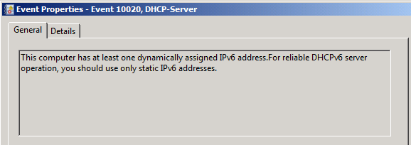
This warning says this server has a dynamic IPv6 address. As with IPv4 IP addresses, a domain controller should have a static IPv6 address. This lab isn’t configured for IPv6, so we can ignore this warning also. Click Close.
- Click DNS Server in the “Roles” section under Server Manager. This will display a list of events and system services associated with the DNS Server. There should be one warning (Event ID 4013) since the last time this server was restarted. Double click on it.
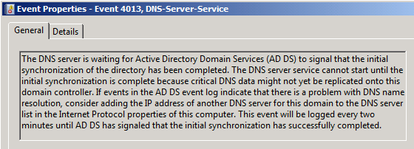
This error states that the DNS server is waiting for Active Directory Domain Services (AD DS) to signal that initial directory synchronization has occurred. This error will be repeated every two minutes until it’s completed. Simply put, one instance of this error is fine. It takes a bit of time for the initial synchronization to occur.

Hyper-V Domain Controller – Best Practice Analyzer
Now that the lab is functional, let’s go through some of the basic tools to look at the services and improve their configuration. To do this we’ll take advantage of Windows Server 2008 R2′s Best Practice Analyzer feature for roles that support it.

Active Directory Domain Services Best Practices Analyzer
- Click “Active Directory Domain Services” in the Roles section under Server Manager.
- Scroll down and click “Scan This Role” in the Best Practices Analyzer section. Windows Server 2008 R2 will take some time scanning the role and display the results.
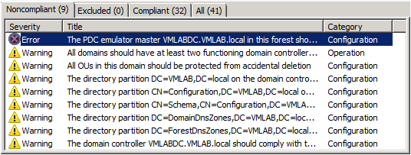

- The results above show one error and a number of warnings. Double click on the error.
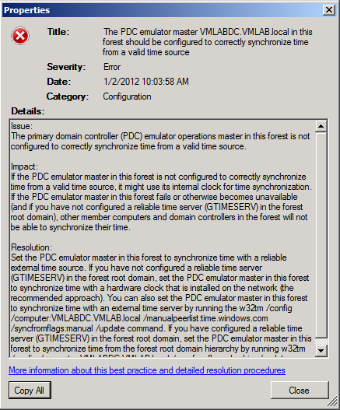
This error states that this domain controller isn’t configured to have an authoritative time source. A time source is critical for a domain environment to insure accurate database synchronization. Our lab environment only has a single domain controller, so this isn’t critical, however, let’s set one up so it will work properly if we do.
- This Domain Controller will be the authoritative time source for it’s domain, so it needs to be configured to get it’s time from an external reliable source. In addition, the virtual machine needs to be configured to not synchronize it’s time with the physical host. We’ll configure this server to use the pool of NTP servers maintained by ntp.org. This pool balances the load across many authoritative time sources and will use servers physically close to this server.
- Open a command prompt by using Start -> Accessories -> Command Prompt.
- Type (or cut and paste) the following (all on one line):
w32tm /config /syncfromflags:manual /manualpeerlist:0.pool.ntp.org,1.pool.ntp.org,2.pool.ntp.org,3.pool.ntp.org
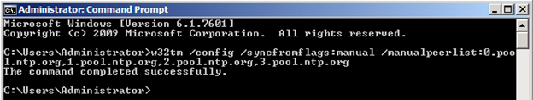
- Rerun the Active Directory Domain Services Best Practices Analyzer and this error will no longer be there.
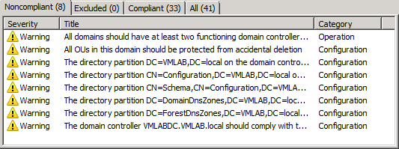
The remaining warnings indicate that this domain should have multiple domain controllers, hasn’t been backed up recently, and is running as a virtual machine. All of these are OK for our Hyper-V Virtual Lab environment.
- Now we should disable time synchronization for this VM. On the Host machine run the Hyper-V Manager (Start -> Administrative Tools -> Hyper-V Manager).
- Right Click on the VMLABDC virtual machine in the Virtual Machines list and select Settings.

- Select Integration Services under the Management section, and unselect the “Time synchronization” option and then select OK.
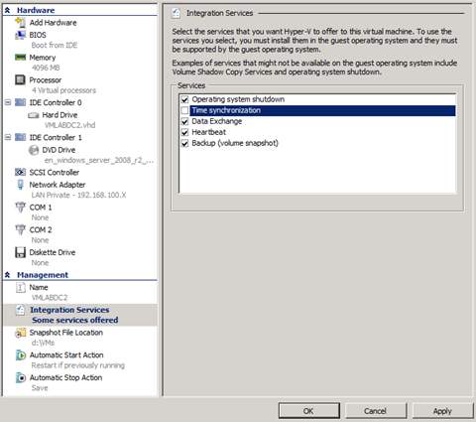

DNS Server Best Practices Analyzer
- Click “DNS Server” in the Roles section under Server Manager.
- Scroll down and click “Scan This Role” in the Best Practices Analyzer section. Windows Server 2008 R2 will take some time scanning the role and display the results.
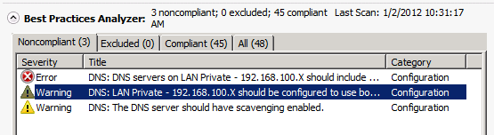

- The DNS Server Best Practices Analyzer will show the following error:
DNS: DNS servers on LAN Private – 192.168.100.X should include the loopback address, but not as the first entry.
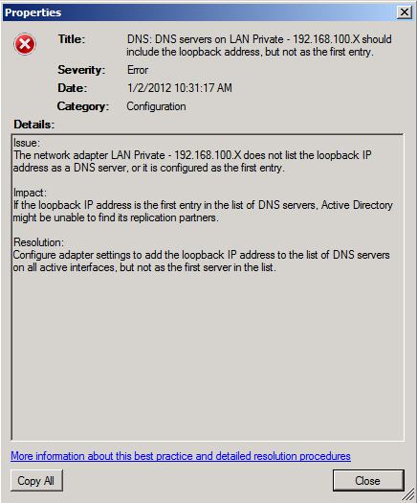
Microsoft does recommend that DNS servers include the loopback address in the list of DNS servers. Let’s go fix that. Click Close.
- Click Start -> Right Click Network -> Properties to open the Network and Sharing Center.
- Click “LAN Private – 192.168.100.X” in the Active networks section.
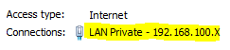
- Click Properties.
- Select Internet Protocol Version 4 (TCP/IPv4) (don’t uncheck it) and click Properties.
- Enter 127.0.0.1 in the Alternate DNS server field.
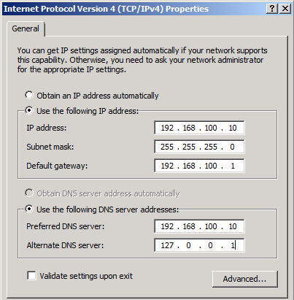
- Click OK to save the entry.

