Build Hyper-V Virtual Lab – Part 3 – Domain Controller
Posted on January 5, 2012 by mike
This article is the third in a four part series describing how to build a Hyper-V Virtual Lab. In Part 1, we added the Hyper-V Role to our physical host and configured the Virtual Network. In Part 2, we added internet connectivity to our Hyper-V Virtual Lab by adding network address translation (NAT) functionality using Windows Server 2008 R2′s RRAS functionality. In Part 3, we’ll create the server that will act as our domain controller. This server will have the Active Directory Domain Services, DNS Server, and DHCP Server roles enabled.
Here is the outline for this article:

Part 3 – Hyper-V Lab Domain Controller
- Create Hyper-V Virtual Lab Domain Controller
- Create New Hyper-V Virtual Machine
- Build Hyper-V Domain Controller – Install Base Windows Server 2008 R2
- Hyper-V Domain Controller – Configure LAN Adapter
- Hyper-V Domain Controller – Rename Server
- Hyper-V Domain Controller – Add Active Directory Domain Services Role
- Hyper-V Domain Controller – Add DHCP Server Role

Create Hyper-V Virtual Lab Domain Controller
The first server we create in our Hyper-V Virtual is the domain controller. This server will host the primary roles needed for any domain environment. For our simplified Hyper-V Virtual Lab, these are Active Directory Domain Services, DNS Server, and DHCP Server roles.
We’ll create a relatively powerful virtual machine to support the setup process that includes 4GB of RAM and four processors. After we’ve created the VM, we can scale back the VM memory and processors depending on what else we’re doing within this Hyper-V Virtual Lab.

Create Hyper-V Virtual Machine
- Create new VM named VMDC
  - 4GB – New Hard drive – 30GB
  - Don’t install OS
- Edit Virtual Machine
  - Edit Virtual Machine – 4 procs.
  - Network Adapter #1: LAN Private – 192.168.100.X
  - Attach Install ISO – Windows Server 2008 R2 with SP1 (downloaded from MSDN, Technet, or BizSpark)

Build Hyper-V Domain Controller – Install Base Windows Server 2008 R2
In this step it’s time to install the base Windows Server 2008 R2 configuration.
- Start the virtual machine created above.
- Run through the default Full Installation
- Choose custom installation and select the new disk we created above.

Hyper-V Domain Controller – Configure LAN Adapter
This server is our Domain Controller, DHCP Server, and DNS so it will need a static IP address. So in this step we’ll rename the LAN Adapter to something meaningful and setup the static IP address for this adapter.
- Start->Right click Network -> Properties.
- Select Change adapter settings.
- There is only one adapter, so right click and choose to “Rename” and name it “LAN Private – 192.168.100.X”
- Right Click the other connection and name it “LAN Private – 192.168.100.X”
- Right Click the “LAN Private – 192.168.100.X” adapter and select Properties.
- Select the “Internet Protocol Version 4 (TPC/IPv4)” item (don’t uncheck it) and click properties.
- Click “Use the following IP address:”
- Click on the IP Address: field and enter “192.168.100.10″.
- Hit Tab and windows will fill in the subnet mask of 255.255.255.0.
- Set the Default gateway to “192.168.100.1″
- Set the Preferred DNS Server to “192.168.100.10″. This server will be the DNS for our Hyper-V Virtual Lab, so the DNS should point to itself.

Hyper-V Domain Controller – Rename Server
Now, let’s rename this new virtual machine to a more meaningful name.
- Start-Right Click Computer -> Properties
- Click Change Settings
- Change Description to “VM Lab DC”
- Click Change…
- Change Computer Name to “VMLABDC”
- Restart the computer.
Note that this server still won’t have network access until we’ve added and configured the DNS Server role below.

Hyper-V Domain Controller – Add Active Directory Domain Services Role
Now that we have the basic server setup, it’s time to add the DC and DNS roles so that this server can be the hub of our Hyper-V Virtual Lab environment.
- Start->Administrative Tools -> Server Manager to launch the Windows Server 2008 R2 Server Manager utility.
- Click on “Roles” under Server Manager (VMLABDC).
- Click “Add roles” to launch the Add Roles Wizard. This step provides some standard warnings to make sure that this system is secure. You’ve already set a strong password when installing the OS, we configured the static IP above, and we’ll run Windows Update once we have network connectivity.
- Click Next.
- Check the Active Directory Domain Services box. This will bring up a warning saying that the .Net Framework 3.5.1 Features need to be installed.
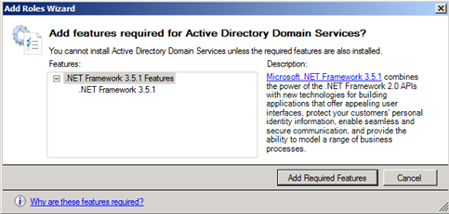
- Select “Add Required Features”
- Select “Next >” to start configuring Active Directory Domain Services. Windows Server 2008 R2 Add Roles Wizard will display an overview of adding the domain services.
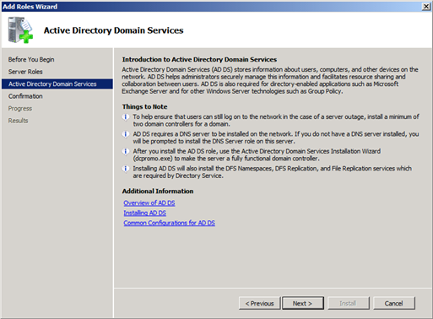
- Select “Next >” to advance past this step.
- Select “Install” to begin the Active Directory Domain Services installation. The wizard will then display a progress bar as it installs both the Domain Services and the .NET Framework 3.5.1 features.

- Select “Close” to clear the Installation Results screen.
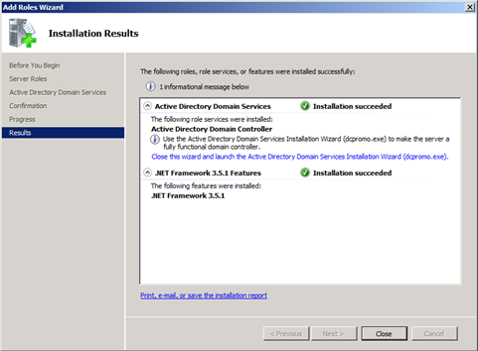
- Select “Go to Active Directory Domain Services” from the Server Manager Active Directory Domain Services pane.
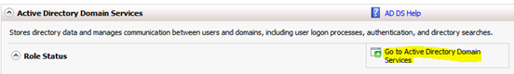
- Select “Run the Active Directory Domain Services Installation Wizard (dc promo.exe).” This will launch the DCPROMO wizard that will allow this server to operate as a domain controller.
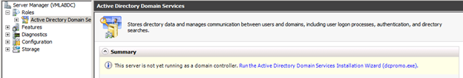

- This will launch the “Active Directory Domain Services Installation Wizard” that will make this server a domain controller. Don’t check “Use advanced mode installation”.
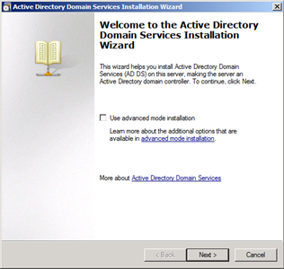
- Click “Next” and the wizard will display an Operating System Compatibility warning.
- Click “Next” to advance to the Deployment Configuration step.
- Select “Create a new domain in a new forest” and “Next”. We will create a new forest specifically for our lab environment.
- Enter “VMLAB.Local” and select “Next”. VMLAB.Local is the name of our Hyper-V Test lab domain. Microsoft recommends using local as the top level domain, however, if you’re using Macintoshes to connect to the test network, then it’s best to use a different top level domain (like “lan”) so that Mac clients don’t require additional configuration.

- Select “Windows Server 2008 R2″ for the Forest functional level. This means this test lab can only contain domain controllers that are Windows Server 2008 R2, but since we want to test the features new to R2, this makes sense. If your test lab will include other versions of Windows Server, then pick the appropriate level.
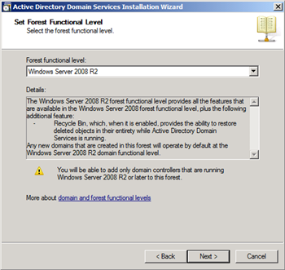
- Click “Next.” To add a DNS server. It’s recommended that the first domain controller include a DNS Server service, so we want to install that with this server.
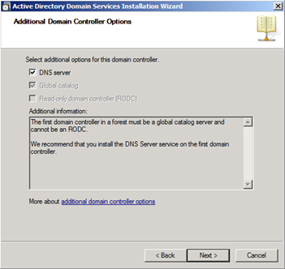
- The Active Directory Domain Services Installation Wizard will now display an error stating:
“A delegation for this DNS server cannot be created because the authoritative parent zone cannot be found or it does not run Windows DNS server. If you are integrating with an existing DNS infrastructure, you should manually create a delegation to this DNS server in the parent zone to ensure reliable name resolution from outside the domain “VMLAB.local”. Otherwise, no action is required.” Our Hyper-V Virtual Lab uses it’s own address space and then uses the RRAS NAT to connect to the internet, we don’t need to worry about this error and can continue. Choose “Yes” to continue.
- Choose “Next” to accept the default locations for the active directory database, log files, and SYSVOL. For our lab, we’ll accept the defaults. For a production domain controller, you would want to create a separate volume that would contain these directories.
- Enter a strong password for the Directory Services Restore Mode Administrator account. This account is different than the the Administrator account and is used when when the domain controller is started in Directory Services Restore Mode. After entering the password twice, click “Next”.
- Click “Next” to continue the Active Directory Domain Services Installation Wizard past the summary screen.
- The wizard will now display a status screen as it configures all of the services of the services associated with the Active Directory Domain Services Installation.
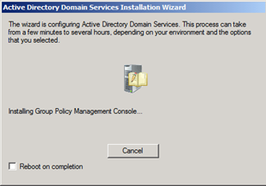
- Click “Finish” to close out this wizard.
- Select “Restart Now” to reboot the server.

When the server VM restarts it will have network connectivity to the internet via the VMNAT VM that is running RRAS. You can now run Windows Update if you would like.

Hyper-V Domain Controller – Add DHCP Server Role
Add DHCP Server – for local LAB environment.
- Roles -> Add Role –> DHCP Server
- Next to start Add DHCP Role wizard
- Next to clear Introduction to DHCP Server step.
The Dynamic Host Configuration Protocol allows servers to assign, or lease, IP addresses to computers and other devices that are enabled as DHCP clients. Deploying a DHCP server on the network provides computers and other TCP/IP-based network devices with valid IP addresses and the additional configuration paramaters these devices need, called DHCP options. This allows computers and devices to connect to other network resources such as DNS servers and routers.
There are a few notes on this introduction screen also:
You should configure at least one static IP address on this computer. – This server has a static IP address that we configured earlier in this guide.
Before you install DHCP Server, you should plan your subnets, scopes, and exclusions. Make a record of the plan in a safe place for later reference. – This lab has a very simple networking topology that we document in this guide.

- Click “Next” to accept continue past the Select Network Connection Bindings step. There is only one network connection in our lab environment and it is selected by default. Notice the Details section at the bottom of that lists the Name and Network Adapter for this setting. Our descriptive names “LAN Private – 192.168.100.X” are shown.
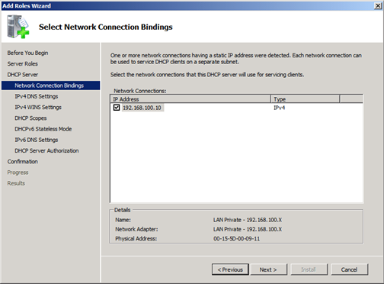

- The next step for adding the DHCP Role is to Specify IPv4 DNS Server Settings. The Parent domain is prepopulated with VMLAB.local which is correct. For the Preferred DNS server IPv4 address, the wizard is suggesting using the loopback IP address. Since this server is the DNS server for our Hyper-V lab environment, we use the static IP for this server here. Enter “192.168.100.10″ in the Preferred DNS server IPv4 address field. Leave the Alternate DNS server IPv4 address field blank. Click “Next” to advance to the Specify IPv4 WINS Server Settings step.
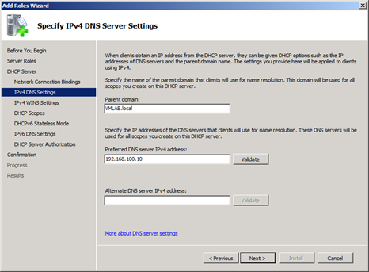
- Click “Next” to advance past the “Specify IPv4 WINS Server Settings” step. WINS servers are needed for legacy applications and Windows networking environments. Our lab doesn’t’ need this service. If you need WINS for this Hyper-V lab environment, then you’d add that role on this server and enter it’s static IP address 192.168.100.10 in the “Preferred WINS server IP address” field. The Alternate WINS server IP address field would be left blank. The DHCP server will then supply this IP address to clients it assigns IP address to.
- The next step is to Add or Edit DHCP Scopes. A DHCP scope is a pool of IP addresses, such as 192.168.100.100 to 192.168.100.250, that the DHCP server can lease to clients. This range must be continuous. Click “Add..” to add the DHCP scope for this Hyper-V Lab networking environment.

- Enter the following into the Add Scope dialog:
  - Scope Name: VMLAB – Private Network
  - Starting IP address: 192.168.100.100
  - Ending IP address: 192.168.100.250
  - Subnet type: Wired (lease duration will be 8 days) – this is the default.
  - Activate this scope: checked – this is the default.
  - Subnet mask: 255.255.255.0 – this is the default.
  - Default gateway (optional): 192.168.100.1
These options tell the DHCP server to assign addresses in this range. Addresses below 100 are excluded so we can use these for static IP addresses or other uses (possibly wireless IP addresses).
Click “OK” to continue.
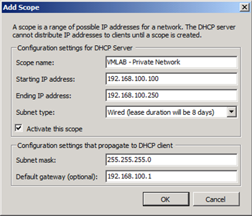
- Verify the summary looks correct and click “Next >” to advance to the next step.
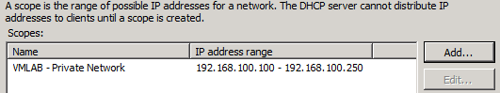
- Click “Next >” to accept the default settings for DHCPv6 Stateless Mode. We’re not configuring this lab environment for IPv6 clients, so the default works here.
- Click “Next >” to accept the default IPv6 DNS Server Settings.
- The next step is to Authorize the DHCP Server. Active Directory Domain Services (AD DS) maintains a list of authorized DHCP servers to service clients. Specifically authorizing the server prevents rogue servers from being introduced into the environment. The default setting “Use current credentials” is correct since we’re logged in as an Administrator. Click “Next >” to advance to the Confirmation step.
- Click “Install” to Confirm the Installation Selections for the DHCP Server Role.
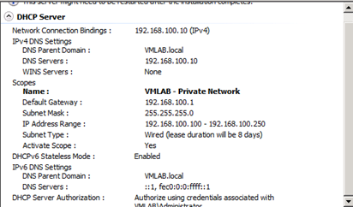
- The DCHP Server role has now been added to this this Windows Server 2008 R2 domain controller server in our Hyper-V lab environment. Click “Close”.
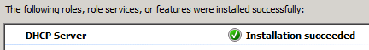
- Restart the server.

