Build Hyper-V Virtual Lab – Part 2 – Internet Connectivity
Posted on January 5, 2012 by mike
This article is the second of four articles describing how to build a Hyper-V Virtual Lab. In Part 1, we added the Hyper-V Role to our physical host and configured the Virtual Network. In Part 2, we’ll add internet connectivity to our Hyper-V Virtual Lab by adding network address translation (NAT) functionality using Windows Server 2008 R2′s RRAS functionality.
Here is an outline for this article:

Part 2 – Hyper-V Lab Internet Connectivity
- Create Hyper-V NAT Using RRAS
- Create New Virtual Machine
- Create Hyper-V RRAS Server – Install Base Windows Server 2008 R2
- Create Hyper-V RRAS Server – Configure LAN Adapters
- Create Hyper-V RRAS Server – Rename Server
- Create Hyper-V RRAS Server – Add RRAS Role

Hyper-V Virtual Lab – Create Hyper-V NAT Using RRAS
Now that the Hyper-V Virtual Networks are setup, it’s time to create the NAT that will connect the new virtual Lab LAN with the external LAN. Windows Server 2008 R2 includes this software NAT function with the Remote Access Service role. We’ll now create a new Hyper-V virtual machine that will provide this service. This may be a little overkill, but it helps create a nice encapsulated Hyper-V Virtual Lab environment.
We’ll create a relatively powerful virtual machine to support the setup process that includes 4GB of RAM and four processors. After we’ve created the VM, we can scale back the VM to 1GB of memory and 2 Virtual Processors.

Create New Hyper-V Virtual Machine:
- Create new VM named VMNAT
  - 4GB – New Hard drive – 20GB
  - Don’t install OS
- Edit Virtual Machine
  - Edit Virtual Machine – 4 procs.
  - Network Adapter #1: LAN Exernal – Shared – Intel Pro 1
  - Network Adapter #2: LAN Private – 192.168.100.X
  - Attach Install ISO – Windows Server 2008 R2 with SP1 (downloaded from MSDN, Technet, or BizSpark)
After making these changes the Virtual Machine Settings will look something like:
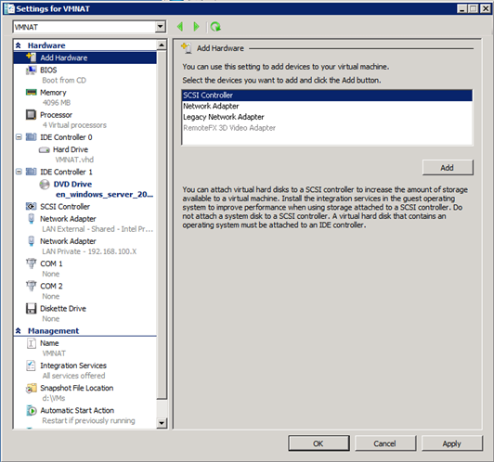

Create Hyper-V RRAS Server – Install Base Windows Server 2008 R2
In this step it’s time to install the base Windows Server 2008 R2 configuration.
- Start the virtual machine created above.
- Run through the default Full Installation
- Choose custom installation and select the new disk we created above.

Create Hyper-V RRAS Server – Configure LAN Adapters
The default names that Windows Server 2008 gives to adapters under Hyper-V aren’t very useful. So now is the time to name them something meaning that will make further configuration much more understandable.
- Start->Right click Network -> Properties
There will be two adapters listed , both with not very meaningful names.
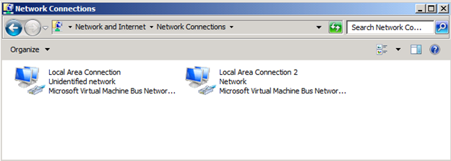
Notice that one of the networks says “Unidentified” and the other says “Network”. If you right click on the “Network” one and choose Status and then Details, you’ll notice that it has a valid IP address within your physical LAN.
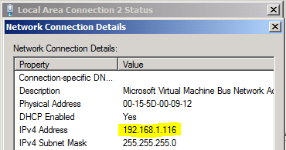
This adapter is connected the “LAN External – Shared Intel Pro 1″ virtual network. So let’s name it that.
- Right Click the connection identified above and select “Rename”. Type in “LAN External – Shared – Intel Pro 1″ to match the network name.
- Right Click the other connection and name it “LAN Private – 192.168.100.X”
- Right Click the “LAN Private – 192.168.100.X” adapter and select Properties.
- Select the “Internet Protocol Version 4 (TPC/IPv4)” item (don’t uncheck it) and click properties.
- Click “Use the following IP address:”
- Click on the IP Address: field and enter “192.168.100.1″.
- Hit Tab and windows will fill in the subnet mask of 255.255.255.0.
- Leave the default gateway and DNS Server entries blank and Click OK.

Create Hyper-V RRAS Server – Rename Server
The default name that Hyper-V gives a new virtual machine isn’t very descriptive. So in this step we rename this Hyper-V Virtual Machine “VM NAT”. It’s important that the machine match the Routing and Remote Access function that this Hyper-V VM is running.
These may be the simplest steps outlined, but here they are:
- Start-Right Click Computer -> Properties
- Click Change Settings
- Change Description to “VM NAT”
- Click Change…
- Change Computer Name to “VMNAT”
- Run Windows Update (Optional)
- Restart the computer.

Create Hyper-V RRAS Server – Add RRAS Role
RRAS – Routing and Remote Access Service – provides multiprotocol LAN-to-LAN, LAN-to-WAN, virtual private network (VPN), Dial-up and NAT (network address translation) services. In this configuration, we use a very simple configuration to provide a NAT for our Hyper-V Virtual Lab to access the host networking environment to access the internet.
The RRAS server will connect to both the private lab network (LAN Private – 192.168.100.X) and the external network (LAN External – Shared – Intel Pro 1). All machines connected to our internal network will be able to access this Hyper-V RRAS Server to connect to the internet.
To add the RRAS Role to our Hyper-V NAT we use the following steps:
- Click on Start > Administrative Tools > Server Manager
- Select Roles, Click on Add Roles, Select Network Policies and Access Services – RRAS is a component of NPAS and Click Next
- Click Next on Information Page and Select Routing and Remote Access Services
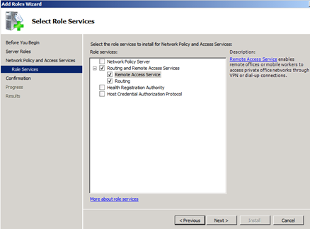

- Click on Next, Click on Install and Click on Close to close the Add Roles Wizard.
- Click on Start > Administrative Tools > Routing and Remote Access. This will bring RRAS console
- Select the server VMNAT (local). Notice that Server has red down arrow which means that RRAS is not enabled and configured.
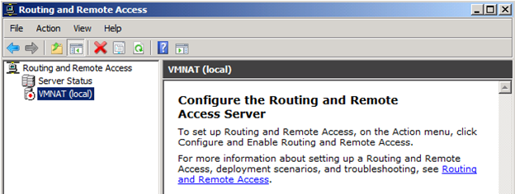
- Right click on VMNAT (Local) and select Configure and Enable Routing and Remote Access to launch the Routing and Remote Access Server Setup Wizard. Click on Next to start the wizard.
- Select Network address translation (NAT) and click Next. The Windows Server 2008 R2 Routing and Remote Access Server Network address translation (NAT) feature allows the clients on our internal private to share the same internet connection.
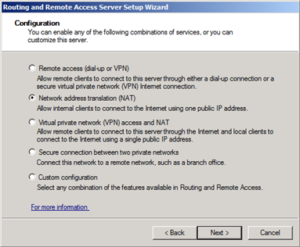

- Select “Use this public interface to connect to the Internet:” and then choose the LAN External – Shared – Intel Pro 1 from the Network Interfaces list. Click Next.
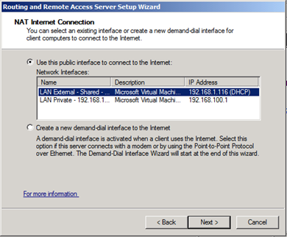
- Select “Enable basic name and address services” and click Next. This option causes Routing and Remote Access to assign addresses automatically and forward name resolution requests to a DNS server on the Internet.
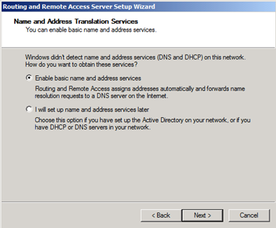
- Select Next to accept the Address Assignment Range and Finish to actually configure the Routing and Remote Access Server.
We’re now finished creating the Routing and Remote Access Server to provide NAT access to our internal clients within our Hyper-V Virtual lab. Since this VM only runs NAT services, it’s most efficient to edit the VM to only allocate 1GB of RAM and 2 processors to this service.
Now it’s time to create the first server in our Hyper-V Virtual Lab, which will be our Windows Server 2008 R2 domain controller.

