Opening and Selecting Task type

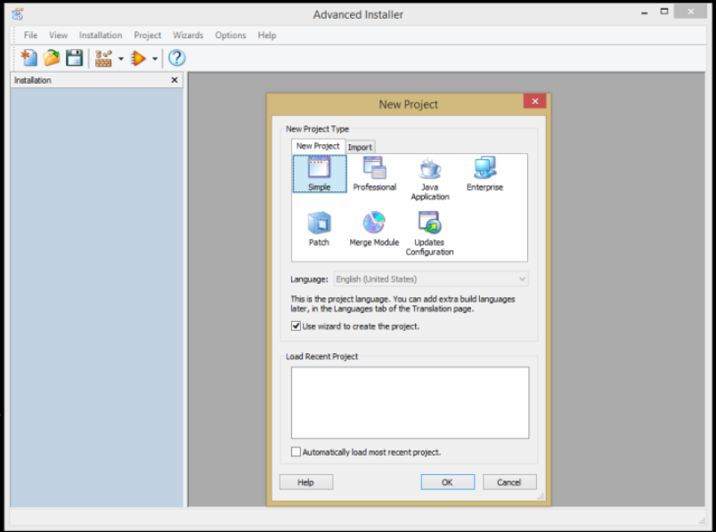
For most MSI packaging simple is fine (most of the professional features are not usable in the free version)
Using the wizard is the easiest option or you can close it and use it without, if you are using the wizard there are a couple of bits you need to do after for the install paths etc.

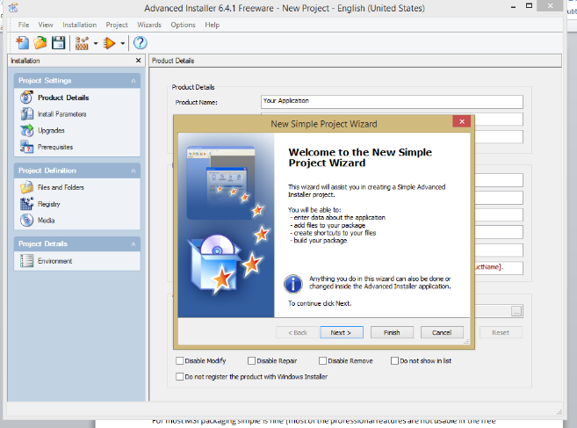
Starting the “wizard” after selecting simple

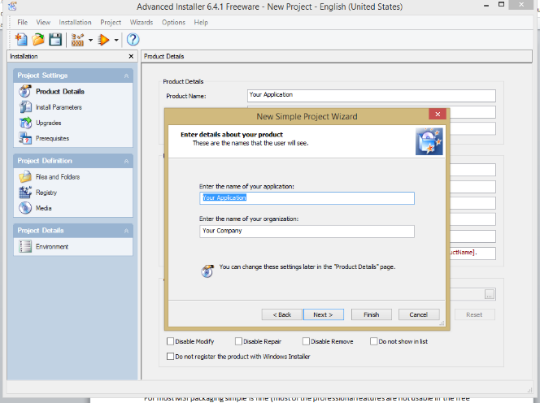
Give your application a name you can fill in your organisation name here as well if you wish.
This can be changed later after the package has been built if it needs to be updated.

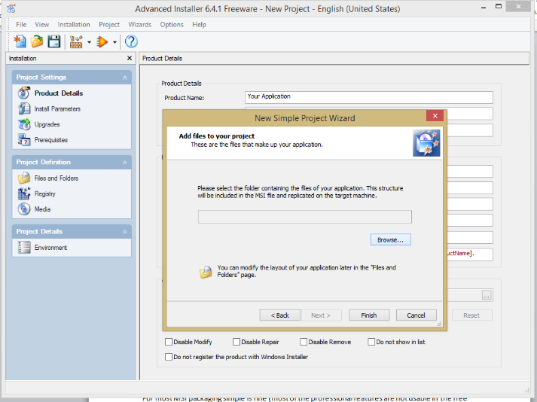
Next stage is to select the location of the application you are looking to package into an MSI is already installed on your computer.

For this example im going to be packaging paintshop pro 5, its already on my PC and it also runs happily from the directory without the need for extra dependencies.

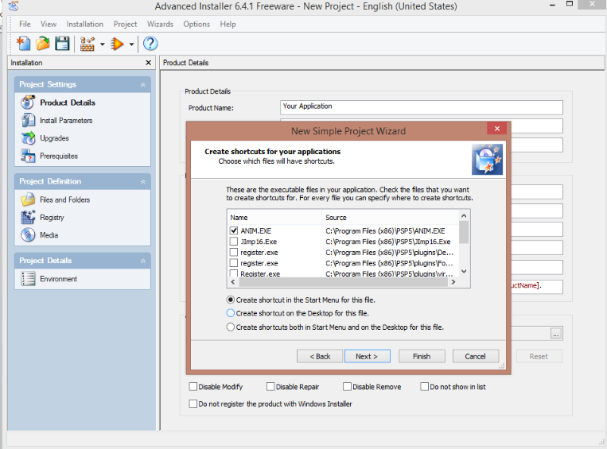
After scanning the directory it will ask you to select which applications you wish to create shortcuts for, Paint Shop Pro has two applications in it which I want to use so these are both ticked.

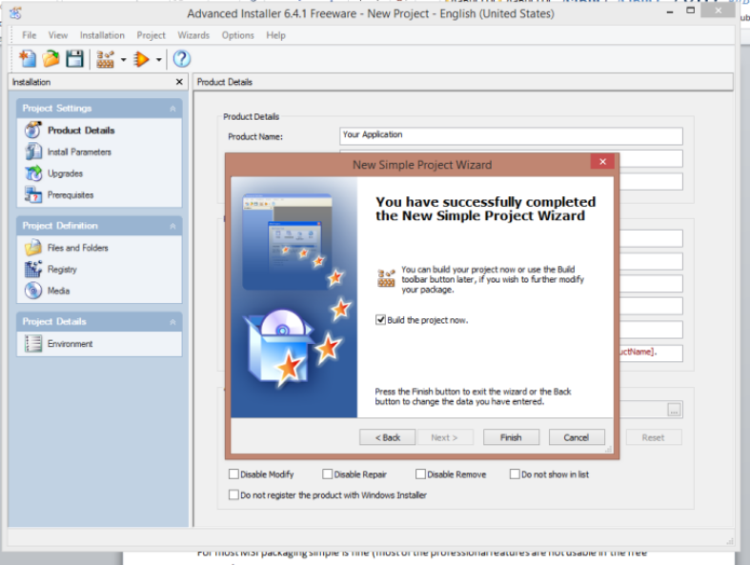
Once you have selected the .EXE you want to create shortcuts for the wizard is complete, make sure the “build package now” bos is ticked

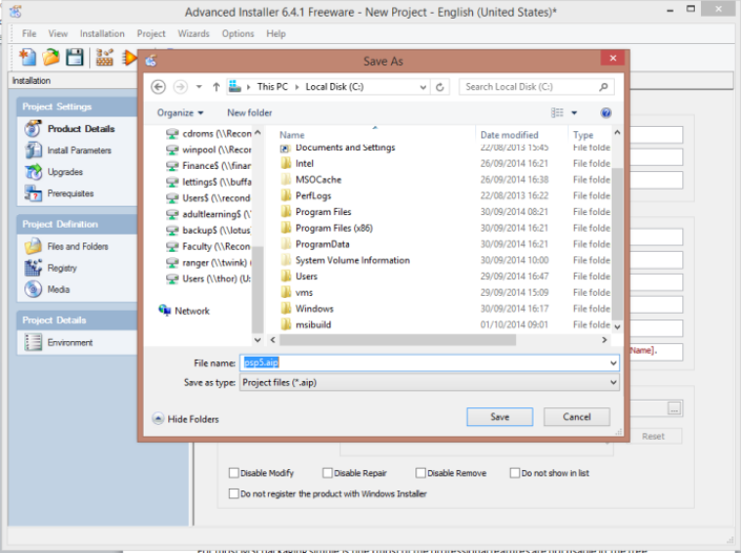
It will ask where you wish to save the “project” I have created an “MSIBUILD” folder on my C:\ Drive.
Give the project a name so PSP5.aip in my case

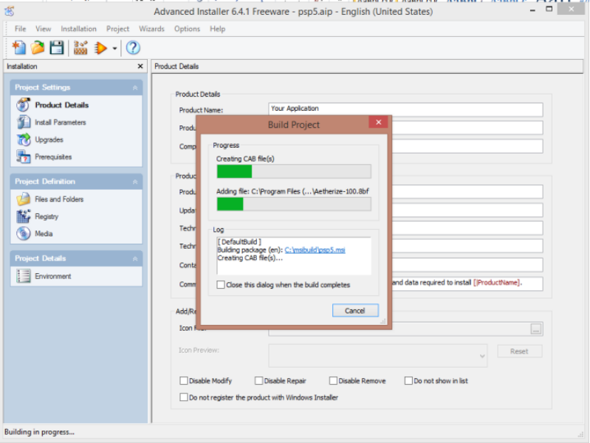

After clicking save the package will be built.
The wizard will close and you be left with the next screen, this is where you can change items in the package.

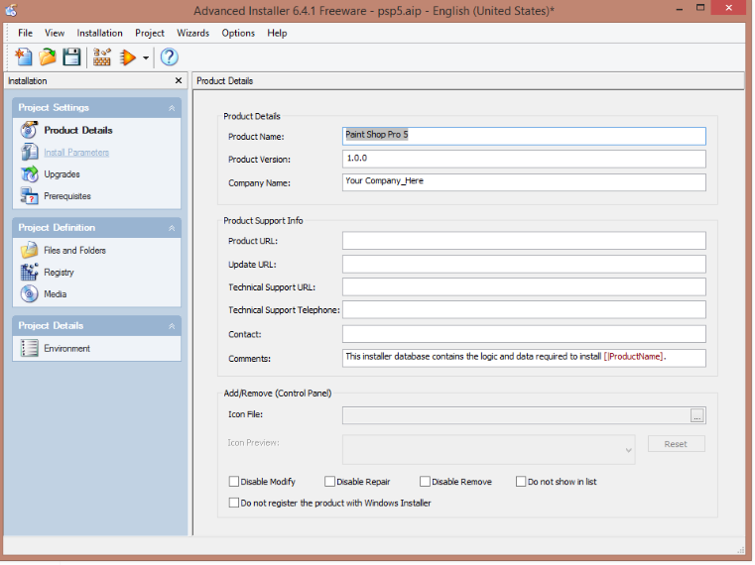

So here you can change the package name
Install parameters
Upgrade options ect.

I mentioned earlier that you will need to change an option so the package installs into the folder you expect.
Under install Parameters of you look at the installation folders the application folder looks like
[ProgramFilesFolder][Manufacturer]\[ProductName]
if you leave it as default the MSI will install to
C:\program files\your company name\application name

To prevent this (if you wish to) remove the Manufacturer from the path so it looks like this [ProgramFilesFolder]\[ProductName]

I don’t tend to change many options other than that you can however use the packager to modify shortcuts the registry entries which are added to the machine if you wish.
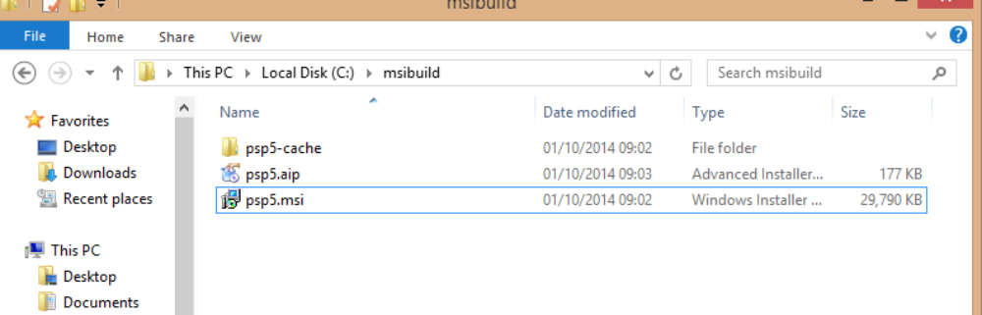

Ok so you have built your package but where is it, if you look at your MSIBUILD folder it will look like below.

-Cache:
is all the files relating to the application and is used by the package file to build the MSI (think of it in the same way moviemaker uses a project file to build the movie, if the project file can’t read the cache the movie can’t be made. Don’t remove this

.AIP:
Is the project file which advanced installer reads when you are modifying or creating the package everytime you make a change to a package it saves it back to here (any changes you make you must ensure the package is rebuilt using the build button on the toolbar of advanced installer, looks like a half built wall) don’t remove this or you will not be able to change the created MSI as advanced installer wont know what it is building and you will have to start again

.MSI:
Assuming your package built without an issue this is your created MSI and should install the application, it is worth testing that it installs manually 1st without issue. Every time you make changes to the project file and build the MSI the changes are automatically saved.

