RM Asus miniBook – First Look

At first glance the Research Machines (RM) Asus miniBook doesn’t seem like much, tiny at 22.5 cm wide, 16.5 cm deep, just 3.5 cm high, and all less than 1KG in weight. Coupled with a white plastic chassis, 7 inch screen and what seemed to be keyboard keys far too small to be used comfortably, it looks more like an oversized PDA or advanced digital photo frame.

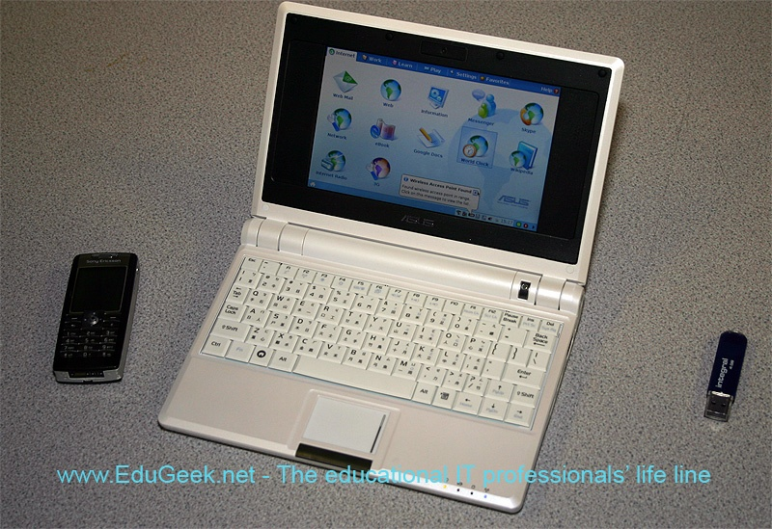
It’s only once you switch it on and use it for a few minutes that you begin to realise your jaw has dropped without you even knowing. The miniBook is something rather special.
The version we played with (the only one in the country as far as we know) was powered by a 900Mhz Celeron-M and having 512MB of RAM it runs the custom Debian Linux core and applications all running from a 4GB RAM drive with almost zero effort.
A quick look around the chassis reveals a plethora of ports and connectivity that makes it better supported than some of its far more expensive big brand sub notebooks. It has 3 USB 2.0 ports, 802.11b/g wireless, as well as a standard LAN port and a modem to ensure that you can connect from almost anywhere. A VGA connector, SD card slot and headphone socket fill up the remaining space around the chassis. There is no CD or DVD drive on this device, and to be frank, it doesn’t need one. It also has 2 speakers mounted either side of the screen to assist the miniBook in video conferencing with its inbuilt webcam and with multimedia functions, of which the miniBook is very well equipped.
When you fire up the miniBook the first thing you really notice is the boot time, or lack of it. In fact, you will probably shut it down and reboot it just to make sure you weren’t bringing it out of sleep mode it is that fast. The 4GB RAM drive is ideally suited to this kind of device.

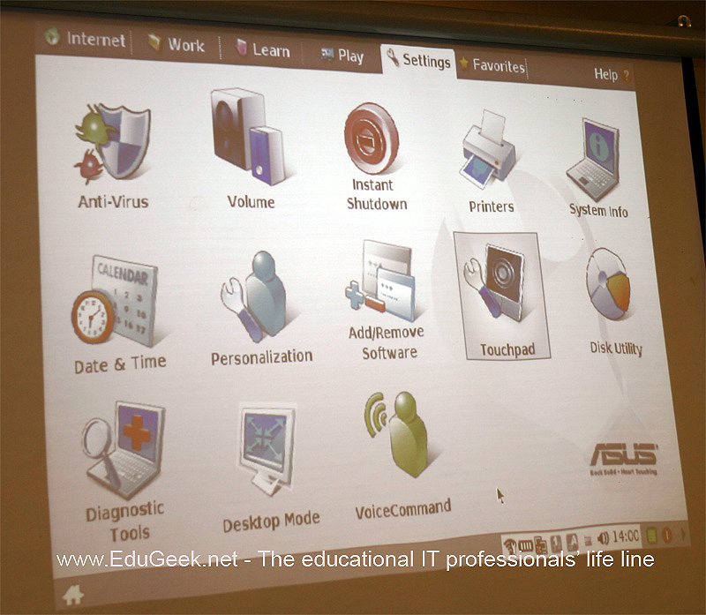
Once the OS has loaded you are presented with what can only be described as a tabbed desktop with a taskbar at the bottom of the screen. The tabs, labelled, Internet, Work, Learn, Play, Settings, Favourites, and of course Help are all stuffed with icons enabling you to perform almost any task you can think of. Selecting the settings tab reveals access to a host of features from the mundane volume control to the useful ‘Add\Remove Programs’ which uses a graphical apt utility to automatically download and install any extra applications you require. Unfortunately we did not have time to see this in operation. Other bundled apps include Open Office 2.0, an anti-virus package, media and music players plus Thunderbird as the mail client and Firefox as the default browser making everything in this little powerhouse as familiar as the icons being used to launch any of the miniBooks’ applications.
It is obvious from the very moment you start to use the miniBook that a great deal of time and effort has gone into its development. Nothing is hidden (well, we couldn’t find a terminal, but we only had it for an hour or so!) all of the available features are easy to find and it is obvious that it is aimed at guiding Windows users without losing them. Connectivity too has been closely looked at with a built in Skype client, Gmail and Hotmail connectors a multi platform instant messaging client.
What is not clear is exactly what type of device it is and where it sits in the PDA, laptop chain. Dave Leach from Research Machines gave us a presentation where RM firmly place it as an ‘access device’ rather than a productivity tool. And access it can. We successfully had it connected to a Sun Secure Global Desktop Connection over a wireless link. For mobile users it may possibly be ideal lightweight thin client.

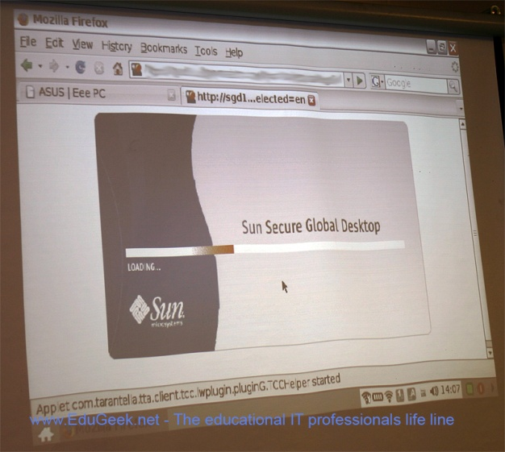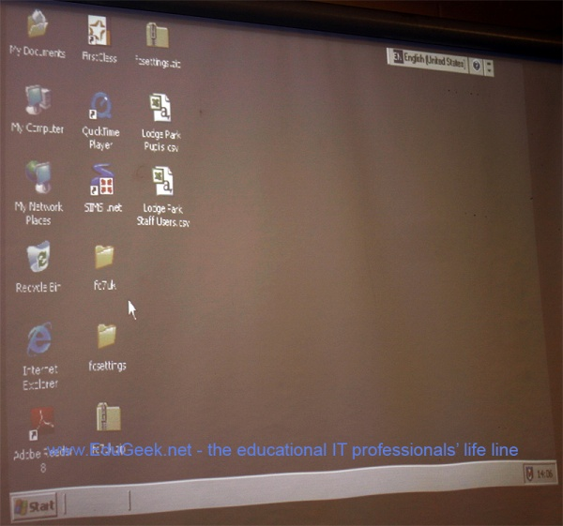

Seeing the miniBook displaying and operating a remote Windows desktop seemed to many to be the icing on top of the cake.
As I have said earlier, we only had it for an hour or so, but our first impressions are very strong. Research Machines tell us that the first batch are mainly destined for the governments ‘Computers for Pupils’ initiative where the most disadvantaged children are given computers and internet connections in a bid to bridge the digital divide. This is the ideal device for it. With two models, the highest spec costing only £200 and lowest £169 it is cheap, exceedingly well thought out and above all, usable from the word go.
Providing no build gremlins creep in, we suspect the miniBook is destined for a huge user and fan base, and more importantly, this could be the way that Linux finally emerges into the UK education sector at user level in massive quantities. RM Admitted to us that the profit margin on these is not very large, but boy, they are going to sell a lot of them.

www.rm.com

Chris Byers, founder EduGeek.net

