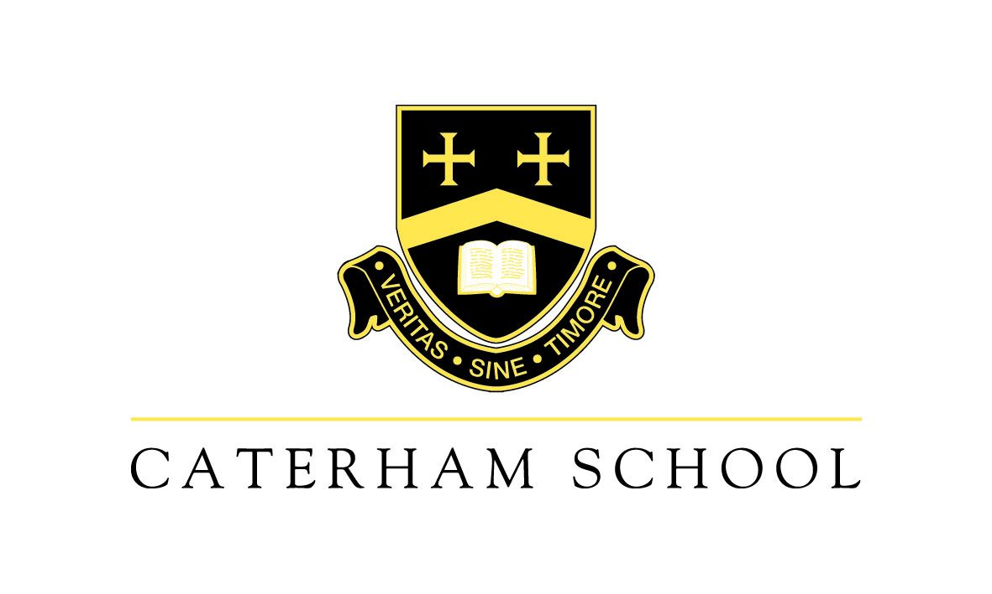
Digital Learning Technician

Salary c£30,000, Full time.

What role can digital tools play in engaging and empowering students in their own learning? How can teachers integrate digital technologies and new approaches into their teaching? Good questions. Here at Caterham School, we recognise the transformative potential of technology in our increasingly digital and connected world, and we are now looking for a talented Digital Learning Technician to support our teachers and pupils in the effective use and ongoing development of our digital learning resources.

This is a fairly new role within the school and the wider education sector, so you will be joining us at an exciting time. Working in a collegiate atmosphere, you will provide a whole-school digital learning support service as part of our IT support team. This will involve giving hands-on classroom support, using your expertise to prepare and maintain digital learning equipment including all Apple devices from iPod Touch through to iMacs and Mac minis (with a particular focus on iPad). In addition, you will support staff with interactive whiteboards, interactive TVs and media devices. You will also attend school groups and clubs to offer advice and ideas to pupils.

There is a strong strategic dimension to this role, too. You will support the Director of Digital Learning in designing, planning and implementing new approaches to digital classroom learning, for example. You may be called on to develop and adapt educational software to enhance classroom learning. And you will take part in a range of training and development activities to support the continuous improvement of our digital learning capabilities.

You are likely to have a Higher Education qualification in Maths, Electronics, Computing or Telecommunication. This will be supported by recent experience working with Apple and Microsoft technology in a technician or software development role. Your good knowledge of key Microsoft services and networking must be supported by a particularly detailed understanding of iPad functionality and the ways in which Apple and Microsoft ecosystems interact. Experience in a school would be an advantage, as would any knowledge of app development and coding or the use of creative software such as Photoshop and Final Cut. You will certainly combine excellent communication, organisational and problem-solving skills with the ability to work well as part of a multi-tasking team.

Along with attractive rewards and ongoing professional development, you will enjoy an exceptional working environment on our 200 acre campus in the Harestone Valley, including access to excellent sports and catering facilities. We are just five minutes’ drive away from the M25 and a short walk from the local station. For an application form and further information, please see our website www.caterhamschool.co.uk or contact our HR Department: HR@caterhamschool.co.uk.

