Connecting Outlook to the new email service
You only need to do this the first time you open up your email after half term, and it’s only five clicks and a password. You can do it. We believe in you!
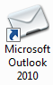

Open Outlook from the desktop – that’s this icon:

This screen will open. Click Next:
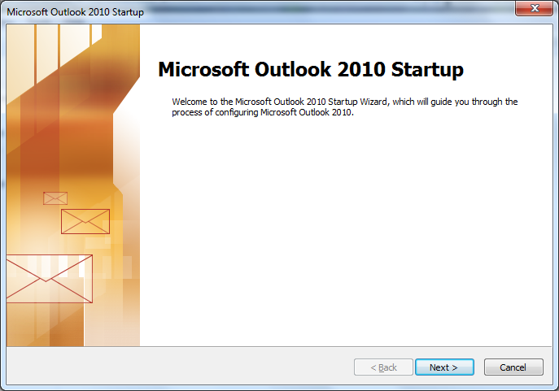

That takes you to this screen. Click Next:
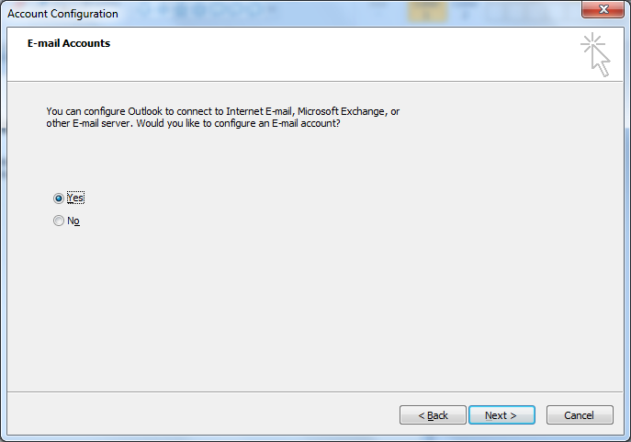
On the next screen, it’s already filled out the details it needs, so just click Next:
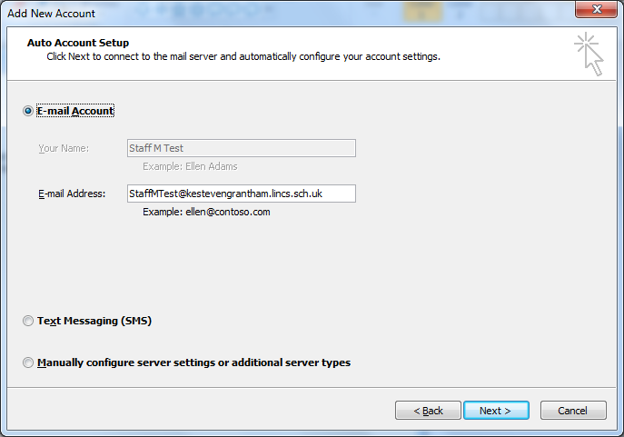

This next step is the most complicated. Fill in your password, tick Remember my credentials, then click OK:
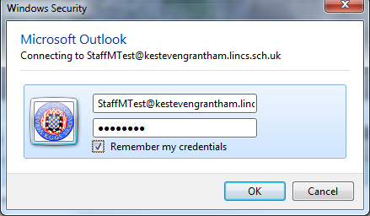
Almost there! Click Finish:
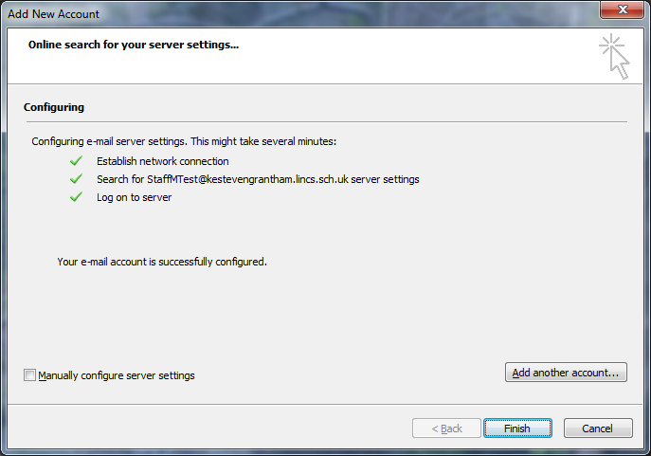
Hey, you’re done! That sure was easy.
Next time you open Outlook it will open straight away. If you didn’t tick the box to Remember your Credentials it will ask for your password each time, but it always offers the same tickbox so tick it when you see it and it should stop asking.
If anything goes wrong and doesn’t act like we said it would, come speak to us in IT Support and we can get it sorted in short order.

