Automating Hardware Installation in Vista and Windows 7
- Basic steps for us are: install app on test machine, copy guid file from driver store to shared folder:

- put it in correct category or make new cat
- Open inf file and add the guid from it to the allowed drivers list
- Add the cert file to it, export to:
- And import to the gpo “Allow non admin to install approved drivers – jby”
- Test on new machine without driver installed.
Task 1: Setting up the Driver Store
Our driver store is at:
Most of us have shares or drives where we keep our software, virtual machines, or downloaded drivers. Some of us probably even have network shares where software is kept for deployment. We have a central store for ADMX files but what about drivers? Well, it is time to create a Central Store for Drivers!
First, set up a network share. All computers and users will need to be able to read/execute drivers from this share so “Everyone” or “Authenticated Users” should have the Read permission on the share and Read/Execute on the folder. No other permissions should be required. For this article, the share name is CentralDrivers.
Underneath the CentralDrivers folder, exists sub-folders for common hardware types. The type of hardware dictates have specific I get. For example, under the folder PC Hardware, sub-folders have been created for Audio devices, system boards, and Video Cards. Set up your share in the way that makes the most logical sense for your organization.
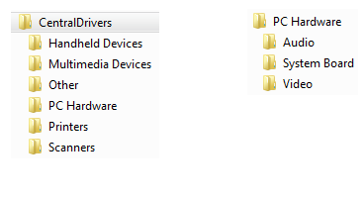
Task 2: Getting Our Drivers in the Central Driver Store
all drivers, when installed, are loaded into the local DriverStore. The entire packages of any drivers that are installed can be found at C:\Windows\System32\DriverStore\FileRepository\.
You want to automate a scanner install. To automate the scanner install, we must first put this scanner driver in the Central Driver Store. After installing the scanner driver on a test machine, open up the locate driver store (C:\Windows\System32\DriverStore\FileRepository).
Drivers are not named in the friendliest fashion (as seen in the picture on the left) but sorting by data modified will show you the newest installed drivers. Simply drag the entire contents of the driver folder over to a folder in your network share. As seen in the picture on the right, I have created a sub folder under scanners and renamed the folder to a user friendly name. This folder contains all of the files needed to install the device.
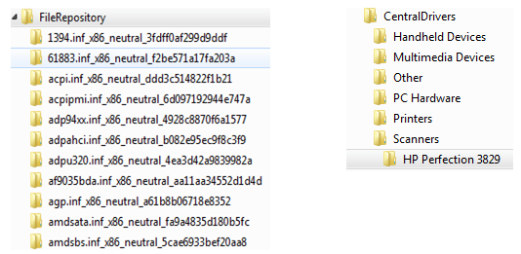
Task 3: Getting our clients to see the Central Driver Store
The GPO to apply this reg setting is in the:
“Allow non admin to install approved drivers – jby”
Properties
Hive | HKEY_LOCAL_MACHINE
Key path | SOFTWARE\Microsoft\Windows\CurrentVersion
Value name | DevicePath
Value type | REG_EXPAND_SZ
Value data | %SystemRoot%\inf;\\wcs-sr-cse\wcs_drivers$
We have created a Central Driver Store. Our Central Driver Store now has at least one driver package in it. Now here comes the easy part – getting our clients to actually use the Central Driver Store. To do so, deploy this one registry key:
HKLM\Software\Microsoft\Windows\CurrentVersion\DevicePath
Value: %SystemRoot%\Inf;\\SERVERNAME\SHARE
EXAMPLE: %SystemRoot%\Inf;\\DRIVERSERVER\Drivers
Task 4: Allowing Standard Users to Install Central Driver Store drivers
To completely automate driver installation, ordinary limited users (which should mean everyone but you/other IT people) should never be prompted for elevated credentials when installing managed hardware (such as when plugging in our scanner for the above task). To do this, the following three criteria must be met:
1. The driver must be in a central driver store.
2. The driver setup class must be allowed
3. The driver publisher must be trusted
We have already tackled item 1 so that shouldn’t be a problem anymore. To meet item 2, we must first find out our driver setup class. Do to this, go to the location of the driver in the central driver store. Right click on any .INF files and click OPEN. At the top of the file, you will see a line named ClassGUID. It should look something like the GUID below. Copy everything to the right of the equals sign (including the brackets).
ClassGUID={4D36E979-E325-11CE-BFC1-08002BE10318}
In a GPO linked to your computers, navigate to Computer Config\Admin Templates\System\Driver Installation. Enable “Allow non-administrators to install drivers for these device setup classes” . Now paste the GUID that you copied from the .INF.
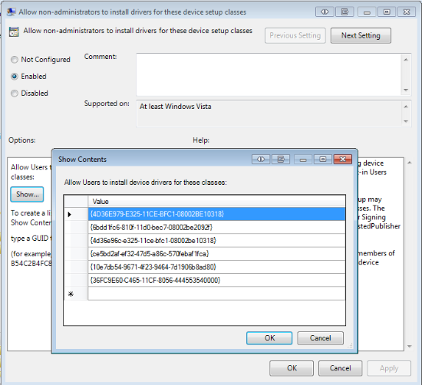
The last thing that we have to do is to make sure that whoever signed the driver is a trusted publisher on our machines. You will only need to do this if you are presented with a Windows Security popup like the one below when installing the driver manually for extraction.
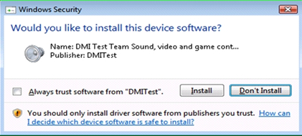
If you are presented with this popup, select “Always trust software from …” and press install. After installation:
- run certmgr.msc.
- Navigate to “Trusted Published” and then select “Certificates”.
- Right click on the certificate and click export.
- This certificate will need to be distributed to all of your computers that will install this hardware.
- This can easily be done by opening a GPO,
- going to Computer Config\Windows Settings\Security Settings\Public Key Polices and importing the certificate under the Trusted Publishers Certificates.
- After importing, you should see the certificate listed (as seen below).
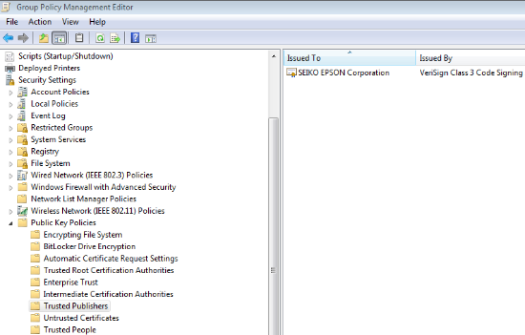
There you have it! You now have the framework to completely automate all of your hardware installations across your entire organization! Gone are the days of having to individually install drivers, enter in Admin Credentials for your users (or worse: making users admins so that they can install hardware!).
You have:
1. set up a central driver store.
2. Organized your store for enterprise use.
3. Started populating your store with drivers that do not automatically install.
4. Configured your clients to search the store for drivers.
5. Allowed non-admins to install the drivers you have in the store.
6. Distributed certificates used in signed drivers to your clients.

