- Open Microsoft Outlook (either 2007 or 2010) from the Start Menu → Programs → Microsoft Office
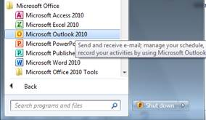

- On the opening wizard page, choose Yes to setup a new email account. If/when you are asked for a Profile name, call it ‘Email’
- Click the option to manually configure server settings
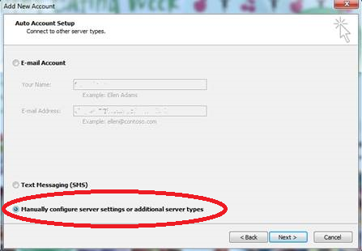

- Select a ‘Microsoft Exchange or compatible service’
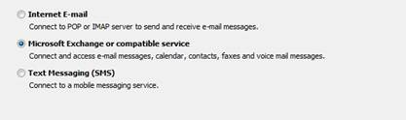

- Enter the server name as LLN-SPP-ES-01 (← this last bit is a number) and fill in your LLN username at the bottom. Untick the box for ‘Use cached Exchange Mode’. Before you click next, go to the ‘More Settings’ button
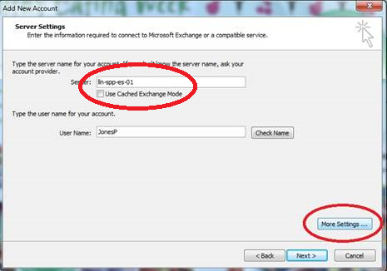

- On the page that appears, go to the ‘Connections’ tab. Tick the box at the bottom to connect using HTTP and then click the ‘Exchange Proxy Settings’ button
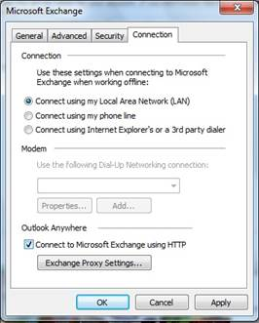

- Enter the connection settings exactly as shown in this screenshot
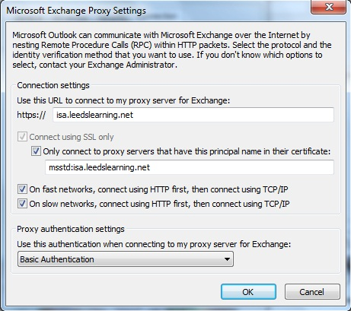

- Click OK on all of the open screens and then click next to complete setting up your account. When the username and password box appear you will need to enter your LLN logon details in the following format:
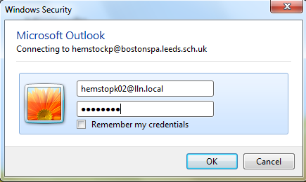

The LLN being what it is, for some reason you are required to enter the @lln.local part after your username

That should be it for the setup.

