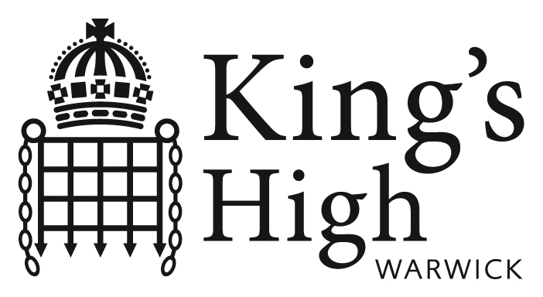

GSA: Day: 646 pupils 11-18,
175 in Sixth Form
Smith Street, Warwick, CV34 4HJ
Helpdesk Analyst/1st Line Network Support Engineer/1st Line/Service Desk/Service Desk Support Engineer/Active Directory /HP/Windows Server is currently required. We are currently looking for a Helpdesk/Service Desk Support Engineer to support complex ICT network.

GSA: Day: 660 pupils 11-18,
160 in Sixth Form
Smith Street, Warwick, CV34 4HJ
www.kingshighwarwick.co.uk
As a 1st Line Desktop Support Engineer your role will be to:
Manage and monitor multisite client networks. This will include handling through to resolution level 1 and level 2 technical incidents, alongside providing proactive monitoring for their clients and providing a 1st Line telephony reporting facility for all ICT Service Desk users.
Duties & Activities:
- First point of contact within the Service Desk for client telephony calls
- Receiving and owning issues; enquiries and change requests for support from clients and prioritise these requests accordingly
- Performing a proactive role in monitoring systems
- Manage the escalation to 3rd Line Support for all relevant user reported incidents
- Perform basic troubleshooting and diagnosis for all issues using the technical resources and monitoring tools available
- Ensuring Incident Management procedures are followed
- Accurate and relevant logging of all user requests and incidents using call logging software
- Attempting to resolve user issues before they require escalating
If you have 1st Line Support/1st Line Network Engineer/Helpdesk/Service Desk experience and have knowledge of HP, Active Directory, Exchange and Windows Server I would be extremely interested in seeing your application form however experience is not essential. This is the perfect role if you have a genuine interest in IT & Technology and will provide a great stepping stone in a future career in ICT. Ideally you need to have excellent customer service skills and be highly motivated and enthusiastic.
The salary range is £15,352 to £18,332 per annum, dependent upon experience and qualifications.

For further details and an application form please visit our website www.kingshighwarwick.co.uk or alternatively you can contact the Human Resources Department on 01926 735472 or at hr@warwickschools.co.uk
Previous applicants will continue to be considered.

Closing date: Monday 1 July at 10:00hrs

This school is committed to safeguarding and promoting the welfare of children and young people and expects all staff and volunteers to share this commitment. All appointments are subject to a satisfactory DBS check.

Warwick Independent Schools Foundation, a Registered Charity, number 1088057
A company limited by guarantee, registered in England; Company number 4252305
Registered Office: Warwick Independent Schools Foundation,
Warwick School, Myton Road, Warwick, CV34 6PP

