Compressing pictures
in Microsoft Office

 |  | 
Word | Publisher | PowerPoint

Saves space and makes your documents open faster.

- Select a picture

- Click on the Picture Tools tab

- Click on this icon
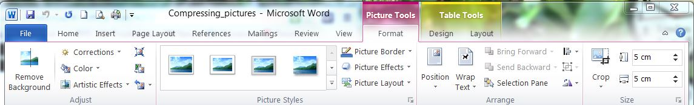

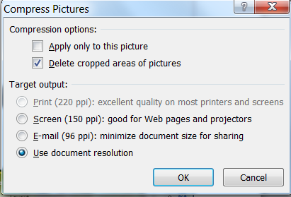
- Untick the “Apply only to this picture” box.
Click on [OK]

- Don’t forget to do it again if you add more images ☺

