Regents Physics
One Dimensional Motion

Notes

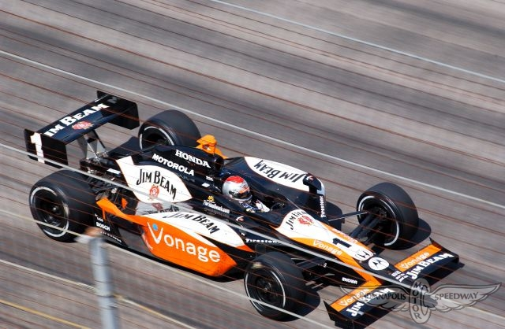

________________________________________
Name

Grading

100% 65%

85% 0%

Scalar and Vector Quantities

Scalar Quantities: Magnitude Only Vector Quantities: Magnitude and Direction
Examples: Distance, Speed Examples: Displacement, Velocity

N

Average Speed = 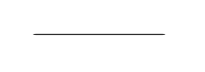

Average Velocity =

Batman decides to go for a spin in the Batmobile. Starting from Wayne Manor he …
First he takes a leisurely 1.00 hour ride heading South for 5 km.

What distance has he traveled so far?

What is his displacement?

What is his average speed?

What is his average velocity?

Next, he joy rides for an hour heading West a total of 8 km.

What total distance has he traveled?

What is his displacement from Wayne Manor?

How much time total?

What is his average speed for the entire trip?

What is his average velocity for the entire trip?

Suddenly he receives an urgent call that there is a break in at the manor.
He heads straight home and arrives in 6 minutes.

What distance does he travel during this final leg of the journey?

What is his final displacement?

What was his average speed overall?

What was his average velocity overall?
Constant and Average Speed

You’re leaving on a jet plane bound for Key West, one thousand miles away. On your trip there you fly at a constant 100 miles per hour. When you reach your destination the captain discovers that pirates have taken the island and so the plane instantaneously turns around and travels at a constant 200 miles per hour all the way back home. What was your average speed during the round trip?

In Words: Average Speed = _______ / _______

In Symbols: v =

Rearranged: _____ = and Rearranged again _____ =

Units: __________ = __________ / __________


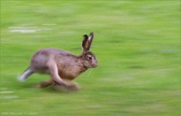
Stedman the steady sea turtle travels 1.5 km in 1 hour. What is his average speed?

a) in km/h

b) in m/s
Horace the Hungarian racing hare blazes through a 400 m race at a constant speed of 12 m/s. How long does it take him?


At a constant speed of 11 m/s. How far can Maurice Green run in 9 seconds?

How long would it take Maurice to run 100m at that rate?

Maurice Green set the world record in the 100m dash by running a 9.79 seconds in the Sydney Olympics in 2000. What was his average speed?

Did Maurice run at that speed during the entire race?


Back to our journey to and from Key West. What was your average speed during the round trip?

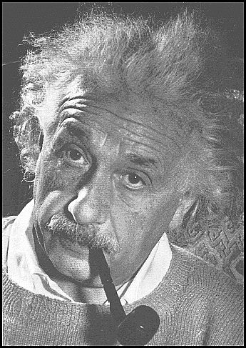
I have been watching your every move. Have you been showing Uncle Al’s three steps for solving physics problems. If not you have been bad, very bad.

The average distance from the earth to the sun can be found on the front page of your physics reference table. Assuming the earth travels in a perfect circle around the sun. What is the average speed at which the earth moves?
a) in m/s

b) in mi/hr (1609m = 1 mi)

A marble traveling to the right at 2 cm/s. Draw a picture at 1 second intervals. Is it traveling a constant speed?

What is its average speed over the entire trip?

A marble traveling to the right at 2.5 cm/s. Draw a picture at 1 second intervals.

When does the grey marble have the same speed as the black marble?

Lets graph this motion!


A picture of the racing snail was taken every 0.2 seconds. How fast is the racing snail moving?



What is happening in this final scenario? What is the snail’s overall average speed? What is the snail’s speed between the first two pictures? What is the snail’s speed between the last two?

Acceleration
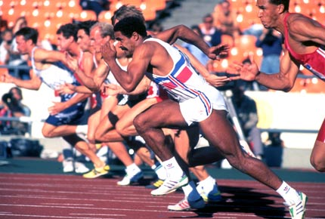
In Words: Acceleration = _______ / _______ = R

In Symbols: a = =

Units: __________ = __________ / __________

Algebra Magic:

1 Scalar versus Vector
2 M_____________ M_____________ and D____________
3 1) _______________ _______________
4 2) _______________ _______________
3) _______________ _______________
4) _______________ _______________

If I travel 3 miles North and 2 miles South, what is my displacement? _________ distance traveled? _________

Motion Diagrams

Moving to the right is defined to be Positive (Example +5 m/s)
Moving to the left is defined to be Negative (Example -5 m/s)

No Acceleration

Speeding Up to the Right: t = 2 s, v_{i} = +2 m/s, v_{f} = +6 m/s ∆v = a =

Speeding Up to the Left: t = 2 s, v_{i} = ____ m/s, v_{f} = ____ m/s ∆v = a =

Slowing Down to the Right: t = 2 s, v_{i} = ____ m/s, v_{f} = ____ m/s ∆v = a =

Slowing Down to the Left: t = 2 s, v_{i} = ____ m/s, v_{f} = ____ m/s ∆v = a =

Positive Acceleration

Negative Acceleration

Graphing Acceleration

1) A racecar driver accelerates from 0 to 60 mi/hr in 10s. What is her acceleration in mi/hr/s?
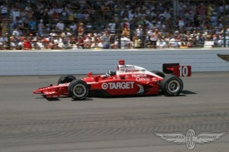

2) A car accelerates uniformly at 3.20 m/s² from an initial speed of 25.0 m/s. Determine the speed of the car after 6.30 seconds.


3) Tom Boonen a famous sprint cyclist approaches the finish line of a bike race and accelerates at a rate of 1.2 m/s² for 5.0 s. He crosses the finish line at a speed of 14.3 m/s. What was his initial speed when he began the sprint in m/s?

4) What was his final speed in mi/hr?

5) Moments after crossing the finish line a raving mad fan jumps out in front of Tom’s bike causing him to slam on the brakes and come to a complete stop in 4 s. What was his acceleration during this time interval?

6) A rocket ship has a constant rate of change of speed of 30 m/s². Determine the time required to accelerate from 10 m/s to 300 m/s.

7) Once the rocket exits the earth’s atmosphere it shuts down its “boosters” and travels at a constant 2000 m/s for 7200 seconds. What is its acceleration?

Kinematics Equations
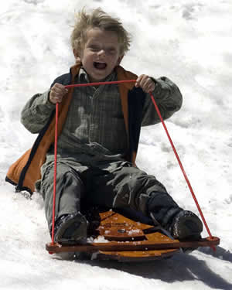
v_{f} = d = v_{f}² = Secret Formula: 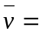
1) A kid in a sled starts from rest at the top of a snow covered hill and slides straight down the 50 meter long slope in 5.0 seconds. What is the magnitude of the acceleration of the kid?

2) A tricyclist increases her speed uniformly from 2.0 meters per second to 7.0 meters per second over a distance of 12 meters. What is the magnitude of her acceleration as she travels this 12 meters?
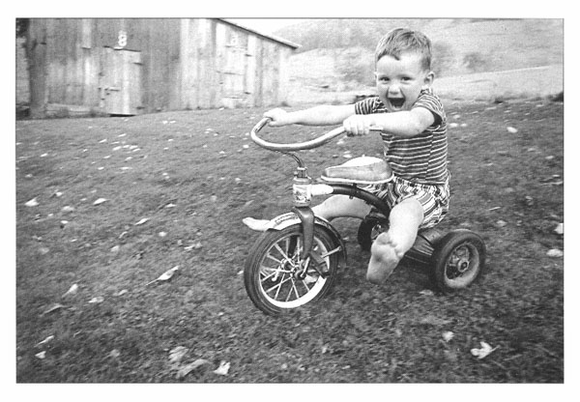

3) The speed of a car is decreased uniformly from 30. meters per second to 10. meters per second in 4.0 seconds. What is the magnitude of the car’s acceleration?
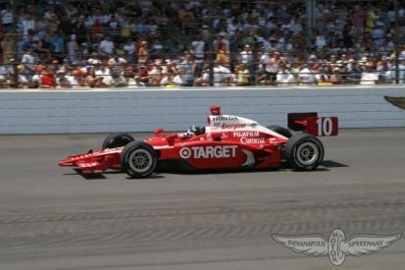

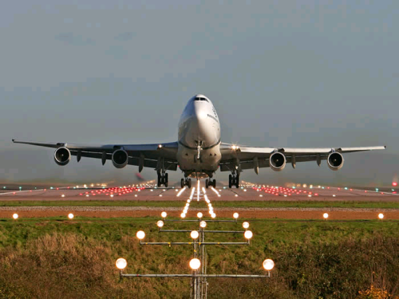
4) An airplane, originally at rest on a runway accelerates uniformly at 6.0 meters per second² for 12 seconds. During this 12 second interval, the airplane travels a distance of…

5) A roller coaster, traveling with an initial speed of 15 meters per second, decelerates uniformly at -7.0 meters per second² to a full stop. Approximately how far does the roller coaster travel during its deceleration?

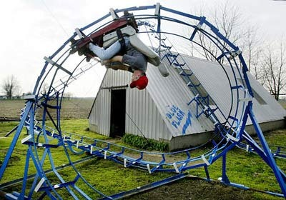

Graphing Motion
Distance (meters)
Time (seconds)
10
0
Distance (meters)
Time (seconds)
10
0
Distance (meters)
Time (seconds) 5
10
0

Distance (meters)
Time (seconds)
10
0
Distance (meters)
Time (seconds)
10
0
Distance (meters)
Time (seconds)
10
0

Distance (meters)
Time (seconds)
10
0
Distance (meters)
Time (seconds)
10
0
Distance (meters)
Time (seconds)
10
0

Physics Salute
Distance (m)
Time (seconds)
10
0
Velocity (m/s)
Time (seconds)
10
0
Accel (m/s²)
Time (seconds)
10
0

Distance (m)
Time (seconds)
10
0
Velocity (m/s)
Time (seconds)
10
0
Accel (m/s²)
Time (seconds)
10
0

PhET: Physics Education Technology: http://phet.colorado.edu/simulations/sims.php?sim=The_Moving_Man
Tour de Physics


_______________'s Ride
Time (s) | Dist (mi) | Dist (m)
0 | 0 | 0
30
60
90
120

Avg Speed = =__________mi/hr

Avg Speed = =__________m/s

Graphing Motion
Describe the motion represented by the following Velocity as a function of time graph.
5

Vel (m/s) Accel (m/s²)

0
0.5 1.0 0.5 1.0
Time(s) Time(s)

-5

1) a. Draw a Velocity-Time graph for a cyclist who starts from rest and accelerates at 10 m/s² for 3 s.
b. What is the cyclist’s final velocity? Do it in your head! Label that on the graph.

c. Let’s find the area under the graph from time equals 0 to 3 seconds. What does this represent?

2) a. Draw an Acceleration – Time graph for this same situation?

b. Let’s find the area under this graph from time equals 0 to 3 seconds? What does this represent?

3) Given an initial speed of 3 m/s. How far did this object travel in 12 seconds?

Accel
(m/s²) 7

6 12
Time (s)

Tour de Physics (Bonus if you can find the time section)

Bike Tire Diameter = _______________ Bike Tire Circumference = _______________

The period of the tire is the “time for one revolution”.
The frequency of the tire is the “revolutions in one second”
The circumference of the tire is the “distance for one revolution”
During one period, the wheel pulls the car a distance equal to its circumference.

Using the overall average speeds from above let’s convert from m/s to the frequency of one of their wheels, in rev/sec.

Next convert frequencies to periods in seconds/revolution.

Practice Problem: A cyclist is traveling at a constant speed of 9.0 m/s. Perform the following calculations:

a. How far does she go in 3.2 seconds?

b. Her bicycle tire has a radius of 0.30 m, how many complete rotations does it make during this time?

Extra Problems

4) 8 The graph shows the motion of a dog chasing a squirrel.
a) Describe the motion of the dog.
Velocity
(m/s)

b) Calculate the acceleration of the dog during the time interval 0 to 4 s.

0 4 10
Time (s)
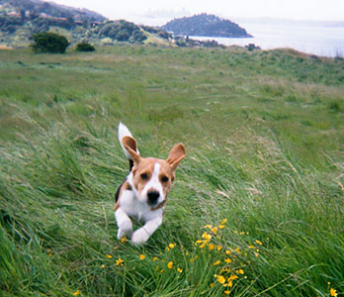
c) Calculate the acceleration of the dog during the time interval 4 to 10 s.

4) A plane touches down on a runway at a speed of 45 m/s and comes to stop 100 m later. What was its acceleration?

3) a. Draw a Distance–Time graph for a runner who travels at a constant 3 m/s for 20 seconds.
b. How far does the runner travel during this time?

Tour de Physics

_______________'s Ride
Time (s) | Dist (mi) | Dist (m)
0 | 0 | 0
30
60
90
120

Avg Speed = =__________mi/hr

Avg Speed = =__________m/s

