Log on to print server
Find the printer and bring up properties, Click on advance and on printing defaults
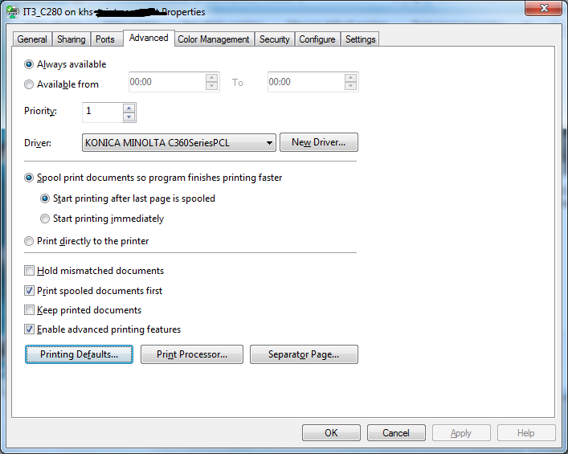
Click on Auth/account track and select public user. (this will use the public user that we selected on the printer click ok on it all. Once back on printer proprites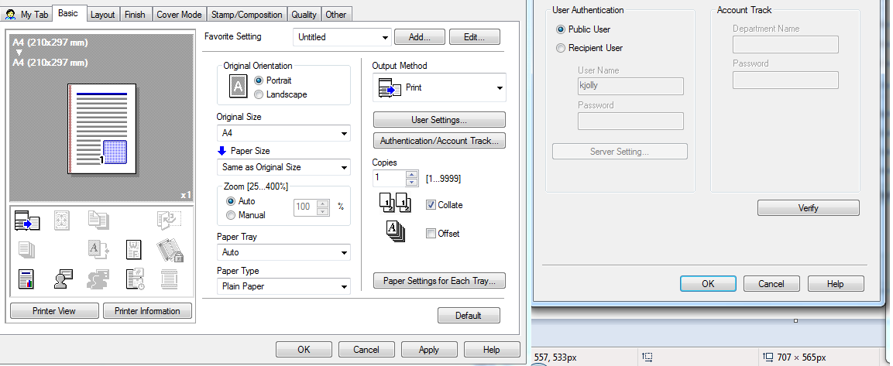

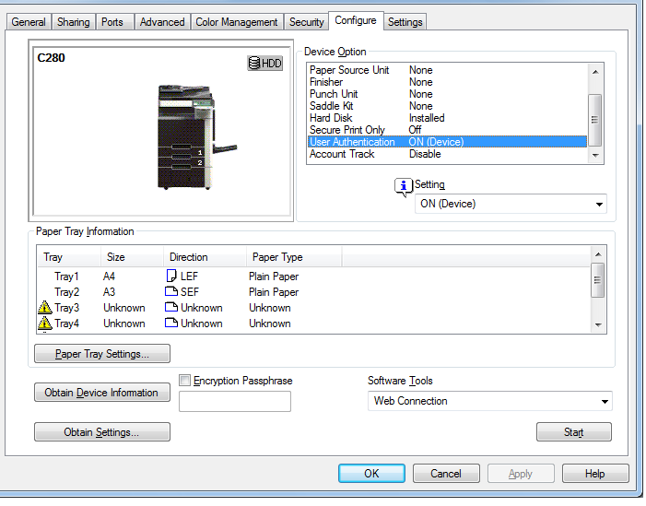
Click on obtain device information which will pull the information from the printer. Click on obtain settings untick auto, Now you should be able to change the selected items.(se mine)

Click on settings and check against mine.
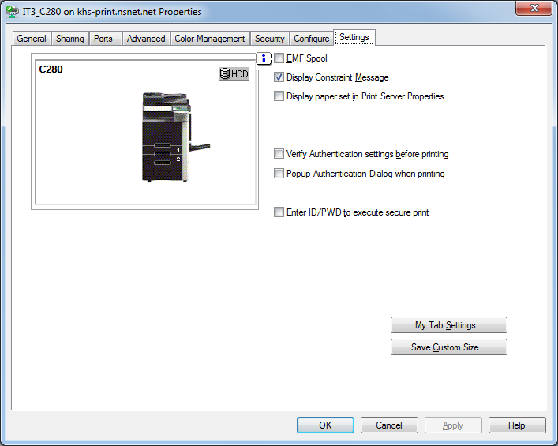
Check printer settings again as mine changed after i changed the config and settings tab.

