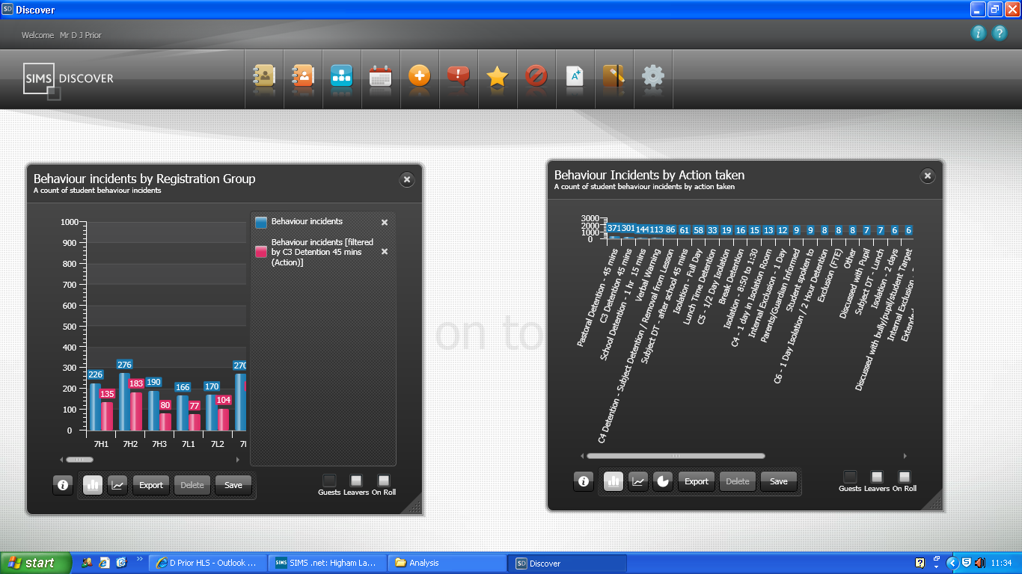
Graph on the left has an item (C3 Detention 45 mins) dragged onto it from the graph on the right. The graph on the right is described as “a count of student behaviour incidents by action taken”. The graph on the left is described as “a count of student behaviour incidents”. The legend describing the new series caused by the drag and drop is described as “Behaviour Incidents [Filtered by C3 Detention 45 mins (Action)]”.

